Columbia County Chess Association
Weekly Newsletter – 17 October 2025
Written by: Travis L. Jones
Editor: Russell (Rusty) Charles

This month there’s a lot of stuff to talk about – recent results, league announcements, and more. We’ll be covering:

- The Chess League
  - October ’25 Results
  - The Final Standings of the 2025 Chess League
  - 2024 Recognition
    - Open Section Champion
    - U1100 Section Champion
    - Most Improved Player
  - League Playoff dates
- 2026 Chess League Information and Dates
- Wednesday Chess
- Rated Online Tournaments
  - Online USCFF Rated Tournaments
  - New Chess.com Group
  - Chess4Life Training Software
- Scholastic Chess Programs
  - CSRA Scholastic Chess League
  - Elementary Schools Programs and Lessons

The Chess League

October ’25, Results

In the final monthly tournament of the 2025 Regular Season, we saw a lot of fierce competition. Isaac Nielson and Alexander Looney were head-to-head all through the day, and Vedant Tiwari had a perfect performance in the U1000 section. These are the results for the day:

Open Section

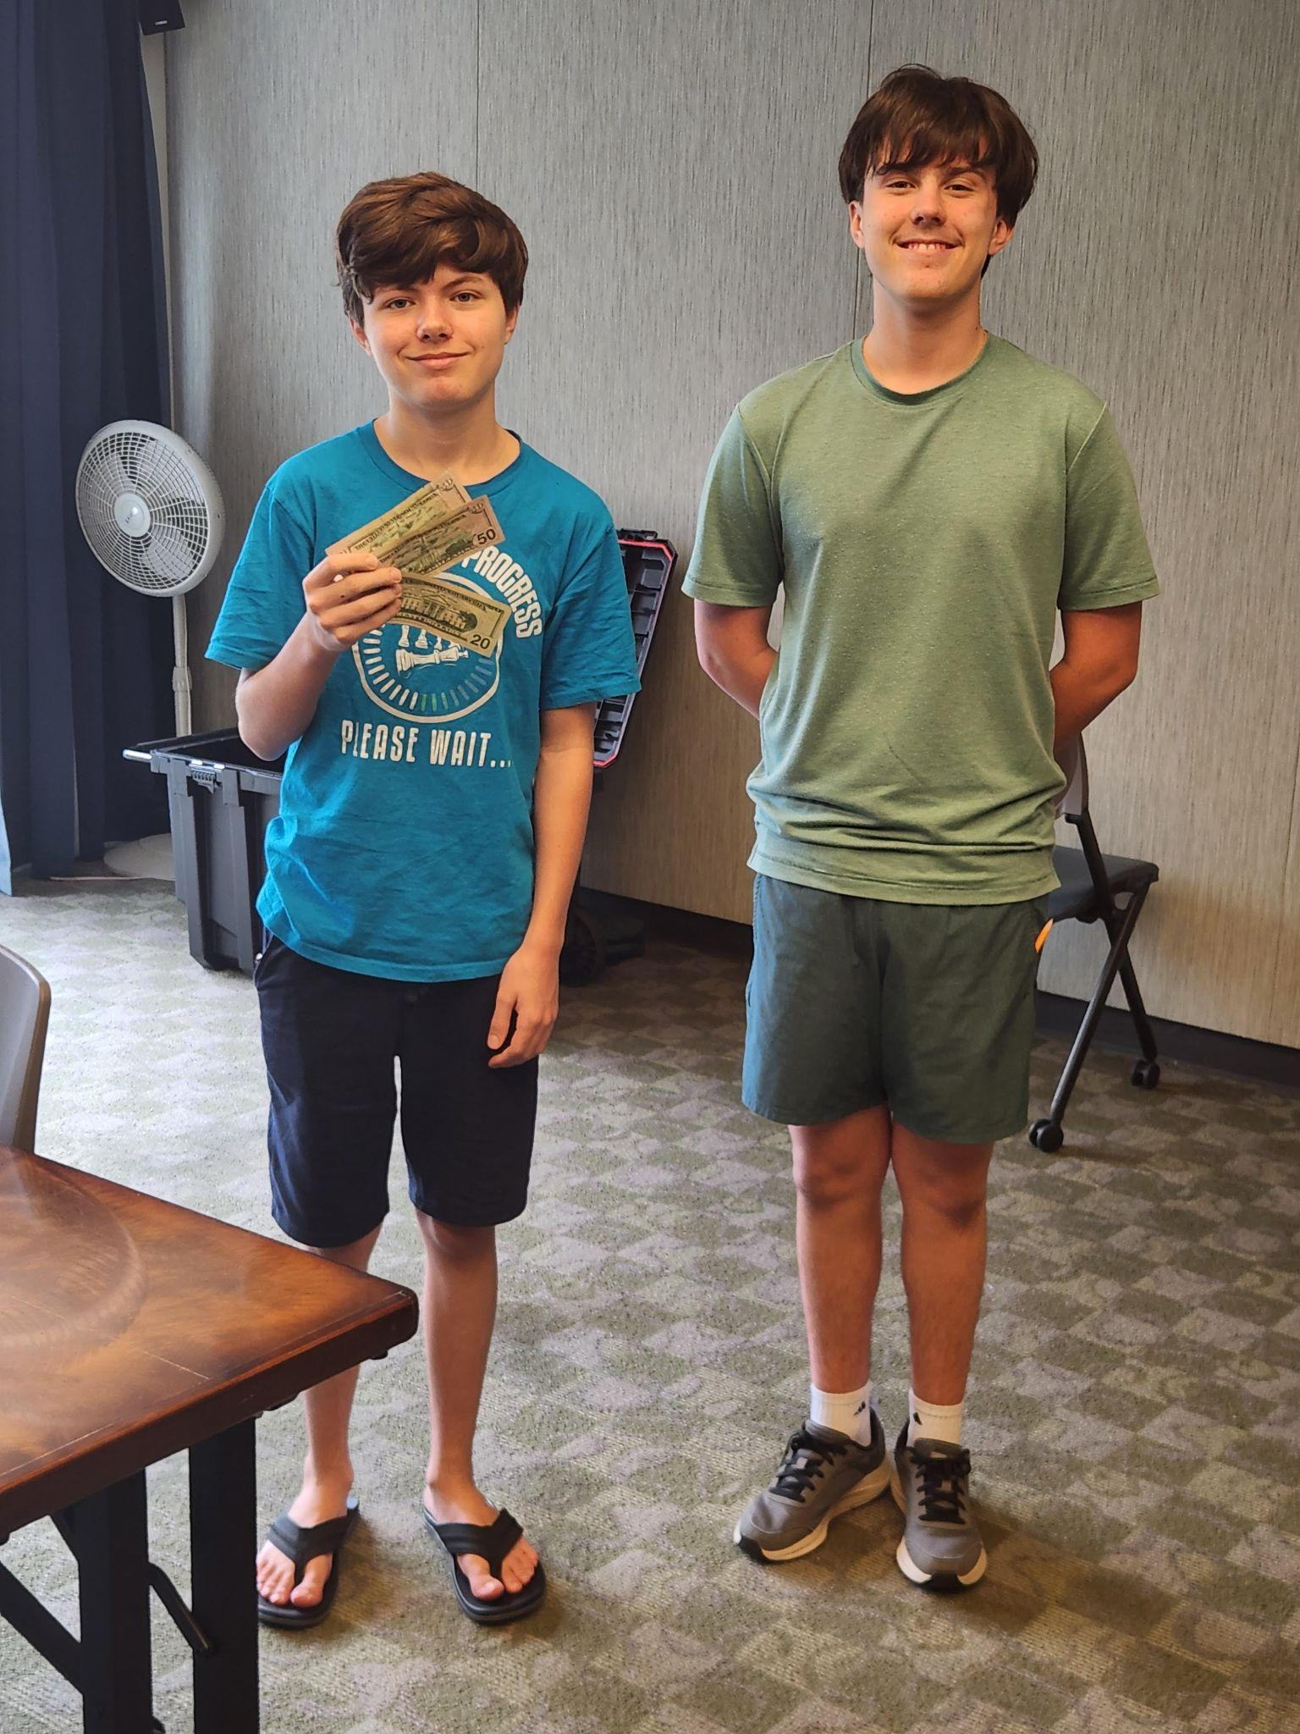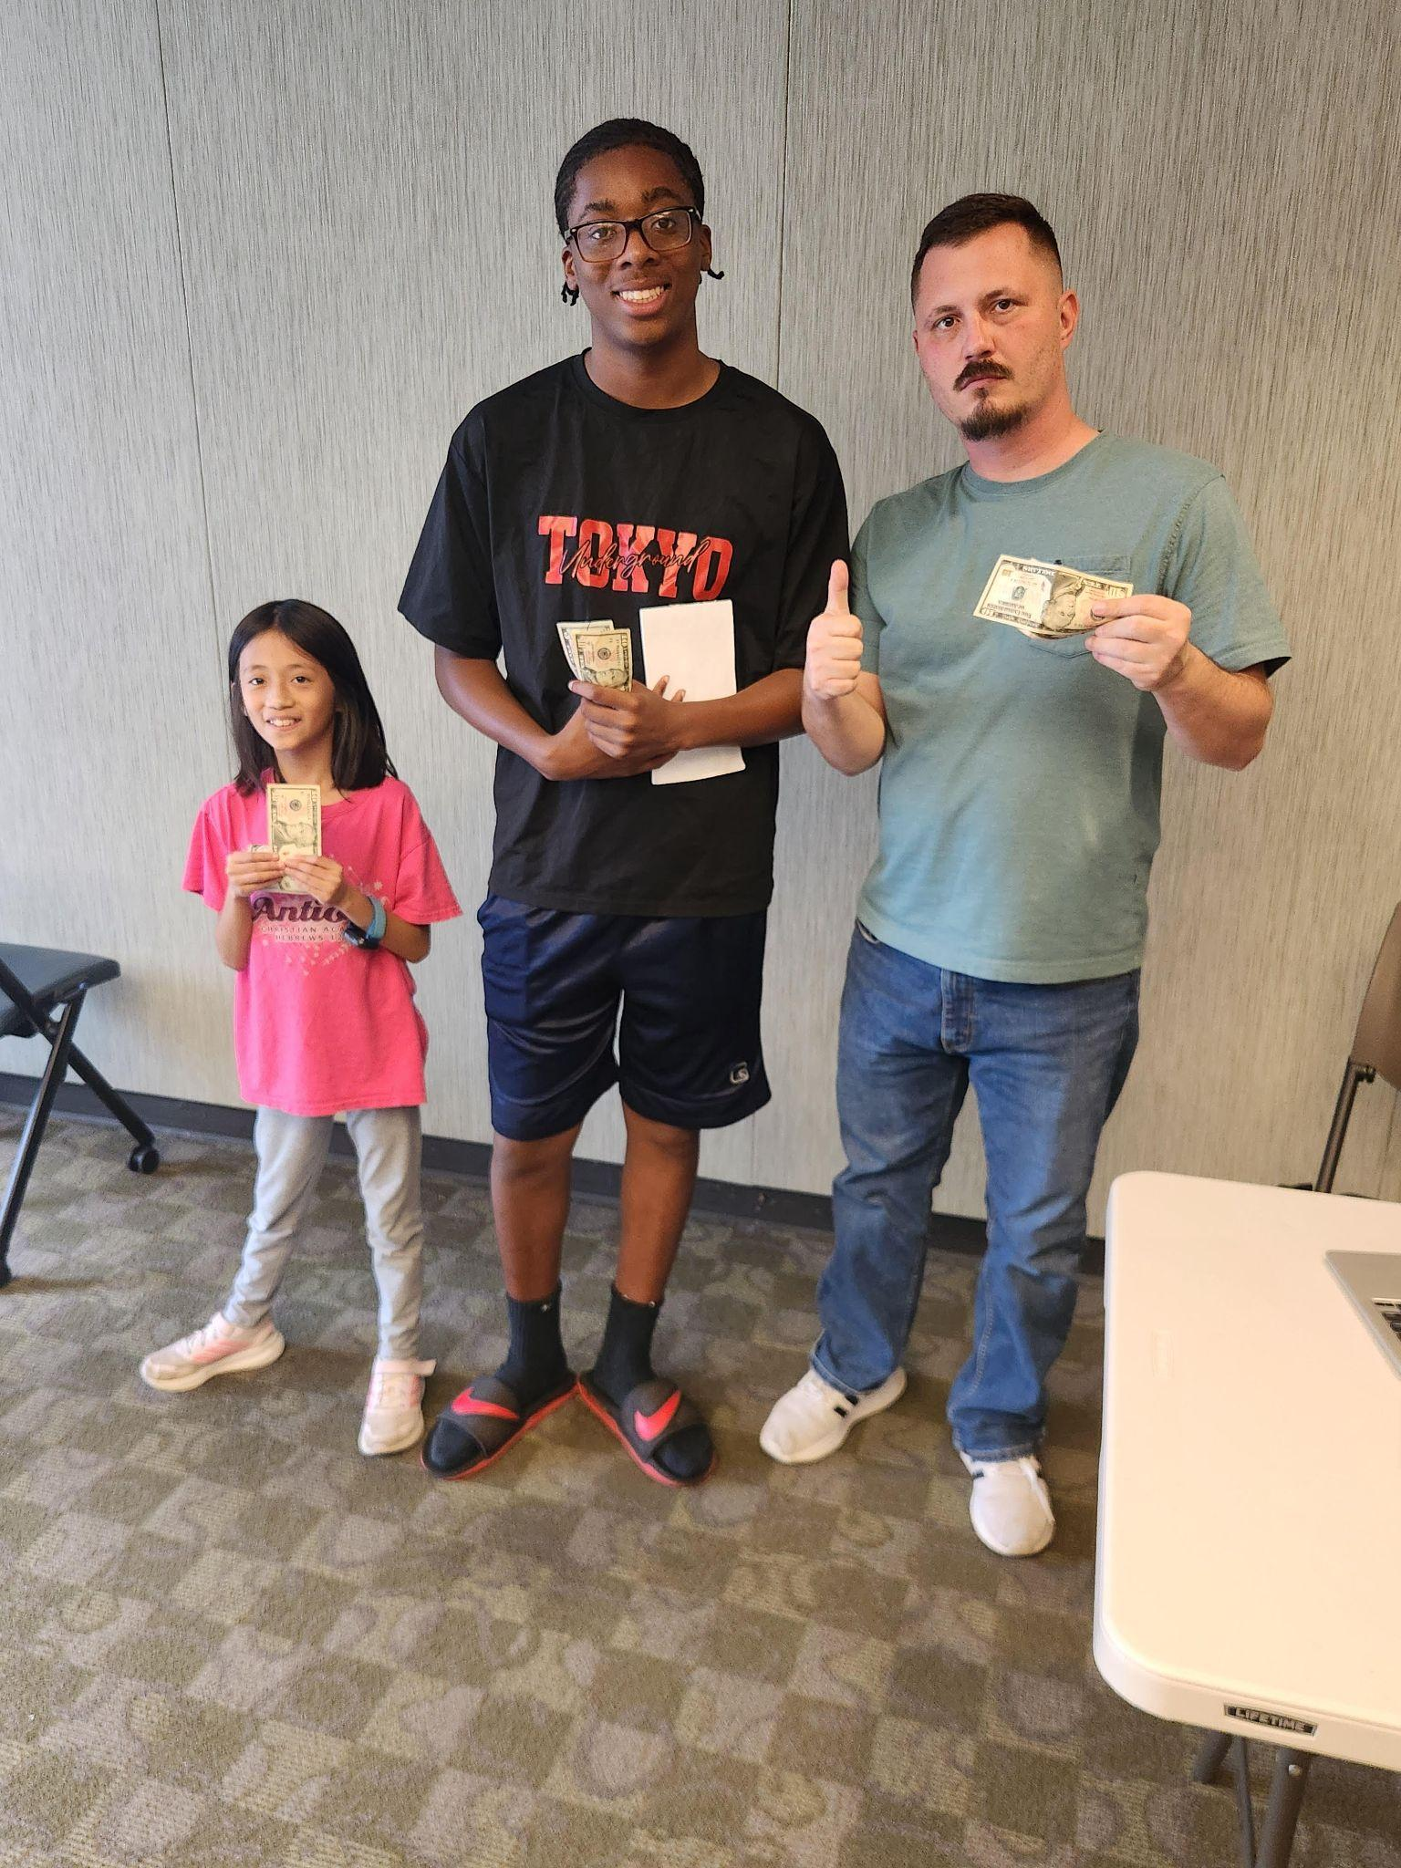

1st Place (2-way tie): Isaac Nielson and Alexander Looney (3.5 / 4 points)
3rd Place (4-way tie): Johnathan Long (not shown), Darby Williams, Lily She, and Jalen Taylor (2.0 / 4 points)

U1000 Section

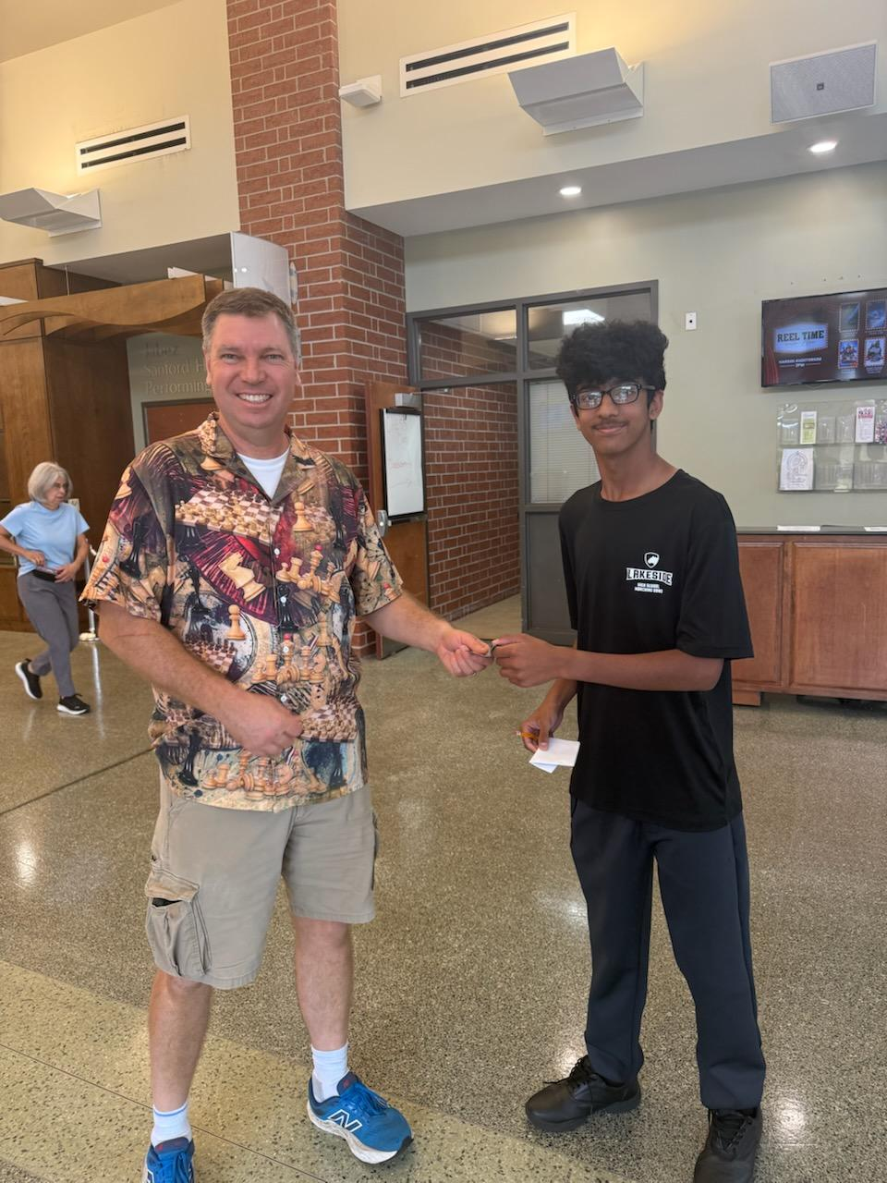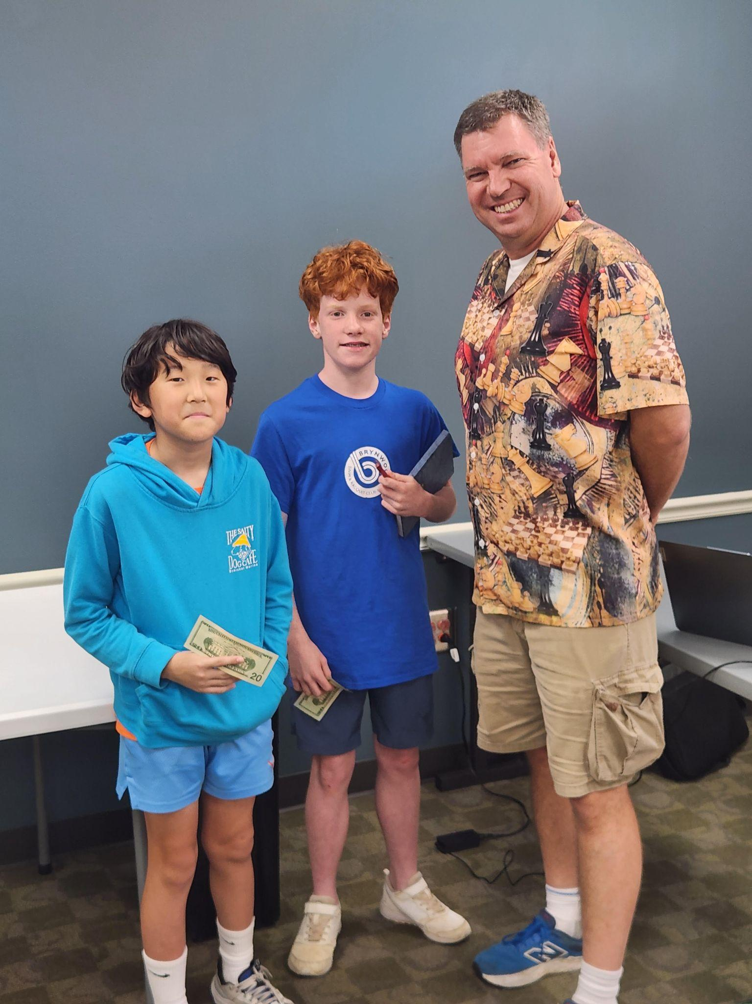

1st Place: Vedant Tiwari (4.0 / 4 points)
2nd Place: Gurnoor Farmaha (3.5 / 4 points)
3rd Place (tie): Peter Newton and Ryan Kim (3.0 / 4 points)

This year has been a wonderful experience for all of us. We’ve had larger crowds and more registrants than we’ve ever seen before.

2025 Chess League - Final Regular Season Standings

The Regular Season portion of the 2025 Chess League has concluded, and the results are in. It’s been a fantastic year, full of surprises and a lot of improvement for everyone.

The winners and Final Standings for the 2025 Regular Season:

Open Section
1st Place, $300: Abigail Lin
2nd Place, $150: Lily She
3rd Place, $100: Matthew Campbell
4th Place, $50: Lucky Walker

U1000 Section
1st Place (tie), $150 each: Peter Newton and Gurnoor Farmaha
3rd Place, $70: Gary Richard
4th Place, $30: Arnav Sharma

Congratulations to all our players this year. We especially want to thank all the families – we couldn’t have this wonderful program without your continued support.

Final Standings found through 2025 Chess League – Columbia County Chess Association .

2025 Chess League Playoff Dates

To finish off the season with a bang, the top 12 players from the Open and U1000 Sections will compete to see just who the best in the CSRA is! These tournaments will be held separately so that there will be enough room for observers and so that players can have the least amount of distraction possible.

Open Section: Playoff Starts November 1st
U1000 Section: Playoff Starts December 6th

The first rounds will include the 12-qualifying players forming two 6-player groups to play a 5-game round robin format of G/25;+5 games. The top two players from each round robin group will advance to the second day of competition, the bracketed playoff. The remaining for players will pair up and face each other in a bracketed tournament. Each round including two G/35;+5 games. The player with the highest point value advances to the finals, the other players will face off to determine the 3rd and 4th place finishes. Should there be a tie after a pairing’s 2 games, then a tie-breaker will be determined with two G/15;+0 games, if still tied G/10:;+0 games after that unitl a winner is determined.

Should any section of the Playoff not fill the 12-spots allotted for Round Robin, then all players will play in the same group in a 5-round Swiss tournament to find the top 4-players. This is to say if the Open Section does not have 12-registrants, then the number of registered players will play against each other in a Swiss-style tournament.

For players who would like to play and participate, but were not qualifiers for the play-off, we can assist! We will hold a round-robin style tournament for all other registered players in groups of 6. All registered players will be grouped with players of similar ratings with prizes to the top two finisher of each group! We invite everyone to participate!

Register for the 2025 Chess League Playoffs and Tournament through Chess League – Columbia County Chess Association .

Registry for the 2026 Chess League is also available with a bonus for 2026. The Columbia County Chess Association has secured licenses for an innovative, child-friendly chess training platform; Chess4Life. 2026 Chess League Season Passes, access to Chess4Life Software and registration through the end of the 2025 (includes playoffs) is available for $400 through Chess League – Columbia County Chess Association .

2024 Recognition

We also want to take a moment to catch up on some recognitions that are overdue from 2024. These members are receiving trophies for their accomplishments.
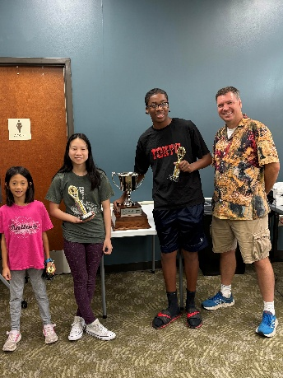
Congratulations go to Lily She, Abigail Lin and Jalen Taylor for their performances through the 2024 Chess League. These three have great potential and bright futures on and off the chess board.

Recognitions are found through 2024 Chess League Champions – Columbia County Chess Association .

Open Section 2024 Champion
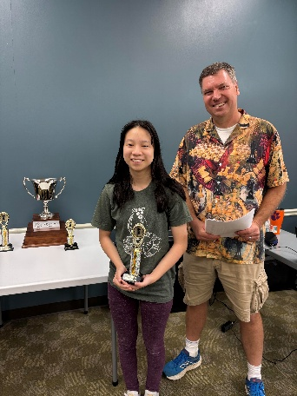

Abigail Lin trounces through the Open Section bracket after moving to the CSRA. Entering the playoff as a 3-seed Abigail wins the final through a rapid tie-break match to claim the title of “2024 CCCA Open Section – Chess League Champion”!

U1100 Section 2024 Champion
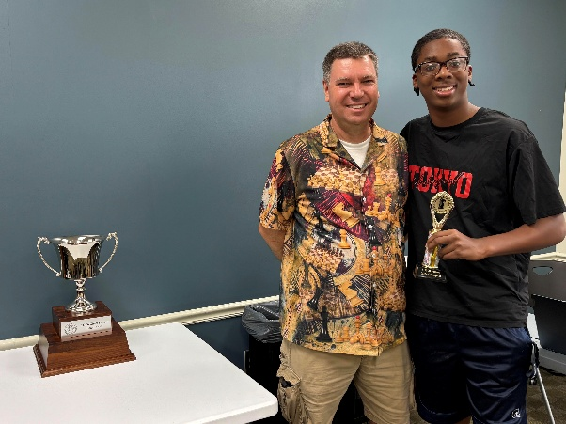
Jalen Taylor provides spunk and entertainment with both his wit and play. As a year-long participant in the Chess League, Jalen had both highs and lows throughout the year. When it came to the playoffs and finals, his focus intensified as he swept the final games to win the “2024 U1100 Section – Chess League Champion”!

2024 Most Improved Player
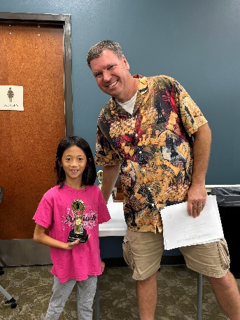

Arriving to our club in January 2024, Lily began her club play as a 300-Elo player. As a connoisseur of chess theory and knowledge, it did not take long to realize the potential Lily has. She has since beaten everyone in our club at least once. She gained 692 ELO throughout the 2024 year to become the “2024 – Most Improved Player”!

2026 Chess League Changes and Tournament Dates

The Chess League will continue in 2026 and we are excited about the changes. Our Chess League will continue to be held in the Columbia County Library in both Room A (upstairs) and the downstairs room. The Game formats are changing in 2026, all games will become G/35;+5. The Columbia County Chess Association will now offer 3 sections for competition and an increased prize pool! We will now include a middle section to aid some of our aspiring players still working on their games. The section will be:
- Open Section
- U1300 Section
- U800 Section

- If the Open section does not have at least 6 registrants, then they will be combined with the U1300 section and will play and Accelerated Swiss-style tournament. Section prizes will then be applicable to the ratings of the players registered

With the success we saw last year, the prize pool increases this year! Each tournament will hold a $700 Prize Pool (Based on 20 Entrants) with prizes as follows:
- Open Section - $300 Prize Pool (1st - $160, 2nd - $80 and 3rd - $60)
- U1300 Section - $200 Prize Pool (1st - $100, 2nd - $60 and 3rd - $40)
- U800 Section - $200 Prize Pool (1st - $100, 2nd - $60 and 3rd - $40)

The Columbia County Chess Association is proud to announce their 2026 Chess League Tournament Dates:
- January 3rd
- February 7th
- March 7th
- April 4th
- May 9th
- June 6th
- July 11th
- August 1st
- September 12th
- October 3rd
- November 14th (Playoff)
- December 5th (Playoff)

Registration is now open for the 2026 Season with an extra bonus! The Columbia County Chess Association will now offer access to the child friendly chess training software, Chess4Life. All those with 2026 League Passes will have accesses to the Chess4Life training software through the 2026 Regular Season. This software is included in the discounted registry of 10 tournaments for the 2026 Season! $350 will cover registration for 10 tournaments and the Chess4Life Software!

Register for 2026 through 2026 Registration – Columbia County Chess Association .

Wednesday Chess

There’s been a lot of active play on Wednesdays at Cardboard Castle. If you’re not going, you’re certainly missing out on a lot of fun! Here’s the results for the past month’s Wednesday Chess tournaments.

Don’t miss out on the comradery and fun! Wednesday Chess – Columbia County Chess Association

10 September 2025 (G/5;+3)
- Open Section Winner – Matthew Campbell
- Under Section Winner – Karthik Arora

17 September 2025 (G/10;+5)
- Open Section Winner – D’Taune Ingram
- Under Section Winner – Vedant Tiwari

24 September 2025 (G/15;+5)
- Open Section Winner – Colin Potts
- Under Section Winner – Sam Shell

1 October 2025 (Chess 960, G/10;+5)
- Winner – Johnathan Long

8 October 2025 (G/10;+5)
- Winner – Abigail Lin

15 October Results (G/15;+5)
- Open Section – Matthew Campbell
- Under Section Winner – (Tie) Arnav Sharma and Suhdruth Gupta Medam

Wednesday Chess fees have increased to $10 for rated play (for the evening) to facilitate a $50 Prize Pool (based on 10 entries). The new prize pool will be Open: $30 / Under: $20

Rated Online Activity

Online USCF Rated Tournaments

The results for the online USCF rated event held on 26 September 2025 was as follows:

Registration is open for the next online USCF rated event. It will be held on 17 October 2025 at 7pm. Registration is $5 for all before 5pm on 17 October. Prizes will be:

Open: $30 pool (1st - $20, 2nd $10)
U1000: $15 pool (1st - $10, 2nd $5)
Games will be between 6-8 rounds of G/5;+3, Swiss Pairings

Register through: Online Tournaments – Columbia County Chess Association .

New Columbia County Chess Association Chess.com Group

There is one other major announcement for online players: The Columbia County Chess Association now has a Chess.com group! We encourage all interested players to join the group on Chess.com so you can get notifications for upcoming rated games, unrated team games against other groups, and other goodies that might be happening in the future. Join through https://www.chess.com/club/columbia-county-chess-association/join .

Chess4Life Training Software Platform

The Columbia County Chess Association, Dr. Larisa Jordan, Augusta Christian Schools, Parents of ACS, and William Bowman are proud to bring the Chess4Life Training software and chess teaching platforms to the CSRA Scholastic League, Augusta Christian Schools and the Columbia County Chess Association! Chess4Life offer innovative, child-friendly and safe software with insightful lessons, drills and games! This will become part of the CSRA Scholastic League Curriculum, Augusta Christian School Students and will be available to players of the Columbia County Chess Association. We are very excited about this progression and opportunity to further the benefits of Chess throughout our community!

Scholastic Chess

CSRA Scholastic Chess League

William Bowman has made great strides in starting up a middle-school Scholastic league integrating four (4) middle schools into competition with each other. We love watching his work, and look forward to the word getting out even more about the growing chess scene in our area!

Updated standings, results and information can be found through CSRA Scholastic Chess League – Columbia County Chess Association .

Elementary School Programs and Lessons

Our after-school chess program began this week with Stevens Creek Elementary students. Our first session of the 72 students participating! Let us know if you would like you school to be a part of our outreach to hold scholastic chess clubs, we will work as best we can to facilitate education of the game!

We are including our lessons on our website for those just starting out!
Elementary School Lessons – Columbia County Chess Association

