Columbia County Chess Association
Game of the Week
8 November 2025
Written by Travis L. Jones

For this week we’re going over a game between two of our very own players: Abigail Lin and Gerald Battaglia.

Event: Columbia County Chess League, March 2025
Round: 2
White: Abigail Lin (1369)
Black: Gerald Battaglia (1591)

Analysis images taken from https://www.365chess.com/analysis_board.php

1. e4 c5
2. Nc3 a6
3. d4 cxd4
4. Qxd4 Nc6
5. Qe3 d6
6. b3 Nf6
7. Bc4 b5
8. Bd5 Bb7
9. Bxc6+ Bxc6
10. Bb2 Qa5
11. f3 b4
12. Nce2 e5
13. Nh3 h6
14. 0-0 Be7

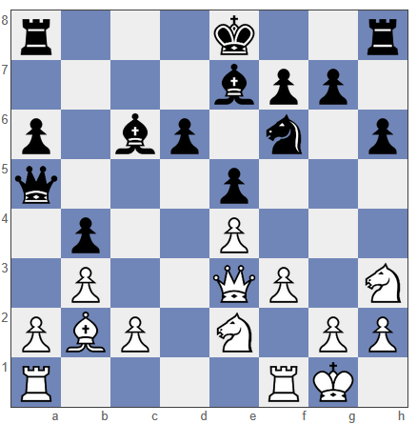
Board position after 14…Be7

Now that the game is past the opening, it’s a good idea to look at the imbalances. White has castled and has traded off the bad white square bishop in exchange for a knight on a board that is still crowded. Black has extra space on the queenside and has done a good job of taking away key squares that the white knights would love to call home. Black hasn’t castled, but the king isn’t in any danger, and the g-pawn might need to go to g6 to block another white knight outpost on f5. White has a couple targets to focus on, such as the b4 pawn and the half open d-file, but both plans would require a lot of maneuvering and wouldn’t be easy to claim. Overall, I read the position as balanced.

15. Ng3 g6
16. f4 Ng4
17. Qf3 f5
18. Kh1 Bh4
19. fxe5 dxe5
20. Nxf5 gxf5
21. Qxf5 Bd7
22. Qh5+

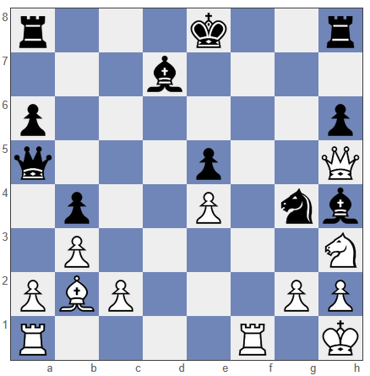
Board position after 22. Qh5+

White has been able to clean out the kingside quite a bit and has come up with a nice way to win back the knight sacrifice, while also opening the f-file for the rook and opening up an attack on the black king.

22. ... Kd8
23. Qxh4+ Kc7
24. Rf7 Rhg8
25. Rd1 Rad8
26. Qe7 Qb5
27. c4 bxc3 EP
28. Bxc3 Rge8
29. Qd6+ Kc8
30. Rc1 Kb7
31. Bxe5

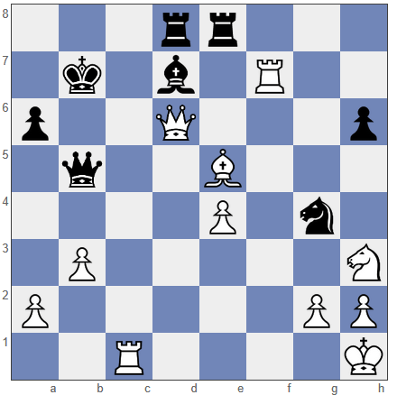
Board position after 31. Bxe5

Black looks to be in quite a pickle here. But is he?

31. … Nxe5
32. Rc7+ Ka8
33. Rc5 Qe2
34. Rxe5 Rxe5
35. Qxe5 Bxh3
White resigned

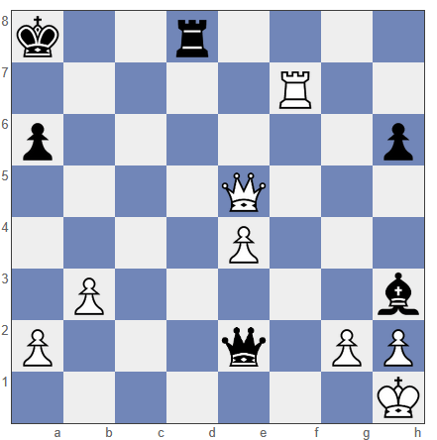
Final board position.

Going by the PGN, black appeared to be under time pressure for the final few moves – he made move 31 with 12 seconds left on the clock - yet still managed to find this winning combination.

