Columbia County Chess Association
Monthly Newsletter – November 2025
Written by: Travis L. Jones
Contributions by William Bowman
Editor: Russell (Rusty) Charles

The end of the regular Chess League season is here. This month saw the first round of the Open League Playoffs, and it was quite the show! We’ve got lots to cover, so let’s get right into it!

- The Chess League
  - 2025 Open Section League Playoffs, Day 1
    - Open Section Final Four
    - Round-Robin Play in December
  - Beginner’s and U1000 Section Round Robin
    - U1000 Section Tournament
    - Beginner’s Section Round-Robin
  - Upcoming 2025 U1000 League Playoff Dates
- 2026 Chess League
  - 2026 Chess League Dates
  - New U1300 Section and U400 Sections
  - Chess4Life Training Software
- Wednesday Chess
  - Wednesday Chess Results
  - Weekly prize information
- Scholastic Chess Programs
  - CSRA Scholastic Chess League
    - End of CSRA Scholastic Regular Season
    - Individual Recognitions
  - Elementary Schools Programs and Lessons

The Chess League

Open Section League Playoffs, Day 1 – Qualification Round

The Open Section Playoffs began with the qualification round, with seven players (after one withdrawal) competing for the top four playoff spots in the Final Four! We found a 3-way tie for 1st place between Erik “Lucky” Walker, Matthew Cambell and Abigail Lin. To determine the fourth seed of the Final Four, Alexander Looney and Lily She played a total of 4 matches; 3 of which were sudden death tie-breaker games. Alexander finished the day triumphant and worthy of the 4th Final Four seed.

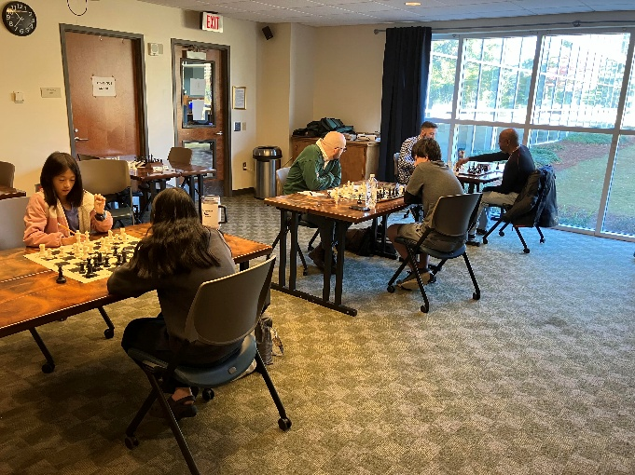

Maxwell Thomas also finished tied for the 4th and final seed however will be unable to participate in December, therefore withdrew after November’s play.

November Open Section Results shown below:
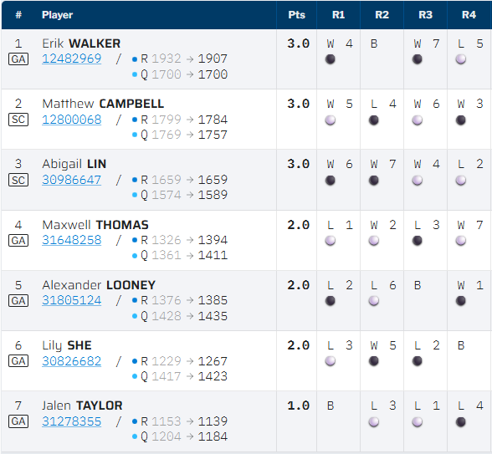

Pictures and results are found through Nov. ’25 Open Playoff – Columbia County Chess Association .

Open Section Final Four
The four Open finalists are Erik “Lucky” Walker, Matthew Cambell, Abigail Lin, and Alexander Looney. Special mention goes to Maxwell Thomas and Lily She who will serve as alternates to the Final Four playoff on December 6th. Should any of the top four not be able to play, then the up-and-coming Lily She will serve as the alternate.

The remaining four players will pair up and face each other in a bracketed tournament. Each round including two G/35;+5 games. The player with the highest point value advances to the finals, the other players will face off to determine the 3rd and 4th place finishes. Should there be a tie after a pairing’s 2 games, then a tie-breaker will be determined with two G/15;+0 games, if still tied G/10:;+0 games thereafter until a winner is determined.
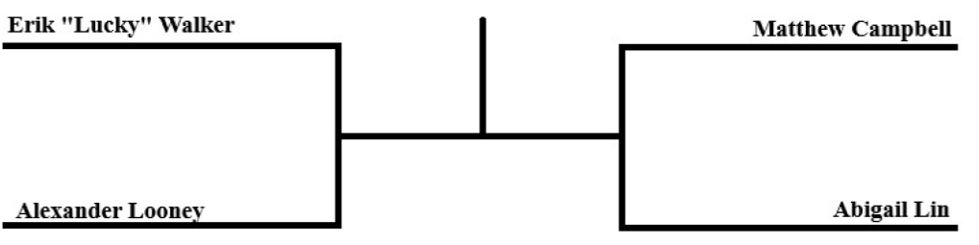

These participants are automatically registered in the December 6th Final Four.

Round-Robin play in December
Rated tournament games will still be offered for all other players interested in playing! Round Robin Play will once again be offered to all other registrants not partaking in playoff play! There will be prizes for each section! $80 to First Place and $40 to 2nd for every group outside of Playoff Play!

Registration though Chess League – Columbia County Chess Association .

Beginner’s and U1000 Section Tournaments
All other players outside of the playoff enjoyed tournament play with similarly rated players. The remaining 14 players were split between the U1000 Section and the new Beginner’s Section!

U1000 Section Tournament
Eight players gathered and participated in the U1000 Section Tournament with five rounds of Swiss play! Peter Newton rebounded from a mid-tournament, unexpected draw to finish in first place with 4.5 / 5 points followed closely by Alan Li at 4.0 / 5 points.
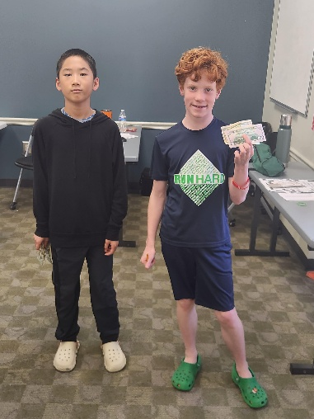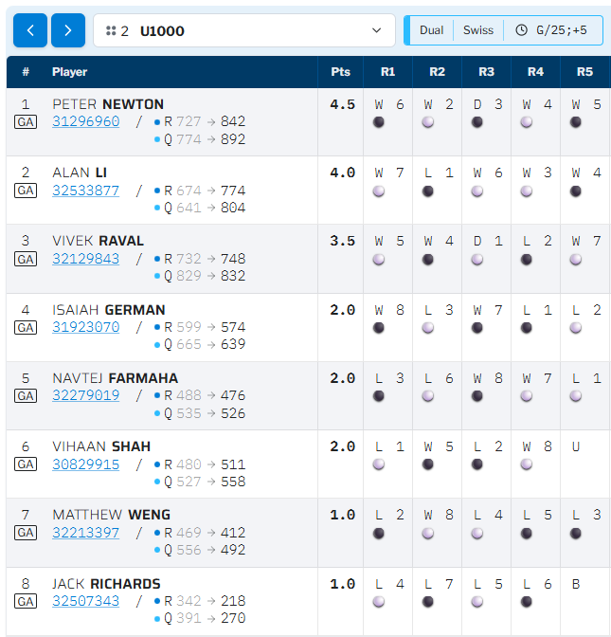

Beginner’s Section Round-Robin
We enjoy a first for the Columbia County Chess Association; A Beginner’s Round Robin! 6 new players to chess all experienced competitive play with similarly rated players. Devaan Somvanshi came away victorious with the 1st Place prize going 4.5 / 5 points with young upcoming competitor Mihir Raval completing a strong day of chess with 4.0 / 5 points! If these player’s had even half as much fun as I did watching their enthusiasm and excitement, then this was no doubt a memorable day!
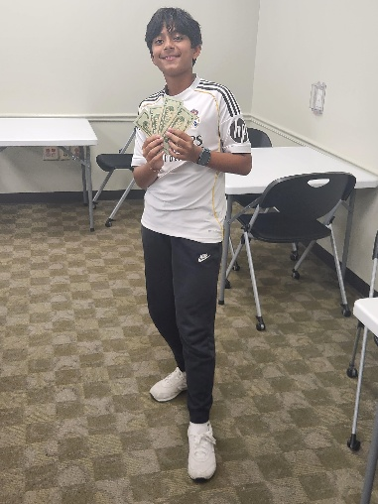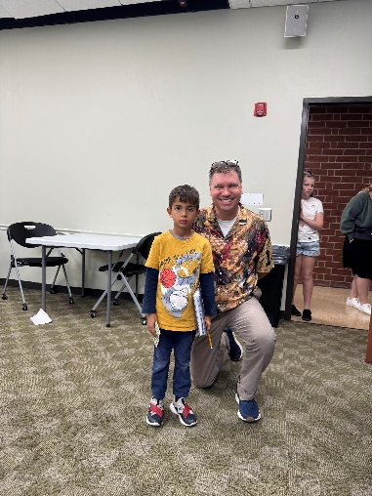

Final Beginner’s Section results shown below:
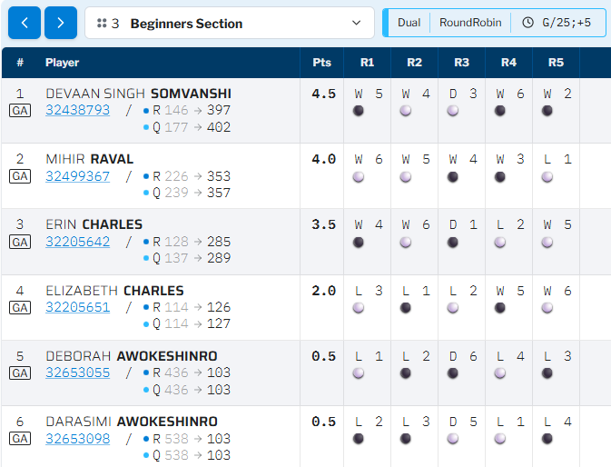

Upcoming 2025 U1000 Section Playoff

The U1000 Section Qualification Playoff Rounds begin on December 6th!

The first rounds will include the 12-players forming two 6-player groups to play a 5-game round robin format of G/25;+5 games. The registered players will be prioritized and seeded in order of their finish in the 2025 Chess League Regular Season.
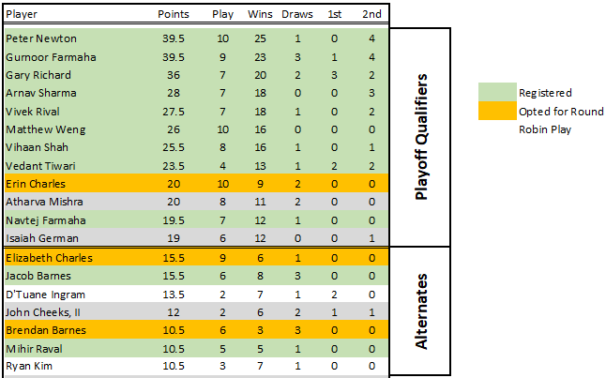
Thus far of the twelve players qualified, nine (9) have registered for the playoff with two (2) alternates also registered. Registration for the playoff will remain restricted to the qualifiers and alternates until December 1st. Should the playoff qualifiers and alternates not fill the twelve spots allotted before December 1st, the remaining spots will open up to the rest of the U1000 field and filled on a first-come-first-serve basis and then will be seeded in order of the U1000 Section standings. Qualifiers and alternates should register before December 1st to secure their spot in the U1000 Section playoffs! The Qualification round is scheduled for December 6th, 2025.

Registration through Chess League – Columbia County Chess Association .

The top two players from each round robin group will advance to the second day of competition, the bracketed playoff. The remaining four players will pair up and face each other in a bracketed tournament. Each round including two G/35;+5 games. The player with the highest point value advances to the finals, the other players will face off to determine the 3rd and 4th place finishes. Should there be a tie after a pairing’s 2 games, then a tie-breaker will be determined with two G/15;+0 games, if still tied G/10:;+0 games thereafter until a winner is determined. The U1000 Final Four participants will be automatically registered to find the U1000 Chess League Champion on December 13th!

For players who would like to play and participate, but were not qualifiers for the play-off, we can assist! We will hold a round-robin style tournament for all other registered players in groups of 6. All registered players will be grouped with players of similar ratings with prizes to the top two finisher of each group! We invite everyone to participate!

Registry for the 2026 Chess League is also available with a bonus for 2026. The Columbia County Chess Association has secured licenses for an innovative, child-friendly chess training platform; Chess4Life. 2026 Chess League Season Passes, access to Chess4Life Software and registration through the end of the 2025 (includes playoffs) is available for $400 through Chess League – Columbia County Chess Association.

2026 Chess League

2026 Chess League Dates
The Chess League will continue in 2026 and we are excited about continuing the league and some changes! Our Chess League will continue to be held in the Columbia County Library in both Room A (upstairs) and the downstairs room. The Game formats are changing in 2026, all games will become G/35;+5.

The Columbia County Chess Association is proud to announce their 2026 Chess League Tournament Dates:
- January 3rd
- February 7th
- March 7th
- April 4th
- May 9th
- June 6th
- July 11th
- August 1st
- September 12th
- October 3rd
- November 14th (Playoff)
- December 5th (Playoff)

2026 Ches League Registration available through 2026 Chess League – Columbia County Chess Association .

New Chess League Sections (U1300 and U400)
After watching the excitement of the Beginner’s Section in November, the Columbia County Chess Association will now offer 4 sections for competition and an increased prize pool! We will now include a Middle and Beginner’s section to aid some of our aspiring players still working on their games. The section will be:
- Open Section (Min. 6 Registered Players)
- U1300 Section
- U800 Section
- U400 Section (Min. 6 Registered Players)

- If the Open and U400 sections do not have at least 6 registrants, then they will be combined with the U1300 section and U800 sections (respectively) and will play and Accelerated Swiss-style tournament. Section prizes will then be applicable to the ratings of the players registered.

With the success we saw last year, the prize pool increases this year! Each tournament will hold a $700 Prize Pool (Based on 20 Entrants) with prizes as follows:
- Open Section - $300 Prize Pool (1st - $160, 2nd - $80 and 3rd - $60)
- U1300 Section - $200 Prize Pool (1st - $100, 2nd - $60 and 3rd - $40)
- U800 Section - $150 (1st - $75, 2nd - $50 and 3rd - $25)
- U400 Section - $50 Prize Pool (1st - $40 and 2nd - $10)

Please note these prize values were adjusted from October’s Newsletter to accommodate the additional U400 Section.

2026 Ches League Registration available through 2026 Chess League – Columbia County Chess Association .

Chess4Life Training Software
Registration is now open for the 2026 Season with an extra bonus! The Columbia County Chess Association will now offer access to the child friendly chess training software, Chess4Life. There are several ways we would like to offer this unique training software tailored for children:
- Remainder of 2025 (December) and the 2026 Regular Season pass - $375
- 2026 Regular Season Pass - $350
- Multi Tournament Pass (minimum 3 months) - $37.50 per Tournament
- 3-Month Wednesday Chess (at Cardboard Castle) pass - $100 (for 3 month)

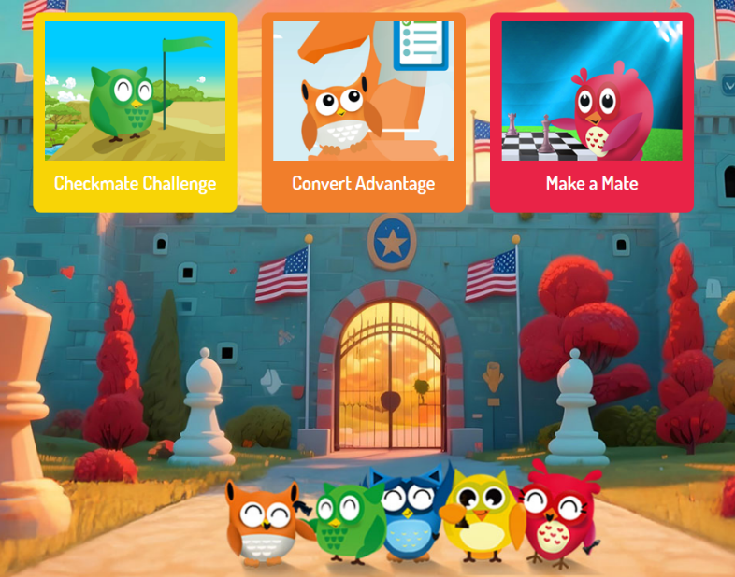

Register for 2026 through 2026 Registration – Columbia County Chess Association .

Wednesday Chess
There’s been a lot of active play on Wednesdays at Cardboard Castle. If you’re not going, you’re certainly missing out on a lot of fun! Here’s the results for the past month’s Wednesday Chess tournaments.

Don’t miss out on the comradery and fun! Wednesday Chess – Columbia County Chess Association .

Wednesday Chess Results

October 22nd, 2025
Blitz play happened on this day with 6 rounds of G/5;+3 games!
- Open Section Winner – Matthew Campbell 6.0 / 6 points
- Under Section Winner – Darby Williams 5.5 / 6 points

October 29th, 2025
Scaling back to Rapid play with G/10;+5 games, 4 Rounds
- Open Section Winners (3-way tie) - Colin Potts, Colson Herrin and Jacob Hanna with 3.0 / 4 points
- Under Section Winner – Karthik Arora 3.5 / 4 points

November 5th
Wednesday Chess included G/15;+5 games this week. 3 Rounds for the Open Section while the under squeezed in an extra round to total 4 rounds of play.
- Open Section Winner – Karthik Arora with 2.5 / 3 points
- Under Section Winners (2-way tie) – Chris Groovy and Aydin Croissant with 3.5 / 4 points

November 12th, 2025
Games included 4 Rounds of play in the Open Section and 5 in the Under, Games of G/10;+5
- Open Section Winners (2-way tie) – Lily She and Karthik Arora with 3.0 / 4 points
- Under Section Winner – Chris Groovy and Aydin Croissant with 4.0 / 5 points

Weekly Prize Increases
The Columbia County Chess Association is excited to offer increased prizes for our rated Wednesday Chess events! Prizes will include a $50 Prize pool (based on 10 entries); $30 Pool for the Open Section and $20 pool for the Under. To support this we have $10 Registrations for our Wednesday Chess events now.

Scholastic Chess

CSRA Scholastic Chess League

We have reached the end of a great regular season of chess for the students of the CSRA! This year the CSRA Scholastic League:
- 57 players from different high schools played 200 games over 21 matches.
- The CSRA Scholastic League established a League Rating System with 27 players finishing with a positive rating (>100) by the end of the season.
- The CSRA Scholastic League and Columbia County Chess Association grew in a successful partnership.

Updated standings, results and information can be found through CSRA Scholastic Chess League – Columbia County Chess Association .
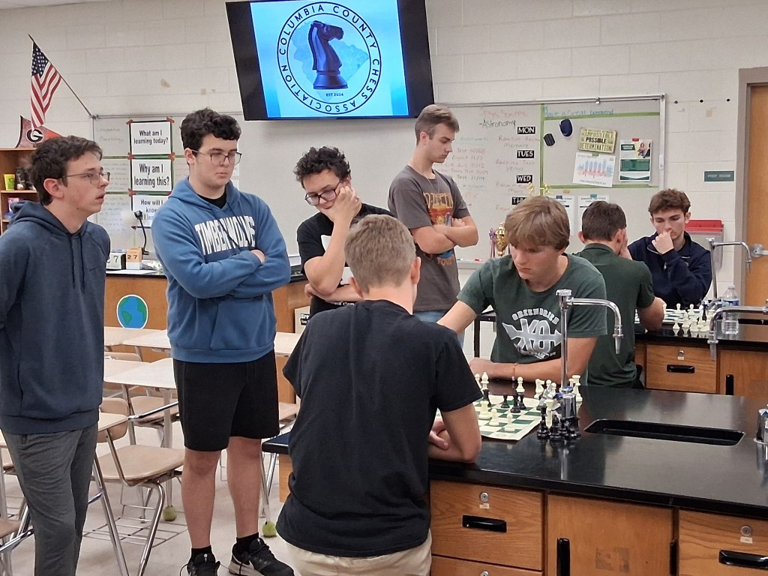

End of CSRA Scholastic Regular Season
Congratulations to Alleluia Community School for winning the regular season! Alleluia and Augusta Christian both finished with 6 match points but Alleluia edge out on tiebreaks with 57.5 game points to Augusta Christian's 54.5 game points.

Final Standings found CSRA Scholastic Chess League Standings – Columbia County Chess Association .

End of season playoff are starting soon!

Elementary School Programs and Lessons
Our after-school chess program began this week with Stevens Creek Elementary students. Our first session of the 72 students participating! Let us know if you would like you school to be a part of our outreach to hold scholastic chess clubs, we will work as best we can to facilitate education of the game!

We are including our lessons on our website for those just starting out!
Elementary School Lessons – Columbia County Chess Association

