Columbia County Chess Association
December 2025
Written by: Travis L. Jones
Scholastic League, Written by: William Bowman
Editor: Russell (Rusty) Charles

Thank you to all who participated and supported the Columbia County Chess Association in 2025! We appreciate our community and thank each and every one of our players, families, Tournament Directors and volunteers for their efforts throughout the 2025. We are so thankful for partnerships with the Columbia County Library, the CSRA Scholastic Chess League and Cardboard Castle as each has played a pivotal role in promotion of chess in 2025!

- The 2025 Columbia County Chess League Playoffs
  - Open Section Championship Playoffs, Day 2
  - U1000 Playoffs
    - Day 1 – Round-Robin Qualifications
    - Day 2 – U1000 Section Championship
  - Non-Playoff Sections
    - Beginners Section
    - Open Section
- 2026 Chess League
  - 2026 Chess League Dates
  - New Chess League Sections
- 2026 CCCA Club Membership Information
- Wednesday Chess at Cardboard Castle
- CSRA Scholastic Chess League

The 2025 Columbia County Chess League Playoffs

The end of the regular Chess League is here. This past two weekends saw the end of both the Open Section and U1000 Section Playoffs! There was lots of great competition, and we share the full results in this month’s newsletter.

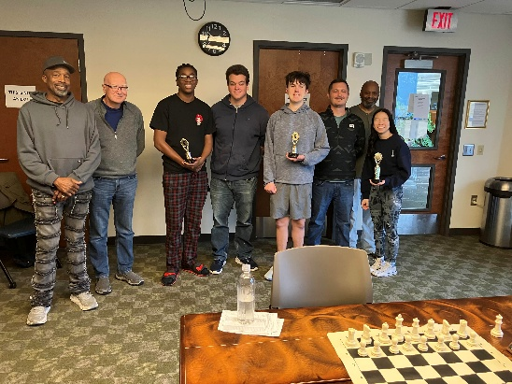

2025 Open Section League Playoffs, Day 2 – Final Round

Pictures, results and Cross-tables are found through Dec. ’25 Playoffs – Columbia County Chess Association .

Following the Open Section Qualification rounds in November, the Final Four bracketed playoff began on December 6th with our top qualifying players striving for the 2025 Chess League Crown! Congratulations go to Jalen Taylor, Alexander Looney, Abigail Lin and Erik “Lucky” Walker for reaching this point! After fearsome foursome battled Jalen Taylor finished in fourth place, Alexander Looney in third with Abigail Lin reaching the finals with a second place finish.

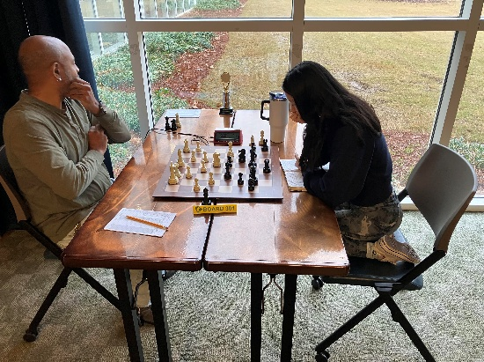
The deciding match for the 2025 Chess League Championship
But without further ado, the Columbia County Chess Association proudly declares Erik “Lucky” Walker the county’s 2025 Chess League Champion!

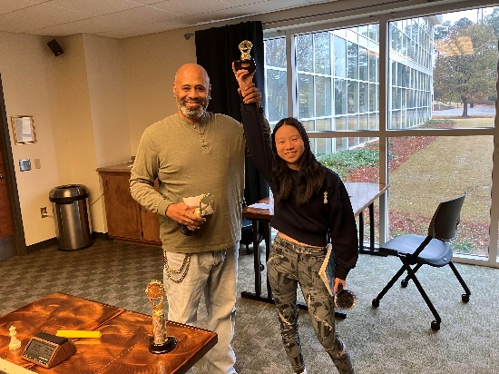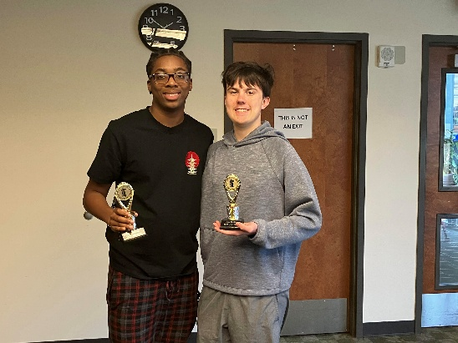
Lucky Walker is your CCCA 2025 Chess League Champion! Congratulations to Abigail Lin (2nd Place), Alexander Looney (3rd Place) and Jalen Taylor (4th Place) for their outstanding performances this year!
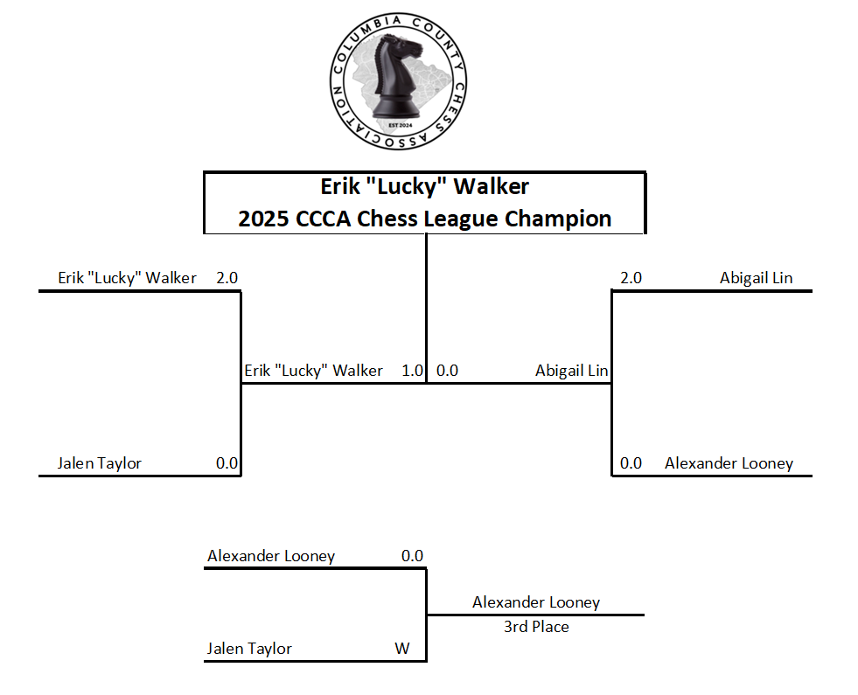
2025 Open Section Final Four Bracket

2025 U1000 Section Playoffs

The U1000 Section Path to the Chess League Championship began by splitting the top twelve qualifiers into two 6-player group for Round-Robin play. Each player competed for the top two spots of each group to advance to the U1000 Section Final Four the following weekend.

U1000 Section Qualification Round – Day 1

Pictures, results and cross-tables are found through Dec. ’25 Playoffs – Columbia County Chess Association .

Our top twelve U1000 section performers, from 2025, gathered to pit rivals against one another to find the top two candidates from each six player group! Congratulations to the following players for reaching the U1000 Playoffs: Peter Newton, Arnav Sharma, Vivek Raval, Vedant Tiwari, Navtej Farmaha, Alan Li, Gurnoor Farmaha, Gary Richard, Matthew Weng, Vihaan Shah, Jacob Barnes and D’Taune Ingram.

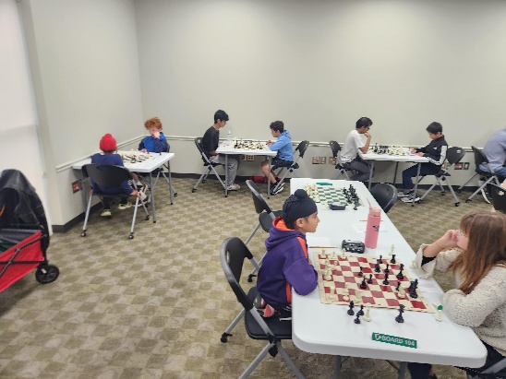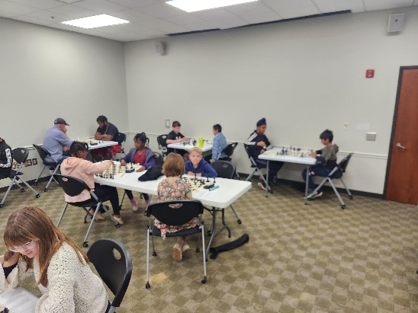
Players going for the top two spots in each group, Group 1 (left) and Group 2 (Right).
After five rounds of round robin play between the groups, Vedant Tiwari wins Group 1 and Arnav qualifies finishing in second place. D’Taune Ingram goes perfect on the day in Group 2 securing his spot, leaving second place in a three-way tie with 2.5 points each. Who moves on to the Final Four between Gurnoor Farmaha, Vihaan Shah and Gary Richard?

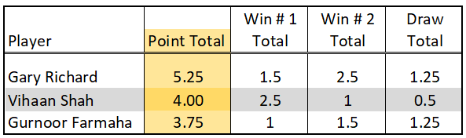

Through the Sonneborn-Berger tie-breaker method, Gary Richard comes away with a qualification to the Final Four through a tie-breaker with Vihaan Shah and Gurnoor Farmaha. Congratulations to all finalists! The Final Four was set!
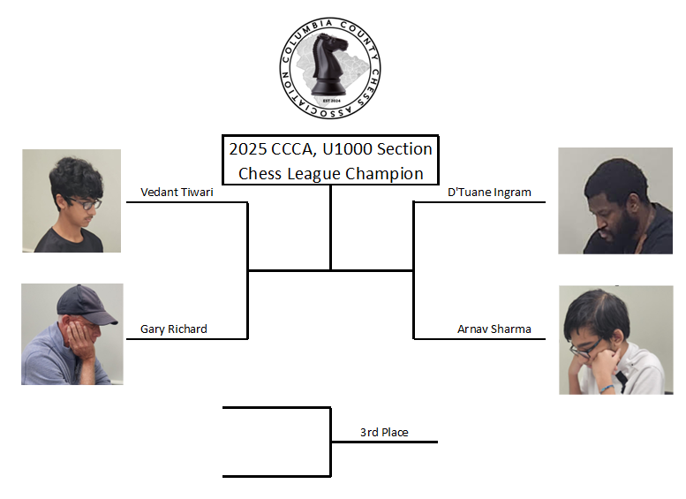
2025 U1000 Section Final Four

U1000 Section Championship Rounds, Final Four

Pictures, results, cross-tables and deciding matches are found through U1000 Final Four – Columbia County Chess Association .

The year came to a conclusion as the U1000 Final Four met to determine the winner of the 2025 U1000 Section, Chess League Championship. All four finalists had outstanding years! Congratulations to Arnav Sharma, Vedant Tiwari, Gary Richard and D'Taune Ingram for all their efforts through the 2025 Regular Season!

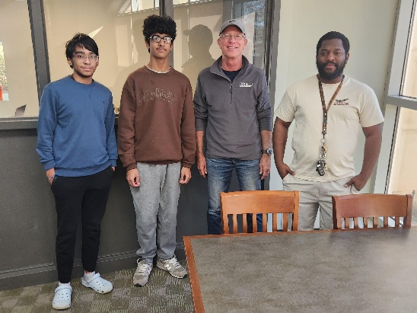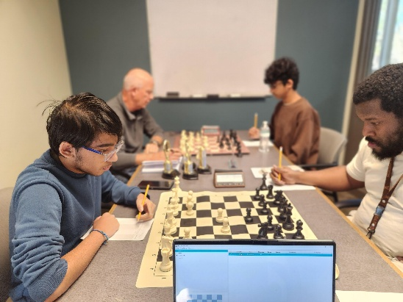

After Opening with the Colle system in the 1st Round, Vedant Tiwari sets it in neutral to reach a draw advancing to the finals 1.5 points to 0.5 points against Gary Richard. D’Taune Ingram goes 2.0 in the Semi-Finals to meet Vedant in the U1000 Section Chess League Championship! Although Gary battled joint pain through the semi-finals, Gary resigns after beginning the 3rd Place games, Arnav Sharma finishes the U1000 Section in 3rd Place!

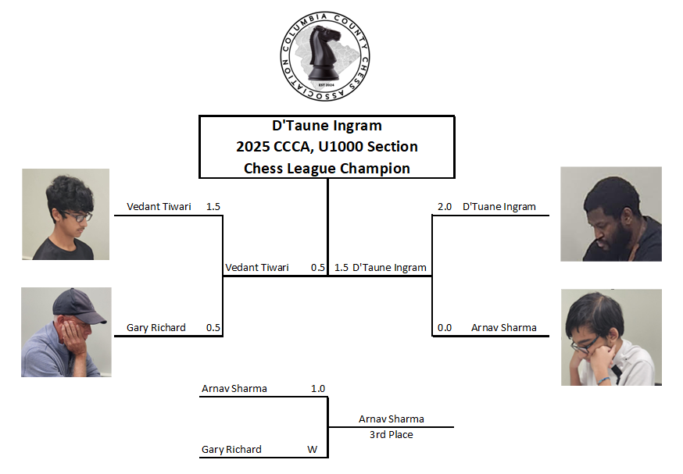

Vedant and D meet in the Championship after impressive years! After reaching a draw in the first game players are left to decide strategies in the 2nd match. After watching 1. e4 played to lead off D announces, “I’m going for the win!” and follows with 1… b6.

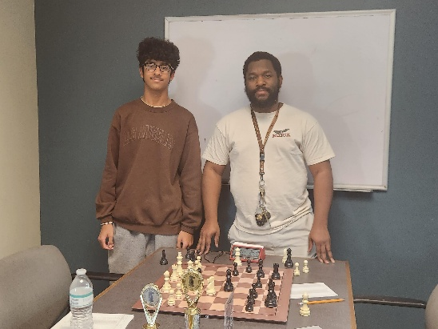
Final position of the 2nd Match in the Championship Roun (left).
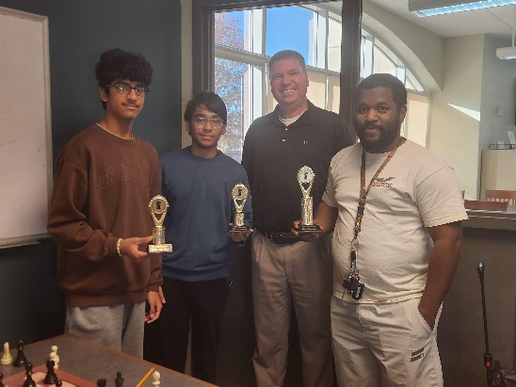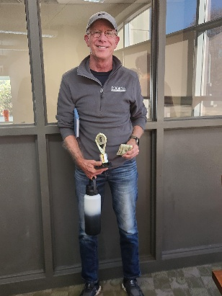
Congratulations to Vedant Tiwari (2nd Place, left), Arnav Sharma (3rd Place), D’Taune Ingram (1st Place) and Gary Richard (4th Place, right) for their outstanding play through 2025.

Players battled and at the end we are proud to announce D'Taune Ingram as the 2025 U1000 Section, Chess League Champion!

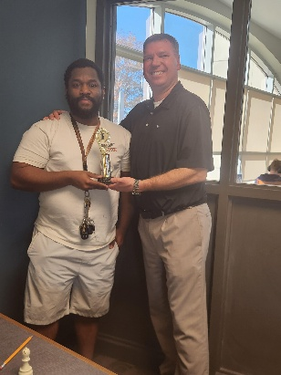

The Non-Playoff Group, Beginners Section

In the U1000 Non-Playoff Group, it continues to bring joy to our hearts to watch young players challenge themselves and watch their excitement as they play! Congratulation to Zhengwen (George) Xiang for finishing in 1st Place, and also to Mihir Raval for finishing in 2nd Place for the 2nd consecutive month!

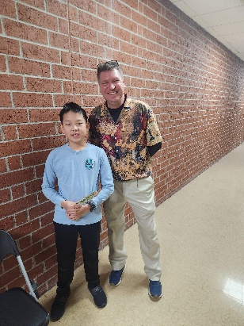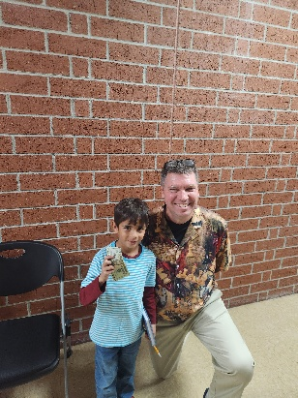

The Non-Playoff Groups, Open Section

We also found participants in our Open Section, non-playoff group! With an impressive level of play, William Bowman comes away victorious edging out Colin Potts for the win!
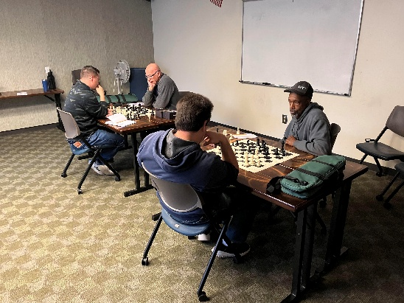

2026 Chess League
2026 Chess League information through 2026 Chess League – Columbia County Chess Association .

Join us in the year-long running USCF Rated Chess League. Compete in as many or as few Chess League events as desired, earning points throughout the year. The top twelve (12) players from each section will be invited to the Chess League Round-Robin Playoff at the conclusion of the 2026 Regular Season.

Each league tournament will consist of 4 Rounds, G/35;+5 games, Swiss-style tournaments at the Columbia County Library (Room A) with four sections; Open, U1300, U800 and Beginners (U400). Section prizes are increase with $700 between the four sections (based on 20 registrants).

Point are award in the 10-monthly events, 4 games per event to total a 40-game season. Results will be tallied and tracked for the entire 2026 season.
- 1 point – participation in a Chess League monthly event
- 1 point – each game won
- ½ point – each game drawn
- 2 points – First place finish in a Monthly League Tournament
- 1 point – Second place finish in a Monthly League Tournament.

*** Please note that the end-of year tournament will not include the Beginner’s section ***

2026 Chess League Dates

2026 Chess League Registrations through 2026 Registration – Columbia County Chess Association .

We are so grateful for the partnership between the Columbia County Chess Association and the Columbia County Library! The library has been so gracious to the growth of chess in Columbia County, and have already reserved our 2026 dates for the 2026 CCCA Chess League:
- January 3rd
- February 7th
- March 7th
- April 7th
- May 9th
- June 6th
- July 11th
- August 1st
- September 12th
- October 3rd
- November 14th (Playoff)
- December 5th (Championship)

New Chess League Sections – Open, U1300, U800, and U400

2026 Chess League Registrations through 2026 Registration – Columbia County Chess Association .

In 2026, we’ll be adding two new sections of players to the League. We’ve got so many players making improvements with their skills that we need to divide things up to make it even more fun! In 2025, we had just the U1000 and Open sections. For 2026, there will be four sections: Beginners (U400), Under 800 (U800), Under 1300 (U1300), and Open.

Adding these middle sections should make competition in all sections more even and competitive!

*** Please note that the end-of year tournament will not include the Beginner’s section ***

2026 Columbia County Chess Association Memberships

2026 CCCA Membership available through 2026 CCCA Memberships – Columbia County Chess Association .

We would like to set you up for your growth as a chess player! For 2026, you can choose to purchase entries into events as you go, or you can get a CCCA Club Membership for $450.

When you purchase a Club Membership, you’ll get the following benefits:

- US Chess Federation (USCF) Membership

Whenever you play rated games anywhere in the United States, you must be a member of the USCF. They’ve got their own separate membership fee, however, if you purchase a Club Membership with Columbia County Chess Association, we’ll cover that fee for you.

Remember: the USCF membership has its own benefits too! Don’t forget to check out their monthly Chess Life magazine (the online version is free for USCF members). After all, your USCF membership also paying for a subscription to the online portion of the magazine, so why not enjoy it?

- Gain entry into one of the following offerings for all of 2026:

a. Wednesday Chess events at Cardboard Castle for all of 2026 (a $500 value)
b. Entry into the 2026 Chess League Regular Season ($400 value, does not include the end-of-year playoffs)

- Access to chess training software

You get to choose your access to one of the following software options:

a. Chess4Life – a child-friendly chess training platform
b. chess.com membership – We’ll pay for you to have a Diamond-level account, which includes puzzles, online training, and more.

- Chess stuff

You get to pick one of two packages:

a: Tournament size chess set including a travel tournament bag, triple weighted pieces, and silicone board
b: High quality chess clock

With the purchase of a full year of membership, you’ll get access lots of really cool stuff and save some money at the same time!

Wednesday Chess
Check out our Wednesday Chess Information through Wednesday Chess – Columbia County Chess Association .

While breaking for the Thanksgiving holiday we had four sessions of our weekly Wednesday Chess matches!

- November 19th, Blitz Night! G/5;+3, One Section
  - 1st Place – Karthik Arora
  - 2nd Place – Matthew Campbell
  - 3rd Place (Tie) – Lucky Walker, Colin Potts and Samuel Perry
- December 3rd, G/10;+5, Two Sections
  - Open
    - 1st Place – Colin Potts
    - 2nd Place – Karthik Arora
  - Under
    - 1st Place – Vedant Tiwari
    - 2nd Place – Gurnoor Farmaha
- December 10th, G/12;+3, Two Sections
  - Open
    - 1st Place – Colin Potts
    - 2nd Place – Karthik Arora
    - 3rd Place – Darby Williams
  - Under – 1st Place – Chris Groovy
- December 17th, Blitz Night! G/5;+3, One Section
  - 1st Place – Abigail Lin
  - 2nd Place – Rusty Charles
  - 3rd Place (tie) – Samuel Perry and Jacob Hanna

Because the remaining Wednesdays in 2025 are Christmas Eve and New Years Eve, we will return in 2026 with Wednesday Chess at Cardboard Castle!

CSRA Scholastic Chess League
Authored by William Bowman.

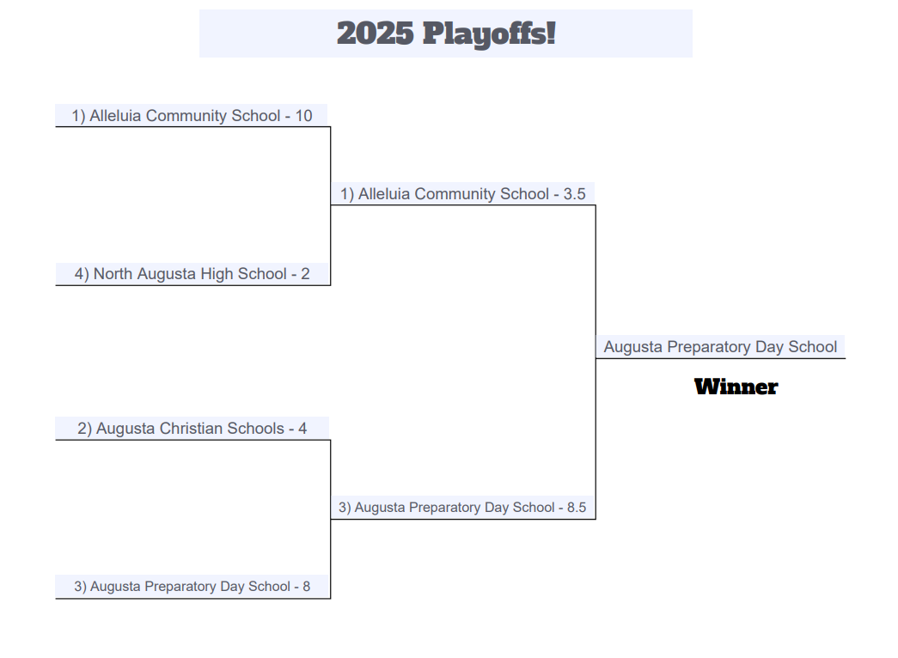

The 2025 CSRA Scholastic Chess League has come to a close. We had an amazing year, welcoming two new schools to the League: Greenbrier High School and North Augusta High School. The new teams together with the returning teams from Augusta Christian Schools, Augusta Preparatory Day School, and Alleluia Community School combined to give us 57 players competing this year. Amazing!
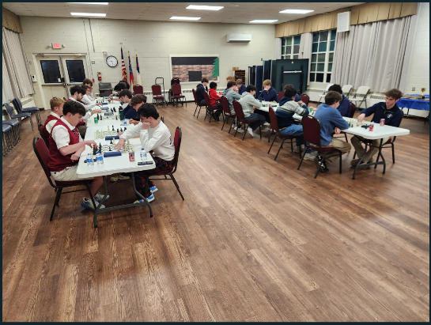

After a hotly contested regular season that had Augusta Christian and Alleluia battling it out for 1st place it was actually Augusta Preparatory Day School that won the Champions trophy in the Playoffs.
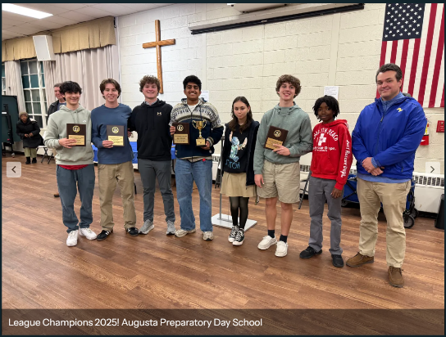
1st Place - Augusta Preparatory Day School
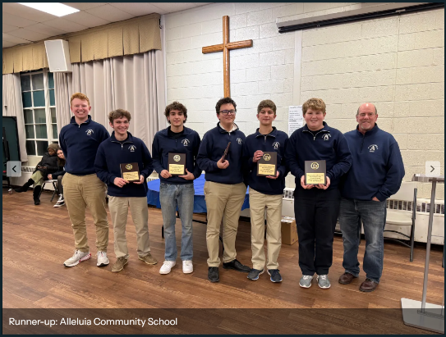
Runner-up - Alleluia Community School
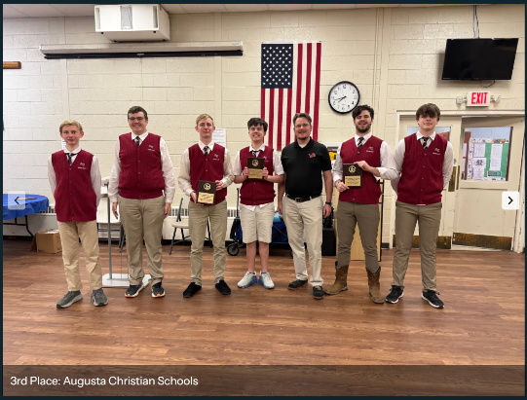
3rd Place - Augusta Christian Schools
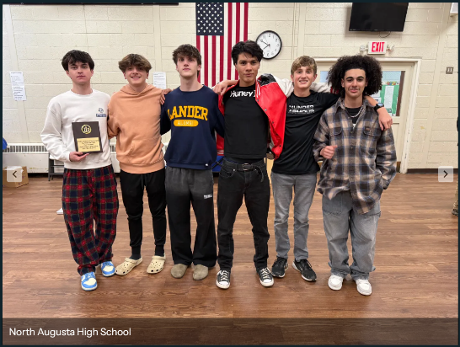
North Augusta High School
15 students received plaques in recognition of their individual performances during the regular season.

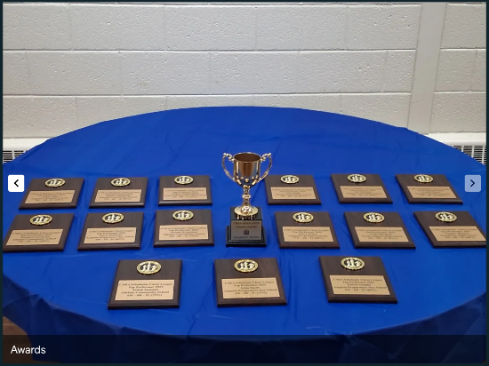

We would like to thank all the players, parents, coaches, and school administrators for making this year's league a success. A special thanks also to Rusty Charles and the Columbia County Chess Association for hosting us on their website and partnering with us to expand or league. We would also like to thank Mr. Stephen Alger for all his hard work implementing an internal rating system for the league. This brought some much needed structure and will help us ensure all players are getting quality competition during every match. And if you have not already heard the very exciting news, all participating schools are receiving a 1-year trial to Chess4Life, a safe, online, Chess curriculum platform, that they can use with their students. Exciting things are happening in the chess world here in the CSRA and across the globe. We hope you will join us in our mission to grow and expand chess in every school so students everywhere can enjoy the benefits that come from playing this great game.

