Columbia County Chess Association
January 2026

Written by: Travis L. Jones
Editor: Rusty Charles

Thank you for joining us for the start of the 2026 year with the Chess League, Scholastic Chess and all our other offerings with the Columbia County Chess Association! We are very excited about all things chess happening this year!

In this month’s newsletter:

- The 2026 Columbia County Chess League
  - Open Section
  - U1300 Section
  - U800 Section
  - U400 / Beginners Section
  - 2026 Chess League News
    - 2026 Chess League Dates
    - 2026 Season Passes
- CSRA Scholastic Chess League
  - Elementary School Chess Clubs
  - Middle School League
- Wednesday Chess
- USCF Membership – Scholastic Players
- 2026 CCCA Club Membership Information
  - USCF Membership
  - Tournament Entries
  - Chess Training Software
  - Chess Gear
- Online with the Columbia County Chess Association
  - USCF Rated Online Tournaments
  - Chess.com Group – Columbia County Chess Association
  - FREE Daily Game Competition Updates
    - Completed Daily Tournaments
    - Ongoing Daily Tournaments
    - Upcoming January 24th Daily Tournament

The 2026 Columbia County Chess League

The 2026 Chess League re-started with a bang with the first tournament of the year! With the introduction of additional sections, increased prize pool and introducing 4 new players to rated chess, our hearts overflow with joy watching the game grow in Columbia County!

In 2026, we’ve added two new sections of players to the League. We’ve got so many players making improvements with their skills that we need to divide things up to make it even more fun! In 2025, we had just the U1000 and Open sections. For 2026, there will be four sections: Under 400 (U400), Under 800 (U800), Under 1300 (U1300), and Open.

Our Monthly, Chess League Tournaments will last through 2026 with the regular season concluding in October. A 12-player tournament will be played from each section (Open, U1300 and U800) beginning in November with the top players of each section. These 12-players with compete in a 6-playter group round-robin competition where the top 2 from each round-robin group will advance to the 4-player bracketed playoff. The winner of this playoff will be crowned the 2026 Chess League Champion (of their given section)!

Who can join the ranks of Abigail Lin, Erik “Lucky” Walker, Jalen Taylor (U1100) and D-Taune Ingram (U1000) as the Columbia County’s Chess League Champions? To join in this year-long competition, please visit and register through 2026 Registration – Columbia County Chess Association .

Summary, results and pictures are through Jan ’26 Chess League – Columbia County Chess Association.

We would like to extend our gratitude to TournaChess for a polished look and website of our updated Chess League Standings.
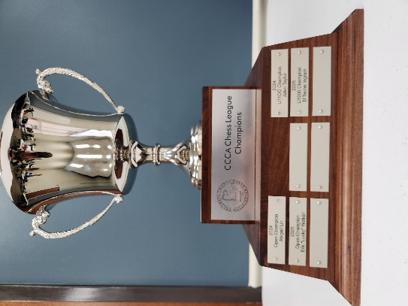
Figure 1 The coveted CCCA Chess League trophy remains on display at the Columbia County Library. League winners have their names forever enshrined for all to see!

Open Section

With the introduction of a handful of new players, local legend William Bowman re-stablishes himself as a force to be reckoned with going a perfect 4.0 / 4 points on the day taking first place. Newcomer Jeremian Contreras ties Alexander Looney, with both finishing 3.0 / 4 points and tying for 2nd Place! With these results, William Bowman assumes the outright lead in the Open Section, followed by Alexander and Jeremian.

1st Place - William Bowman
2nd Place (tie) - Alexander Looney and Jeremian Contreras

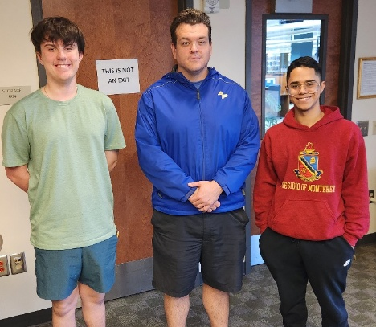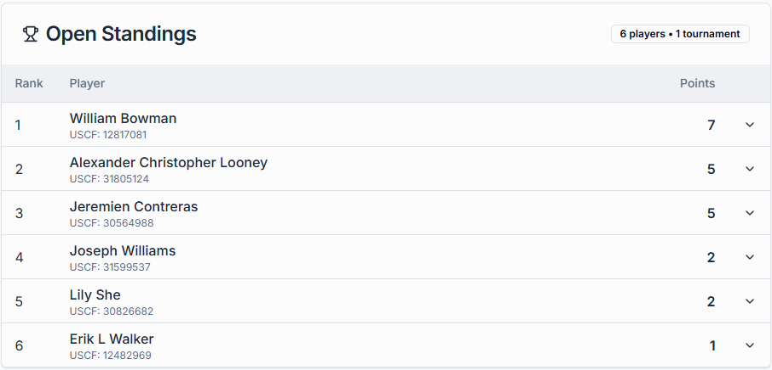
Figure 2 Congratulations to the Winners of the Open Section!
Alexander Looney (Left), William Bowman and Jeremian Contreras (right).

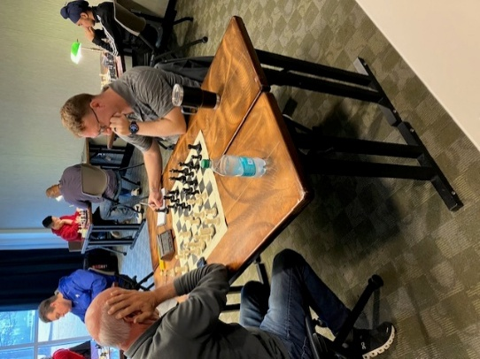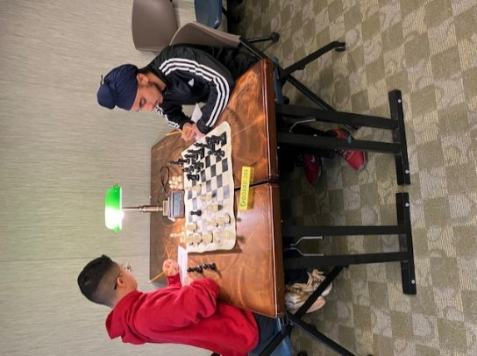
Figure 3 First Round play commences
at the Columbia County Library!

U1300 Section

After combining with the Open section, increasing their level of competition in Accelerated Swiss play, Matthew Hopper and Sheldan Kaplan finish as the top two finishers of those that registered in the U1300 Section, while Gary Richard and Gurnoor tie for the third place finisher of the section!

Matthew Hopper and Sheldan Kaplan assume the overall lead in the U1300, while Ryan Kim advances into third place of the standing after winning the U800 section!

1st Place (tie) - Sheldan Kaplan and Matthew Hopper
3rd Place (tie) - Gary Richard and Gurnoor Farmaha

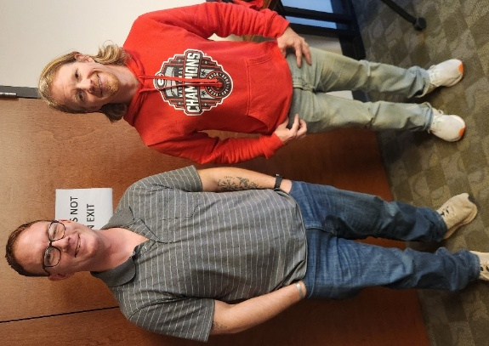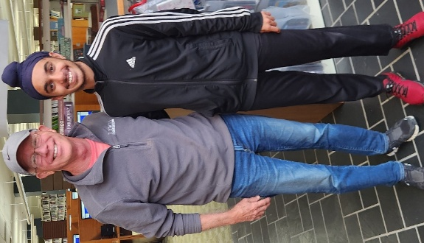
Figure 4 Congratulations to Sheldan Kaplan (left), Matthew Hopper,
Gary Richard and Gurnoor Farmaha (right) for placing in the U1300 section!

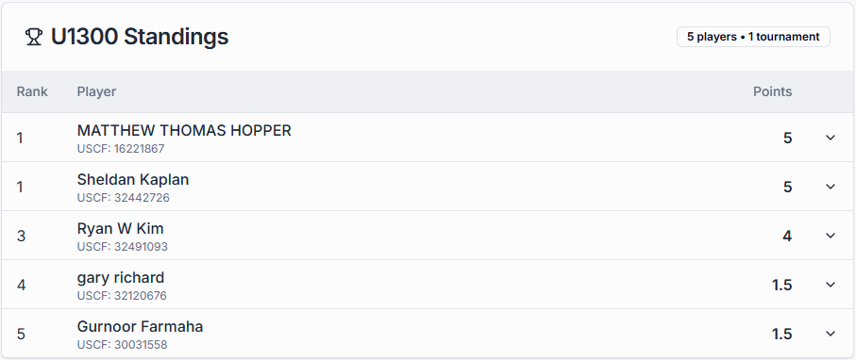
Figure 5 Latest 2026, U1300 Section Chess League Standings

U800 Section

With the introduction of the U800 section, Ryan Kim has been studying and studying and studying… and its shows! Ryan Kim goes a perfect 4.0 / 4 points on the day finish in first place in the U800 Section. Navtej Farmaha continues his impressive climb up the rating finishing in 2nd Place with 3.0 / 4 points. Peter Newton, Alan Li and Zhengwen (George) Xiang all tie for 3rd place with 2.0 / 4 points.

With the victory, Ryan Kim moves up to the U1300 Section, leaving Navtej currently in first place in the U800 Section Standings. Atharva Mishra, after his U400 Section victory, moves into 2nd Place in the standings. Evan Tran also progresses into the U800 with his finish!

1st Place - Ryan Kim (moves up to the U1300 Section)
2nd Place - Navtej Farmaha
3rd Place (tie) - Peter Newton, Alan Li and Zhengwen (George) Xiang

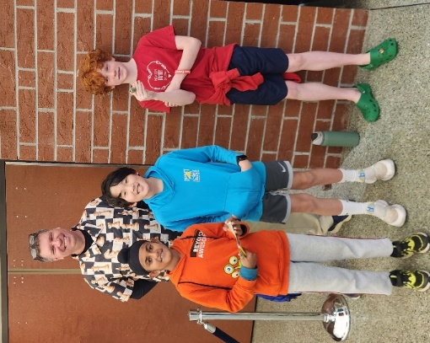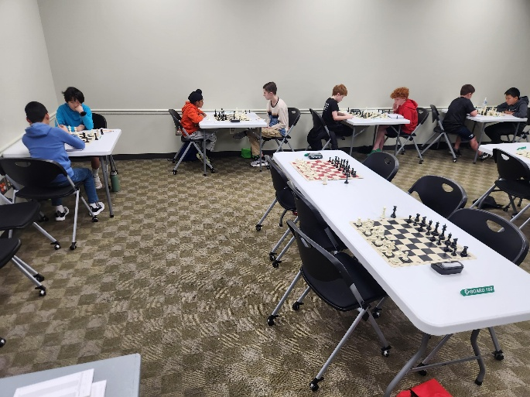
Figure 6 Congratulations to Navtej Farmaha (left), Ryan Kim and Peter Newton (right) for their top finishes in the U800 Section! Not shown are Alan Li and Zhengwen Xiang who finished in 3rd Place

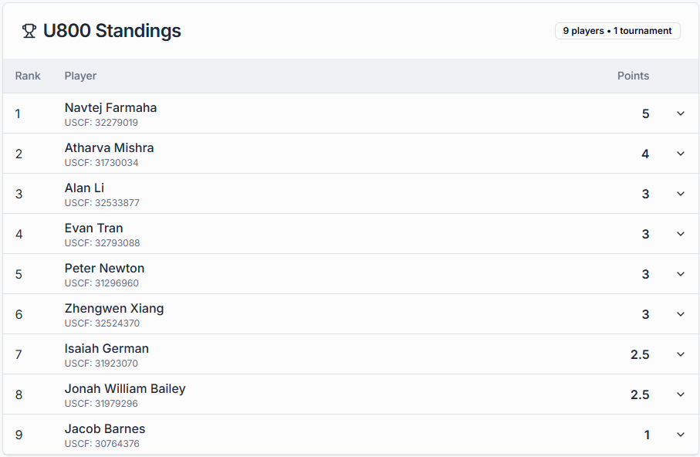
Figure 7 Latest 2026, U800 Section Chess League Standings

U400 / Beginners Section

Continuing the U400, Beginners Section from the end of last year we found some exciting new players plating for the first time; Evan Tran and Zoya Looney! Through heavy thought and concentration, Atharva Mishra goes perfect on the day finishing in first place! Jack Richards and Evan Tran go 3.0 / 4 points to end tied for second!

With both Atharva and Evan progressing into the U800 section, Jack Richards assumes the overall lead with the rest of the players trailing closely behind!

- 1st Place - Atharva Mishra
- 2nd Place (tie) - Jack Richards and Evan Tran

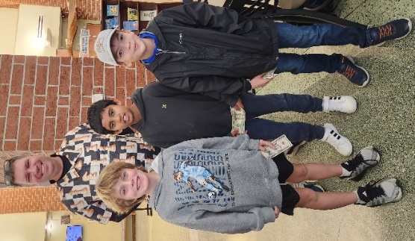
Figure 8 Congratulations to Jack Richards (right), Atharva Mishra
and Evan Tran (left) for their prize-winning finishes in the
January '26 Chess League's U400 (Beginners) Section!

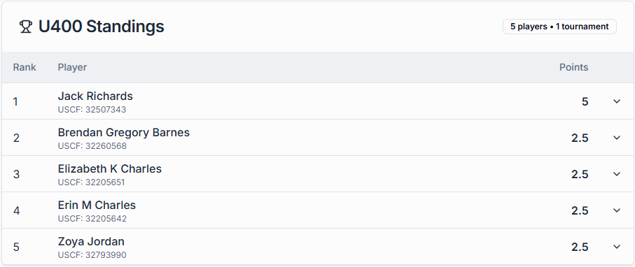
Figure 9 U400 (Beginners) Section Standings

2026 Chess League News

2026 Chess League Dates
There are still nine (9) more chess tournaments scheduled through the 2026 Regular Season with plenty of opportunity left to qualify for the playoffs! We offer an invitation to experience the journey through chess on the following tournament Saturdays in 2026!
- February 7th
- March 7th
- April 7th
- May 9th
- June 6th
- July 11th
- August 1st
- September 12th
- October 3rd

Playoffs will follow with the top twelve (12) from each section competing for the top four spots in a round-robin playoff! From there the Chess League Champion will be crowned (for each section) after a 4-player playoff!

More information and registrations are available through 2026 Registration – Columbia County Chess Association .

2026 Season Passes
We are excited for this season and love providing opportunities to play more! To let the game expand minds and grow through the County! We are excited to extend the offerings of the Season Pass through the February Tournament at the same rate of $35 per tournament. We hope you can join us through the remainder of the regular season with either the Season Pass or as a part of our CCCA Club Memberships!

Season passes remain available through 2026 Registration – Columbia County Chess Association .

CSRA Scholastic Chess and League

Elementary Chess Clubs

This month we had the distinct honor of an invitation to Barton Chapel Elementary school in Augusta with an established their own chess club. It always brings so much joy to our hearts to watch the excitement grow around the county and we relish the opportunity help foster this enthusiasm! Thank you to Patricia Jones (from Stevens Creek Church) and Mr. Stokes (from Barton Chapel School) for both starting this club and allowing us to be a part of it. Thank you for including us with your great work!
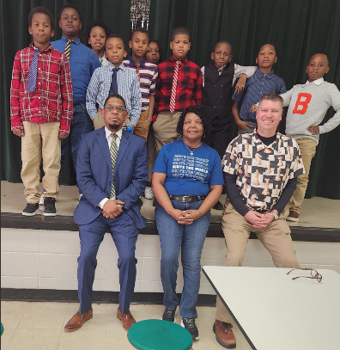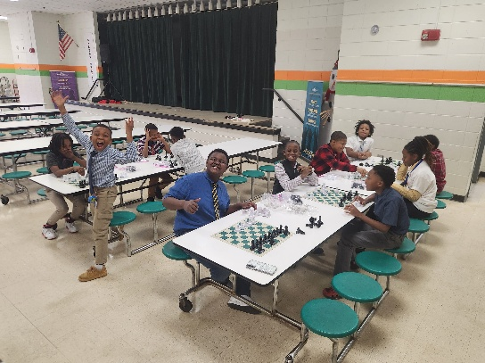
Figure 11 Barton Chapel Elementary Chess Club with Mr. Stokes and Patricia Jones
We also returned with our Stevens Creek Chess Club in 2026 continuing our lessons focusing on the abilities and strengths of individual pieces, this week focusing on the knights and queens!

We’d love to help your school develop their concentration, math and cognitive skills through chess! Please let us know how we can help foster chess at your school! Please email columbiacounty.chess@gmail.com .

We are happy to offer our lessons from our Elementary school chess clubs to help you get started or assist in one you already run! We are happy to share through our website Elementary School Lessons – Columbia County Chess Association .

Middle School League

After the wonderful offering of the High School Chess League in the fall of 2025, the 2026 School year started the Middle School Chess League between four Middle Schools from the CSRA:
- Augusta Christian Schools
- Augusta Preperatory Day School
- St. Mary on the Hill Catholic School
- Evans Middle School
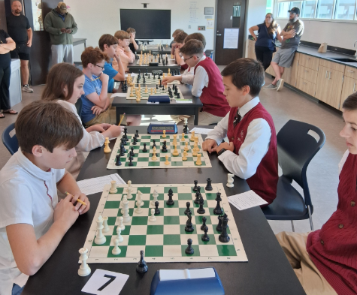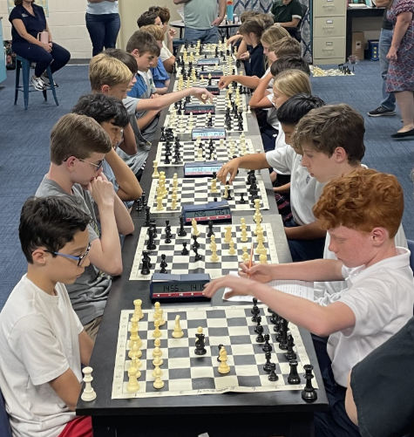
Figure 12 The Middle School Chess League has begun!
William Bowman continues his wonderful work leading the Scholastic Chess Clubs across the area. If your school needs help starting or developing a chess club, or would like to join the Scholastic Chess League, please connect with us or William Bowman. We would love to help!

Wednesday Chess

We continue to meet all available Wednesdays at Cardboard Castle and we are so excited to have everyone back in this year. We have returned to our regular schedule of Wednesday chess and have already seen many new eager players from the area.

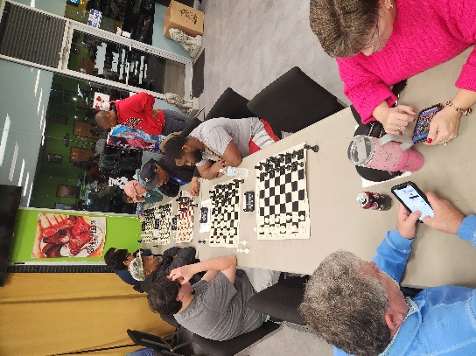

We continue to offer both the free casual and rated (mini-)tournaments each Wednesday. The results of these are as follows:

- January 7th, 2026 – G/10, inc. 5 Games
  - Open Section
    - 1st Place (Tie) – Lily She and Carlo Kenner
  - Under 1000 Section
    - 1st Place – Suhrudh Medam
    - 2nd Place – Zhengwen (George) Xiang
- January 14th, 2026 – G/15;inc. 5 Games
  - Open Section
    - 1st Place – Lily She and William Bowman
  - Under Section
    - 1st Place – Robert Jackson
    - 2nd Place – Suhrudh Medam

Blitz night is next on deck for Wednesday, January 21st, 2026 with (at least) 6 Rounds of G/5;+3 games. With our look-ahead for the next three weeks:
- January 21st – G/5;+3 games
- January 28th – G/10;+5 games
- February 4th – G/ 15’+5 games.

Please visit our website for updates, schedules and results of our Wednesday night offerings at Cardboard Castle through Wednesday Chess – Columbia County Chess Association .

USCF Memberships - Scholastic Players

The United States Chess Federation (USCF) requires all chess players player under their guidelines to have USCF Membership. This can be a cumbersome part of playing chess by ensuring registration prior to chess play. This can also be expensive because memberships just increased to $54 for a single players. We are very excited to foster and nurture the enthusiasm surrounding chess and are actively finding new ways to make chess more accessible.

The Columbia County Chess Association has invested in the future of our scholastic players with USCF Vouchers. For this reason we are excited to offer the following to our first time scholastic players:
- USCF Rated Online Tournament + an Annual USCF Membership (for K-12 players) for $25
- Wednesday Chess + an Annual USCF Membership (for K-12 players) for $25
- Saturday Chess Tournament + an Annual Membership (for K-12 players) for $50

This offer also extends to our existing scholastic players membership, which we can now offer for $18 for an annual USCF Membership renewal! We hope this helps everyone enjoy this beautiful game!

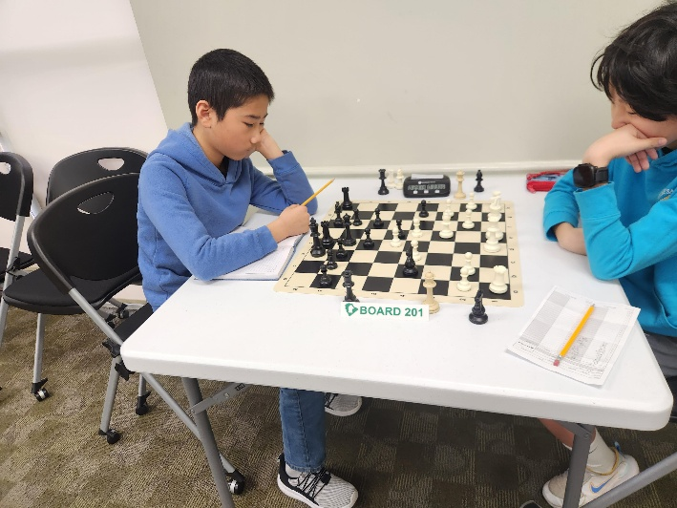

2026 Columbia County Chess Association Membership

For 2026, you can choose to purchase entries into events as you go, or you can get a CCCA Club Membership for $450.

When you purchase a Club Membership, you’ll get the following benefits:

US Chess Federation (USCF) Membership

Whenever you play rated games anywhere in the United States, you must be a member of the USCF. They’ve got their own separate membership fee, however, if you purchase a Club Membership with Columbia County Chess Association, we’ll cover that fee for you.

Remember: the USCF membership has its own benefits too! Don’t forget to check out their monthly Chess Life magazine (the online version is free for USCF members). After all, your USCF membership also paying for a subscription to the online portion of the magazine, so why not enjoy it?

Gain entry into one of the following offerings for all of 2026:

1) Wednesday Chess events at Cardboard Castle for all of 2026 (a $500 value)
2) Entry into the 2026 Chess League Regular Season ($400 value, does not include the end-of-year playoffs)

You get to choose one of the above options as part of your membership. If you want to participate in both, then there will be an extra fee.

Access to chess training software

You get access to one of the following software options:

1) Chess4Life – a child-friendly chess training platform
2) Chess.com membership – We’ll pay for you to have a Diamond-level account, which includes puzzles, online training, and more.

Chess stuff

You get to pick one of two packages:

- Tournament size chess set including a travel tournament bag, triple weighted pieces, and silicone board
- High quality chess clock

With the purchase of a full year of membership, you’ll get access lots of really cool stuff and save some money at the same time!

Apply for memberships online through 2026 CCCA Memberships – Columbia County Chess Association .

Online with the Columbia County Chess Association

USCF Rated Online Tournaments

USCF Rated online tournaments are returning in 2026 with increased prizes and new tournament directors leading the tournaments! The Columbia County Chess Association is proud to have Darby Williams heading up our online tournaments with our next session scheduled for Friday, January 23rd, 2026, starting at 7:00 pm.

We have an increased prize pool this year and are excited to offering the following the top two positions of each section (Based on 10 entries):
- Open Section: $60 Pool (1st Place - $40, 2nd Place - $20)
- Under 1000 Section: $30 Pool (1st Place - $20, 2nd Place - $10)

Games this Friday will be G/10;+5 games with an estimated 4 Rounds.

Also, if you or your child would like to play and need a new USCF membership or extension of their existing membership, we are excited to offer memberships to all ages with a $3 discount using our USCF Affilliate ID A9054010.

Also, for the Scholastic level players (K-12) we are excited to offer the combination of the New (or renewal) annual USCF membership with registration for the Online tournament for $25!

Register through Online Tournaments – Columbia County Chess Association .

Not sure how USCF Rated Online Tournaments work? Please visit Instructions – Online Tournament – Columbia County Chess Association for more information.

Chess.com Group – Columbia County Chess Association

Would you like to connect through an online chess platform to play and connect with other local players? We invite you to join our chess.com group, “Columbia County Chess Association”. We are excited to offer monthly FREE monthly daily game tournaments, along with different “Vote Chess” and “Team Chess” competition against other clubs in the South Carolina and Georgia areas!

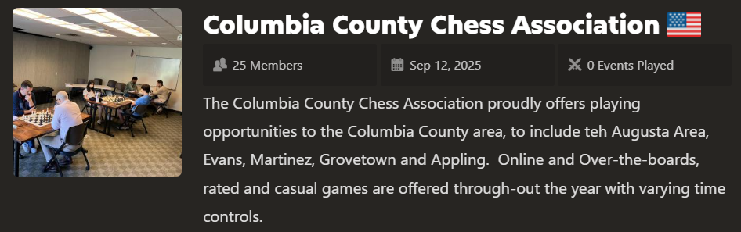

We would love for you to join us through https://www.chess.com/club/columbia-county-chess-association/join .

FREE Daily Game Competition Updates

Completed Daily Tournaments
With some of the county’s finest players gathering online to compete, Darby Williams wins the daily competition and the first place badge. Final Standing are as follows:
- First Place – “Darby321” Darby Williams
- Second Place – “Meanmug88” Desmund Ried
- Third Place (Tie) – “chesss-1995” Abigail Lin and “mgthoma2” Maxwell Thomas
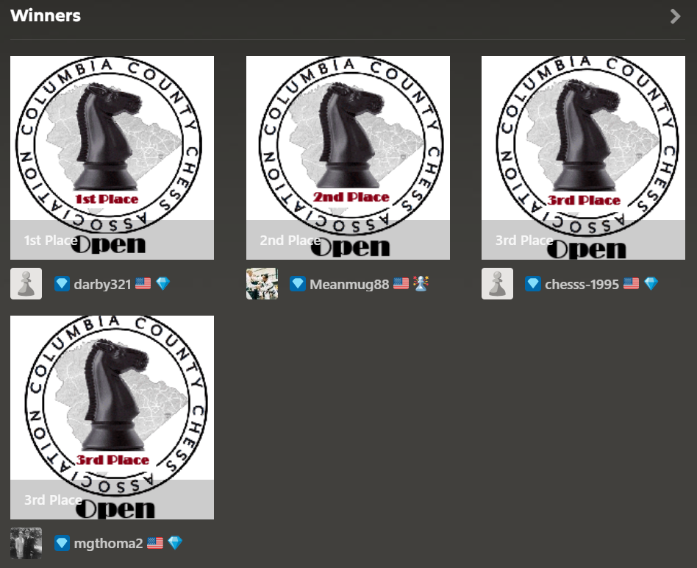
Figure 10 September ’25, Daily Tournament Results!

Ongoing Daily Tournaments
The December ’25 Daily Tournament plays on with 5 of the 7 players remaining for the tope three spots. Who will come away victorious between Darby Williams, Russell Bryant, Bradon Walker, Desmend Ried and (your’s truly) Rusty Charles.

Updates available through https://www.chess.com/tournament/ccca-december-25-daily-tournament-open .

Upcoming January 24th Daily Tournament
Come join us for our January '26 Daily Tournament! Free entry and games begin on January 24th to compete for the coveted CCCA Winners badges! Join us now through https://www.chess.com/tournament/ccca-january-26-daily-tournament-open/join/676df5 .

