Columbia County Chess Association
February 2026

Thank you for joining with our Scholastic Chess, Chess League, and all our other offerings with the Columbia County Chess Association! We are very excited about all things chess happening this year!

In this month’s newsletter:

- 2025 Most Improved Player
- CSRA Scholastic Chess and League
  - Middle School League
  - High School Chess
  - Elementary School Chess Clubs
  - Augusta Prep Scholastic Tournament
- The 2026 Columbia County Chess League
  - Open Section
  - U800 Section
  - U400 / Beginners Section
  - 2026 Chess League News
    - 2026 Chess League Dates
- Wednesday Chess
- USCF Memberships – Scholastic Players
- 2026 CCCA Club Enthusiast Package
  - USCF Membership
  - Tournament Entries
  - Chess Training Software
  - Chess Gear
- Online with the Columbia County Chess Association
  - USCF Rated Online Tournaments
  - Chess.com Group – Columbia County Chess Association
  - FREE Daily Game Competition Updates
    - Completed Daily Tournaments
    - Ongoing Daily Tournaments
    - Upcoming March 21st Daily Tournament

2025 CCCA Most Improved Player

We held the presentation of the 2025 Most Improved Player before the start of our event in February to recognize the significant advancements of our players. The criteria was that the players participated in a minimum of three CCCA events throughout 2025 and the player with the highest rise in their regular rating.

We had many impressive players whose ratings rose throughout the year;
- Peter Newton with a 379-point gain,
- Maxwell Thomas with a 387-point gain

One player began playing with our club in 2025, quickly introducing with confidence, artistry and creativity to our club. In one tournament, this player attempted to introduce moves that have only been seen on before on YouTube videos, challenging the USCF rulebook with his inventions. This Stevens Creek student saw his rating jump by over 400-points in 2025, a total of a 420-point gain! Congratulations to Vivek Raval as the 2025 CCCA Most Improved Player!

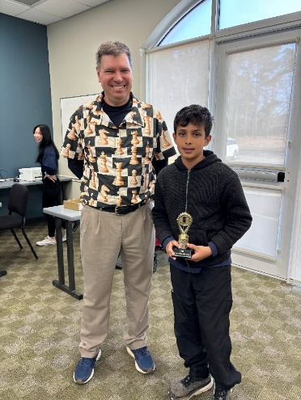
Figure 1 Vivek Raval wins the 2025 CCCA Most Improved Player

CSRA Scholastic Chess and League

Middle School League

Thank you to William Bowman for organizing the CSRA Scholastic Chess League for middle schools in the area! And another large thanks to all of our coaches, teachers and volunteers who continue to lead and coach through the grades of our schools! We want to extend our thanks to:
- Amy Bean
- Greg and April Tredore
- Sarah O’Neill
- Stephen Algers.

After twelve exciting sessions where the middle schools met, the Middle School regular season has come to an end. Evans Middle School finishes in first place with 10.0 / 12 team points on the year. Augusta Prep wins 2nd Place with 8.0 / 12 points with Augusta Christian and St. Mary’s finishing third and fourth (respectively). Congratulations to all schools for their performances throughout the year!

Place | Team | Match Points
1 | Evans Middle | 10.0 / 12
2 | Augusta Prep | 8.0 / 12
3 | Augusta Christian | 6.0 / 12
4 | St. Mary’s | 0.0 / 12

Meeting results and standing can be found through CSRA Scholastic Chess League Standings – Columbia County Chess Association .

Players, coaches and organization are excited to conclude the 2025-26 CSRA Scholastic Chess League on March 3rd where schools will face off to which will be the top finisher for this Schools Year!

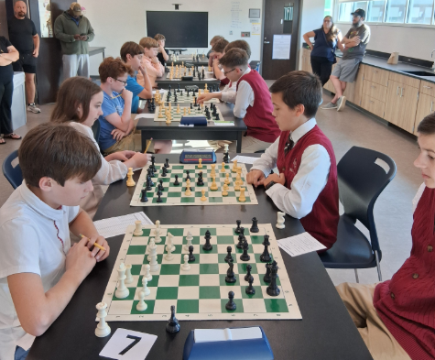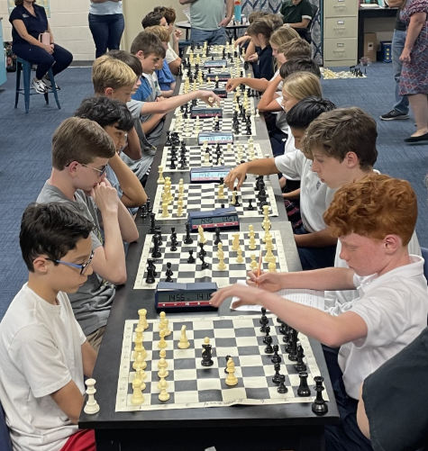
Figure 2 The Middle School Chess League regular season has concluded!
William Bowman continues his wonderful work leading the Scholastic Chess Clubs across the area. If your school needs help starting or developing a chess club, or would like to join the Scholastic Chess League, please connect with us or William Bowman. We would love to help!

High School Chess

High School Chess Coach, Tom Valios led his high school players from Alleluia to a regional scholastic competition. We are excited to congratulate his teams for their outstanding performances! Alleluia held two of the top three spots in the regional competition! Team 1 are the regional champions and the Alleluia Team 2 finished in third place!

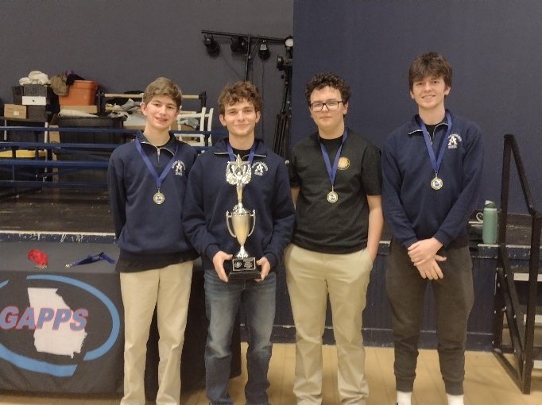
Figure 3 Alleluia wins first and third place in the regional competition!

Elementary Chess Clubs

Barton Chapel

Mr. Stokes and Particia Jones continue their good work with their chess club at Barton Chapel Elementary School. The Columbia County Chess Association was happy to provide the online access of the Chess4Life software for their students to further their awareness and knowledge of chess. We hope to see more of these students over the boards in the future!

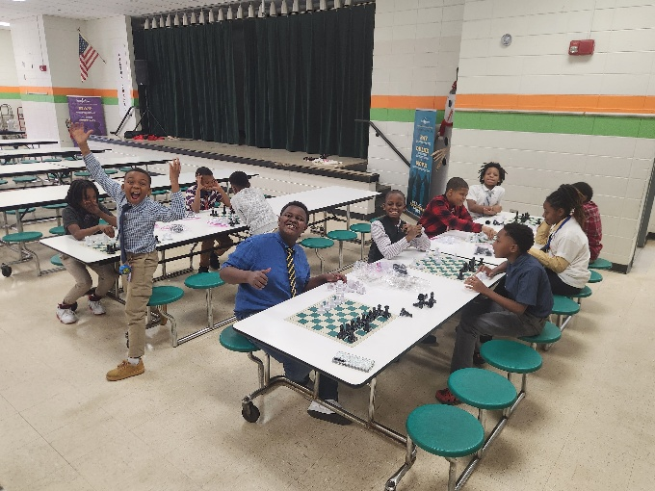
Figure 4 The students are Barton Chapel love their chess!

Stevens Creek Elementary

We draw to the close of our Stevens Creek Chess Club in 2026 continuing our lessons focusing on the abilities and strengths of individual pieces. Our final lesson of the school year concluded all the pieces movements with Rooks, Kings and Castling! We are capping of this year’s chess club with an in school tournament where students compete head to head in three separate sections! We have thoroughly enjoyed teaching chess to these students and are so thankful for the accommodation that Mrs. Ennis and Stevens Creek provided for their students!

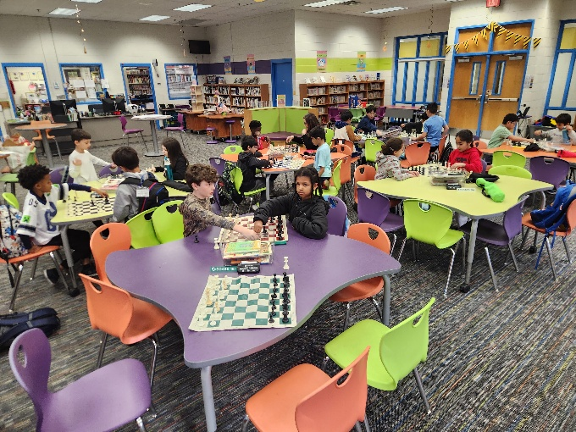
Figure 5 The end of year STCE Tournament commences!

We’d love to help your school develop their concentration, math and cognitive skills through chess! Please let us know how we can help foster chess at your school! Please email columbiacounty.chess@gmail.com .

We are happy to offer our lessons from our Elementary school chess clubs to help you get started or assist in one you already run! We are happy to share through our website Elementary School Lessons – Columbia County Chess Association .

Scholastic Tournament at Augusta Prep

William Bowman hosted the Scholastic Winter Tournament at Augusta Prep this month where the area’s top scholastic players met. Twenty (20) students gathered and played, where proceeds went to benefit the Augusta Preparatory Day School.

Alexander Looney continues his outstanding play going a perfect 5.0 / 5 points on the day winning the tournament, with Olivia Rains finishing in second place at 4.0 / 5 points. Six players finished in tie for third place. Congratulations to Vihaan Shah, Zhengwen Xiang, Matthew Weng, Rian Welch, Jacob Barnes and Vishali Patel for the top performances of the day!

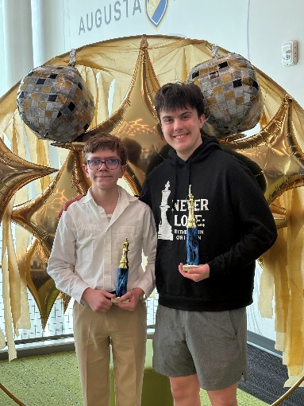
Figure 6 Alexander Looney (right) finishes in first place going a perfect 5 / 5.0 points.

The 2026 Columbia County Chess League

February marked the 2nd of the chess league events of 2026 with excitement overflowing in the Under sections! With, yet again, the introduction of another 4 new players to rated chess, we continue to enjoy the growth of chess in our community!

Our Monthly, Chess League Tournaments will last through 2026 with the regular season concluding in October. A 12-player tournament will be played from each section (Open, U1300 and U800) beginning in November with the top players of each section. These 12-players with compete in a 6-player group round-robin competition where the top 2 from each round-robin group will advance to the 4-player bracketed playoff. The winner of this playoff will be crowned the 2026 Chess League Champion (of their given section)!

Who can join the ranks of Abigail Lin, Erik “Lucky” Walker, Jalen Taylor (U1100) and D-Taune Ingram (U1000) as the Columbia County’s Chess League Champions? To join in this year-long competition, please visit and register through 2026 Registration – Columbia County Chess Association .

Summary, results and pictures are through Feb ’26 Chess League – Columbia County Chess Association.

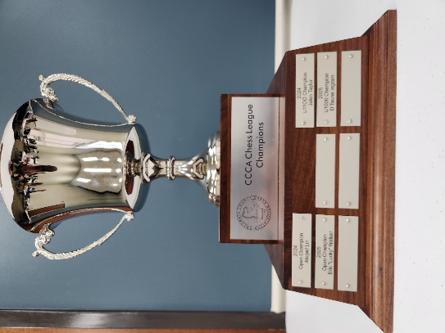
Figure 7 The coveted CCCA Chess League trophy remains on display at the Columbia County Library.

Open Section

With our young and quickly improving players moving up sections, newcomer John Helman introduces himself to the Columbia County Chess Association winning the Open Section of the February ’26 Chess League! Jacob Hanna finishes alone in 2nd Place while the tie for third place included four players; Alexander Looney, Lily She, Vedant Tiwari and Ryan Kim.

1st Place – John Helman
2nd Place – Jacob Hanna
3rd Place (tie) - Alexander Looney, Lily She, Vedant Tiwari and Ryan Kim

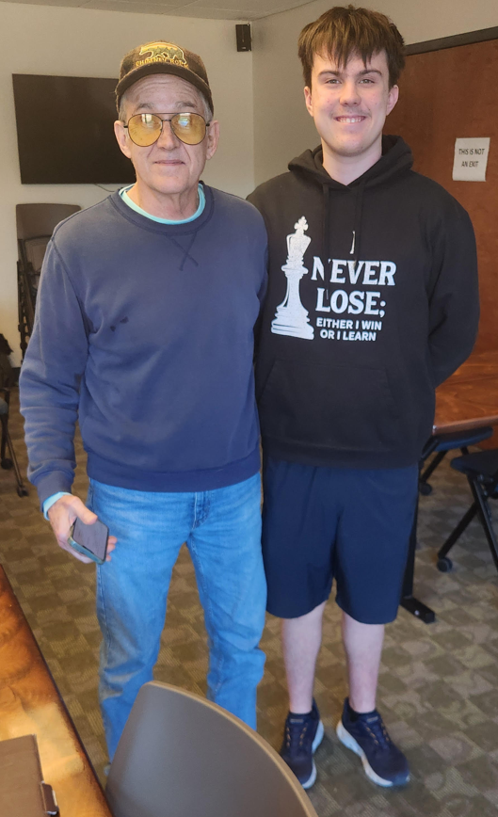
Figure 8 Congratulations John Helman (1st) and Alexander Looney (3rd) for their performances.

Alexander Looney takes over first place in the Open Section points lead after his consistent play throughout 2026. After his introduction to the U1300 Section, Ryan Kim takes the overall point lead in the 2026 Chess League Standings, U1300 section.

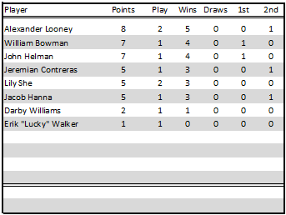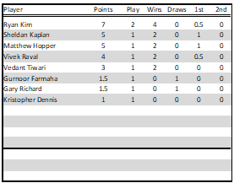
Figure 9 Chess League Standings after the February '26 Chess League Event; Open (left) and U1300 (right).

U800 Section

Players moving up section opened opportunities to our younger players. Vivek Raval compliments his receipt of the 2025 Most Improved Player with a victory of the U800 section! Vivek goes a perfect 4 / 4.0 points on the day winning 1st Place! Vihaan Shah and Alan Li finish closely behind second place going 3.0 / 4 points on the day. With his play, Vivek surges to the U1300 Section next month!

1st Place – Vivek Raval (moves up to the U1300 Section)
2nd Place (tie) – Vihaan Shah and Alan Li

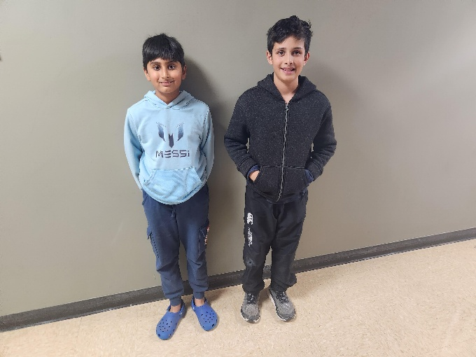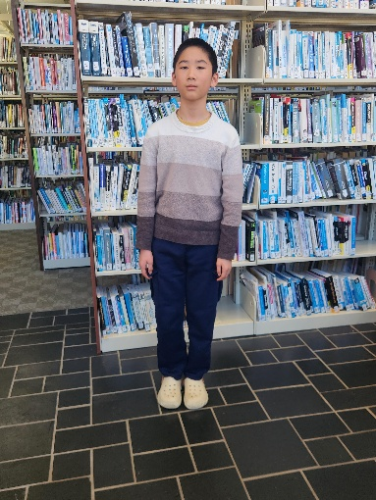
Figure 10 Congratulations to Vivek Raval (left picture, right) wins first place in the U800 section! Vihaan Shah (left picture, left) and Alan Li (right picture) finish in a 2nd Place tie!
Alan Li and Navtej Farmaha assume the overall point lead in the U800 section with Vivek’s ascension to the U1300 Section.

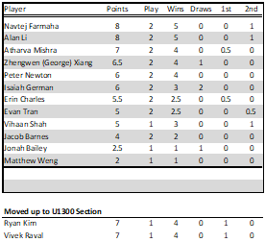
Figure 11 Latest 2026, U800 Section Chess League Standings

U400 / Beginners Section

Sharpening her chess skills and feel for the board through 2025, Erin Charles breaks out of her shell and impresses going a perfect 4 / 4.0 on the day winning top prize of the section! Jack Richards finishes in 2nd Place going 2.5 / 4 points.

- 1st Place – Erin Charles
- 2nd Place - Jack Richards

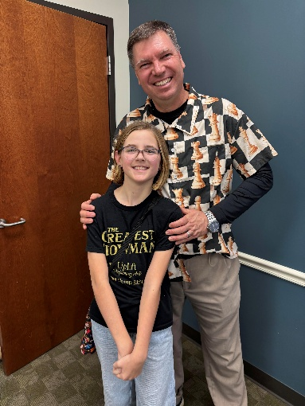
Figure 12 Congratulations to my daughter, Erin Charles, winning the U400 Section!
Erin climbs to the U800 section, Jack Richards assumes the overall lead with the rest of the players trailing closely behind!

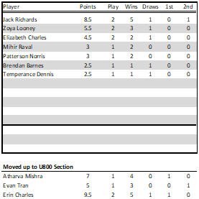
Figure 13 U400 (Beginners) Section Standings

2026 Chess League News

2026 Chess League Dates
There are still eight (8) more chess tournaments scheduled through the 2026 Regular Season with plenty of opportunity left to qualify for the playoffs! We offer an invitation to experience the journey through chess on the following tournament Saturdays in 2026!
- March 7th
- April 7th
- May 2nd
- June 6th
- July 11th
- August 1st
- September 12th
- October 3rd

Playoffs will follow with the top twelve (12) from each section competing for the top four spots in a round-robin playoff! From there the Chess League Champion will be crowned (for each section) after a 4-player playoff!

More information and registrations are available through 2026 Registration – Columbia County Chess Association .

Wednesday Chess

We have been infused in the past weeks with many new (to us) players at our Wednesday Chess events at Cardboard Castle. We continue our regular schedule of Wednesday chess and have already seen many new eager players from the area.

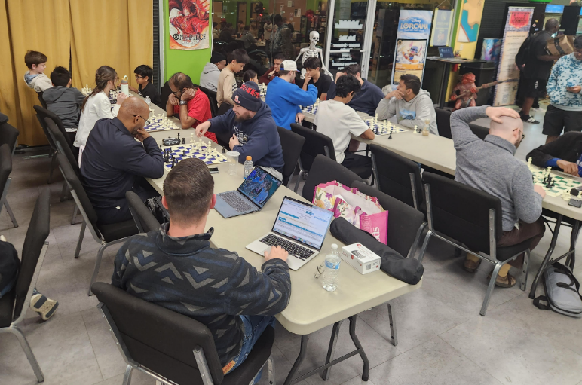

We continue to offer both the free casual and rated (mini-)tournaments each Wednesday. The results of these are as follows:

Blitz night is next on deck for Wednesday, March 4th, 2026 with (at least) 6 Rounds of G/5;+3 games. With our look-ahead for the next three weeks:
- March 11th – G\10;+5 games
- March 18th – G\15;+5 Quads
- March 25th – G\10;+0 games.

Please visit our website for updates, schedules and results of our Wednesday night offerings at Cardboard Castle through Wednesday Chess – Columbia County Chess Association .

Online with the Columbia County Chess Association

USCF Rated Online Tournaments

USCF Rated online tournaments are returning in 2026 with increased prizes and new tournament directors leading the tournaments! The Columbia County Chess Association is proud to have Darby Williams heading up our online tournaments with our next session scheduled for Friday, March 20th, 2026, starting at 7:00 pm.

With our increased prize pool this year and we are excited to offering the following the top two positions of each section (Based on 10 entries):
- Open Section: $60 Pool (1st Place - $40, 2nd Place - $20)
- Under 1000 Section: $30 Pool (1st Place - $20, 2nd Place - $10)

Games on March 20th will be G/10;+3 games with an estimated 4 Rounds.

For our Scholastic level players (K-12) we are excited to offer the combination of the New (or renewal) annual USCF membership with registration for the Online tournament for $25!

Register through Online Tournaments – Columbia County Chess Association .

Not sure how USCF Rated Online Tournaments work? Please visit Instructions – Online Tournament – Columbia County Chess Association for more information.

February ’26 – USCF Rated Online Tournament
Players gathered online and enjoyed games with some of our former members who’e games are exploding! Brayden Van de Graaff (Top 100 of Players of 16-years old) who once played with us before his family’s move to Utah, returns and goes a perfect 4.0 / 4 winning the first place prize. Young up-and-comer Ryan Kim and Alexander Looney impress going 3.0 / 4 points, finishing in a tie for 2nd Place.

The U1000 section finished with three players tied from first place. Congratulations to Vihaan Shah, Vivek Raval and Russell Bryant for their outstanding online play for the U1000 Section!

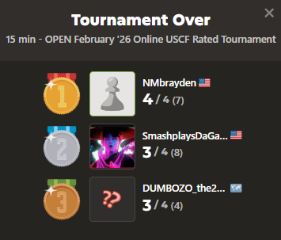

Chess.com Group – Columbia County Chess Association

Would you like to connect through an online chess platform to play and connect with other local players? We invite you to join our chess.com group, “Columbia County Chess Association”. We are excited to offer monthly FREE monthly daily game tournaments, along with different “Vote Chess” and “Team Chess” competition against other clubs in the South Carolina and Georgia areas!

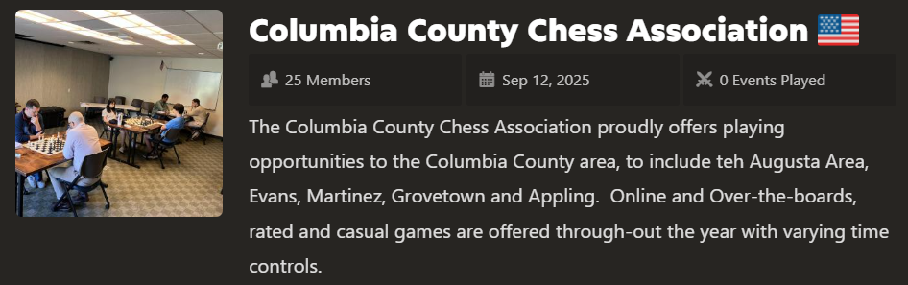

We would love for you to join us through https://www.chess.com/club/columbia-county-chess-association/join .

FREE Daily Game Competition Updates

Completed Daily Tournaments

December ’25 Daily Tournament
With some of the county’s finest players gathering online to compete, I steal a win away from Russell Bryant to win the December ’25 Daily CCCA Tournament!
- First Place – “russelc79” Rusty Charles
- Second Place – “r_b_123” Russell Bryant
- Third Place – “Darby321” Darby Williams

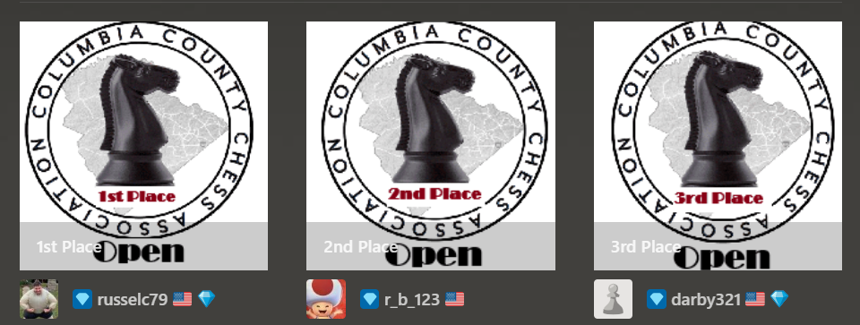
Figure 14 December ’25, Daily Tournament Results!

Ongoing Daily Tournaments

January ’26 Daily Tournament
The Columbia County Chess Association restarted 2026 with the new *** FREE *** Daily Tournament, with ten local players competing for the coveted CCCA badges! Eight players remain as the competition continues. Competition remains tight for the January ’26 prize!

February ’26 Daily Tournament

Open Section
Six players gathered, and 6 players remain in contention for the Open Section badges and bragging rights for the month of February! Who comes away the victor?!

U1000 Section
We re-started the U1000 section of the ***FREE*** Daily tournaments in February. Three up-and-coming players put out their best games for the badges, and all three are still in competition! Good luck to all players!

Upcoming March 20th Daily Tournaments
Come join us for our March '26 Daily Tournaments! Free entry and games begin on March 21st to compete for the coveted CCCA Winners badges! We are excited to continue to offer both the U1000 and Open sections for our various level of players!

Join us now through:
- Open Section: https://www.chess.com/tournament/ccca-march-26-daily-tournament-open/join/81ff98 .
- U1000 Section: https://www.chess.com/tournament/ccca-march-26-daily-tournament-u1000/join/a28ee6 .

USCF Memberships - Scholastic Players

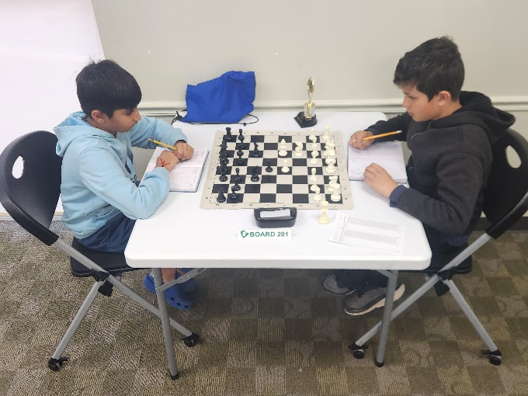

The United States Chess Federation (USCF) requires all chess players player under their guidelines to have USCF Membership. This can be a cumbersome part of playing chess by ensuring registration prior to chess play. This can also be expensive because memberships just increased to $54 for a single players. We are very excited to foster and nurture the enthusiasm surrounding chess and are actively finding new ways to make chess more accessible.

The Columbia County Chess Association has invested in the future of our scholastic players with USCF Vouchers. For this reason we are excited to offer the following to our first time scholastic players:
- USCF Rated Online Tournament + an Annual USCF Membership (for K-12 players) for $25
- Wednesday Chess + an Annual USCF Membership (for K-12 players) for $25
- Saturday Chess Tournament + an Annual Membership (for K-12 players) for $50

This offer also extends to our existing scholastic players membership, which we can now offer for $18 for an annual USCF Membership renewal! We hope this helps everyone enjoy this beautiful game!

2026 Columbia County Chess Association Chess Enthusiast Packages

For 2026, you can choose to purchase entries into events as you go, or you can get a CCCA Club Membership for $380.

When you purchase the Chess Enthusiast Package, you’ll get the following benefits:

US Chess Federation (USCF) Membership

Whenever you play rated games anywhere in the United States, you must be a member of the USCF. They’ve got their own separate membership fee, however, if you purchase a Club Membership with Columbia County Chess Association, we’ll cover that fee for you.

Remember: the USCF membership has its own benefits too! Don’t forget to check out their monthly Chess Life magazine (the online version is free for USCF members). After all, your USCF membership also paying for a subscription to the online portion of the magazine, so why not enjoy it?

Gain entry into one of the following offerings for all of 2026:

1) Wednesday Chess events at Cardboard Castle for the remainder of 2026 (a $380 value)
2) Entry into the remainder of the 2026 Chess League Regular Season ($320 value, does not include the end-of-year playoffs)

You get to choose one of the above options as part of your package. If you would to participate in both, then there may be an extra fee associated.

Access to chess training software

You get access to one of the following software options:

1) Chess4Life – a child-friendly chess training platform
2) Chess.com membership – We’ll pay for you to have a Diamond-level account, which includes puzzles, online training, and more.

Chess stuff

You will receive one of two packages:

- Tournament size chess set including a travel tournament bag, triple weighted pieces, and silicone board
- High quality chess clock

With the purchase of a full year of membership, you’ll get access lots of really cool stuff and save some money at the same time!

Apply for memberships online through Chess Enthusiast Packages – Columbia County Chess Association .

