Columbia County Chess Association
March 2026

Thank you for joining with our Scholastic Chess, Chess League, and all our other offerings with the Columbia County Chess Association! We are very excited about all things chess happening this year!

In this month’s newsletter:

- Thank you to our Tournament Directors and Leaders
- CSRA Scholastic Chess and League
  - Middle School League Playoffs
  - Elementary School Chess Clubs
  - Augusta Prep In Atlanta for a Scholastic Tournament
- Women in Chess Event coming May 2nd, 2026!
- The 2026 Columbia County Chess League
  - Open Section
  - U800 Section
  - U400 / Beginners Section
  - 2026 Chess League News
    - 2026 Chess League Dates
- Wednesday Chess
- Online with the Columbia County Chess Association
  - USCF Rated Online Tournaments
  - Chess.com Group – Columbia County Chess Association
  - FREE Daily Game Competition Updates
    - Completed Daily Tournaments
    - Ongoing Daily Tournaments
    - Upcoming March 21st Daily Tournament
- USCF Memberships – Scholastic Players
- 2026 CCCA Club Enthusiast Package
  - USCF Membership
  - Tournament Entries
  - Chess Training Software
  - Chess Gear

Thank you to all of our Tournament Directors

The Columbia County Chess Association is so blessed by all the wonderful families and children who make our events possible, but the behind the scenes work that all of our Tournament Directors do should not go unnoticed. The wonderful work of our Tournament Directors was never more evident than at our March ’26 Chess League Event. Because of policy changes with the Columbia County Library at the start of 2026, early set-up for the Tournament was not permitted. The good and hard work of our Tournament Directors, it was hard to notice a difference in the start and fluidity of the tournament.

Please take some time to acknowledge at leaders and Tournament Directors with us.

Travis Jones

Travis Jones has been playing with us not long after the founding of the Columbia County Chess Association, and became re-certified as a “Local” TD in 2025. Travis has been critical to the advancement of the CCCA and chess in the community. He has been available Directing the Open Sections of the Chess League and heavily involved in setting up and breaking down before and after each tournament. Travis also has been integral in writing our monthly newsletters, promotion of club activities and support. We thank and appreciate Travis Jones for his contributions to chess and the Columbia County Chess Association.


Darby Williams

Darby Williams has been with the Columbia County Chess Association before the club was founded. Darby played locally in the early days while in different locations and different time formats, always having a thoughtful approach to chess but the relationship he culminates. Darby became a certified Tournament Director in 2024, and directs tournaments in our Wednesday Chess events and runs our online tournaments. He has the balance of raising a new-born baby with his career and still has time to support the community through chess. We thank and Darby Williams for his contributions to chess and the Columbia County Chess Association.



William Bowman

William Bowman plays an integral role in development of chess through not only the Columbia County Chess Association, but also his founding and management of the CSRA Scholastic League. He has inspired hundreds of scholastic players sharing his knowledge chess, and opening opportunities for students to compete with alongside their schoolmates. The CSRA Scholastic League has been a success in both the middle and upper school levels, and working to integrate elementary schools into the League. William upgraded his Tournament Director qualification to “Local” in 2025. We thank and appreciate William Bowman for his contributions to chess, the CSRA Scholastic League and the Columbia County Chess Association.

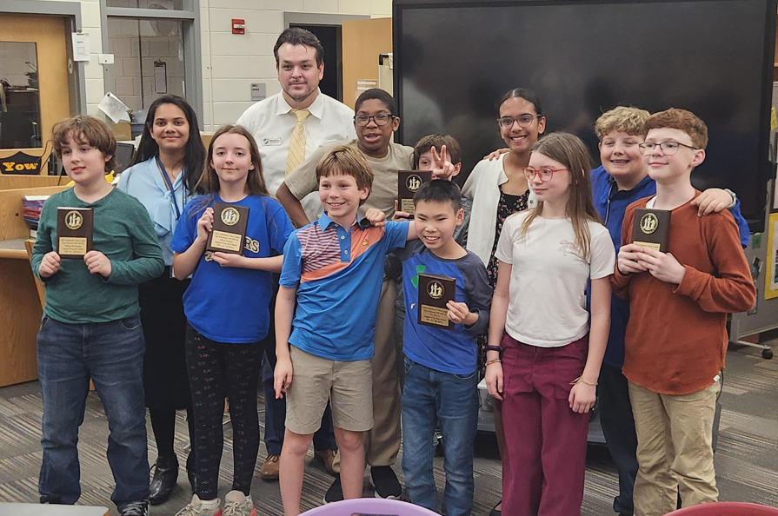

Abigail Lin

Abigail Lin moved to the area from Charleston in 2024 and quickly established herself as one of the premier players, winning the inaugural Chess League Crown in 2024. She decided to challenge and develop herself qualifying as a “Club” level tournament director in 2025, quickly learning techniques and the intricacies of the USCF Rule Book. She has been essential support of the CCCA Chess League, starting in the Under Sections and progressing to lead the Open Section in the March ‘26 Chess League Event. She continues to challenge herself as she prepares to act as Chief Tournament Director in an upcoming “Women in Chess” event. She leads and coordinates a chess club for home schooled children weekly. We thank and appreciate Abigail Lin for her contributions to chess, “Women in Chess” and the Columbia County Chess Association.

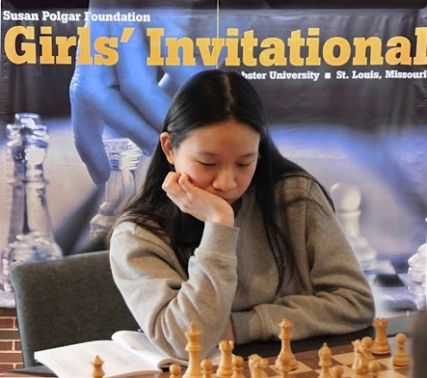

Vincent Lovello

Vincent Lovello began playing chess with the CCCA during our club’s founding. While he was a senior in High School, he became qualified as a “Club” Level Tournament Director. Now, as he completes his freshman year at UGA his USCF Rating is climbing as he plays in National Events. He has been a critical leader in the development of chess in the community, and for the execution of our March ’26 Chess League event. We appreciate Vincent’s drive, work ethic and excitement to expand chess through the community. We thank and appreciate Vincent Lovello for his contributions to chess and the Columbia County Chess Association.

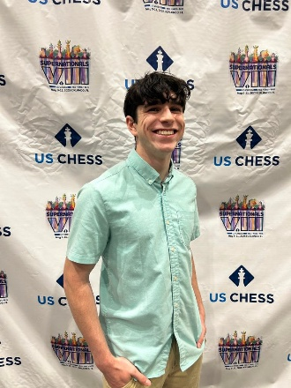

Jeff Corbin

Jeff Corbin is an enthusiastic leader of the Columbia County Chess Association and has been committed to leading our casual sections in the chess league events. Jeff is an enthusiastic player and personality, always bringing an element of southern charm into the conversation. As a devout Christian, Jeff continues his service as a member and volunteer at Grace Baptist Church. We thank and appreciate Jeff Corbin for his contributions to chess and the Columbia County Chess Association.

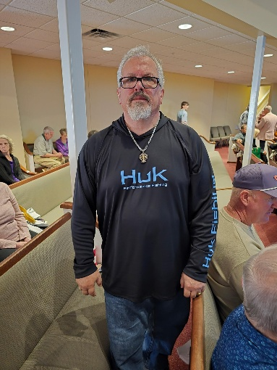

Jenny Charles

My amazing wife loves community, loves relationships and loves spreading the Joy of the Gospel to everyone she meets. She is a critical piece and contributor to our club, warmly welcoming all newcomers and friends alike to join in fellowship during our Chess League events. Her endless energy allows her to not cap her responsibilities with raising our daughters, but help promote the club, chess and be a warm welcoming presence to both players and parents in the Chess League. I can’t do life or this club without her by my side, of which I am so thankful for. I and we thank and appreciate Jenny Charles for her, her contributions to chess, the community and the Columbia County Chess Association.



Karina Ennis

The Columbia County Chess Association helped with the chess club at Stevens Creek Elementary for the 2nd year, and this time around had over 72 students participate and learn chess. Karina Ennis was the teacher / faculty sponsor at the school. Mrs. Ennis is an extremely caring and energetic teacher and Stevens Creek Elementary, and commits herself on a daily basis to not only the betterment of her students but also her family. We are very fortunate to be associated with such a caring person who encourages and supports all of her students. We thank and appreciate Mrs. (Karina) Ennis for her development and care of the Stevens Creek Elementary Students, of which were blessed to be witness of through the STCE Chess Club.

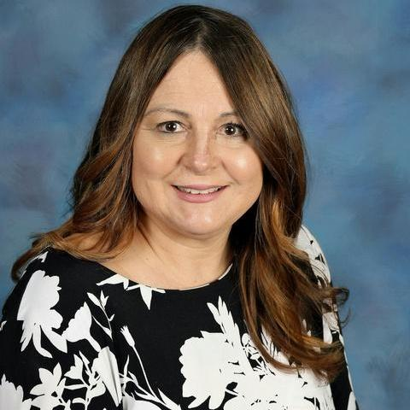

Middle School Chess Coaches

Thank you to William Bowman for organizing the CSRA Scholastic Chess League for middle schools in the area! And another large thanks to all of our coaches, teachers and volunteers who continue to lead and coach through the grades of our schools! We want to extend our thanks to:
- Amy Bean
- Greg and April Tredore
- Sarah O’Neill
- Stephen Algers.

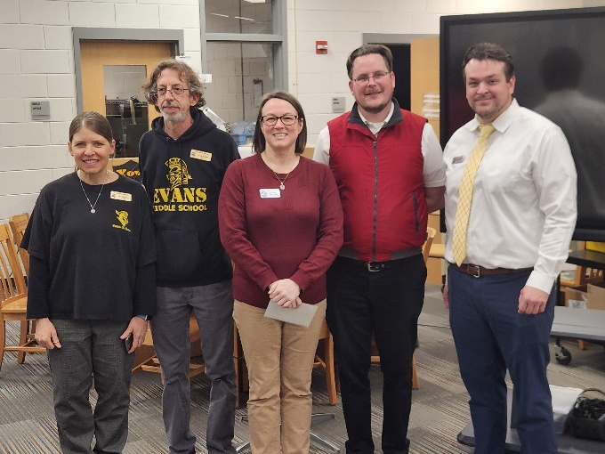

CSRA Scholastic Chess and League

Middle School League Playoff

Players, coaches and organization were excited to conclude the 2025-26 CSRA Scholastic Chess League on March 3rd where schools will face off to which will be the top finisher for this Schools Year!

In the opening rounds of the playoff, Evans Middle Schools paired up against St. Marys on the Hill. After a finishing score of 12.5 to 3.5, Evans Middle Schools advanced to the finals. Concurrently, Augusta Prep Day School played Augusta Christian School and edged out a 8.5 to 7.5 round to meet Evans Middle School in the Final!

In the Finals, Evans Middle School put up a valiant effort but was overtaken by Augusta Preparatory Day School by a score of 9 – 7 games. Augusta Preparatory Day School wind the 2025-2026 Middle School Playoff!

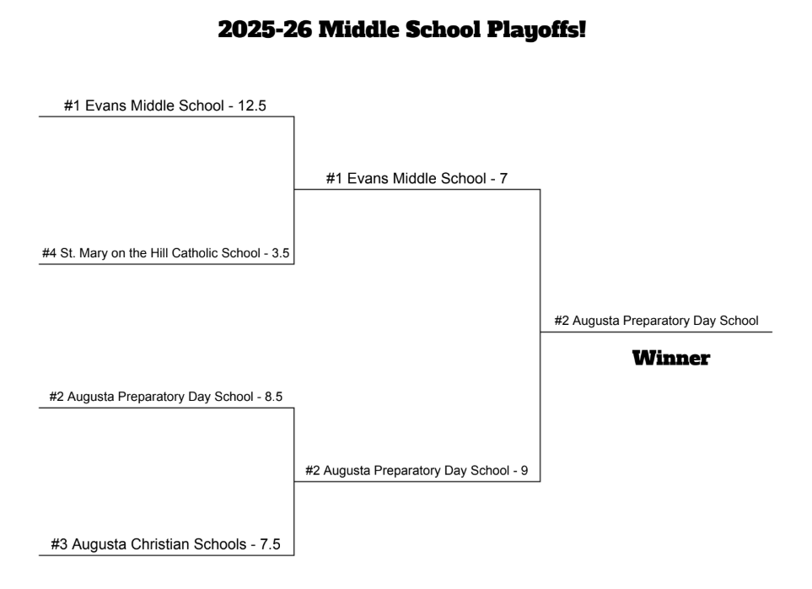
Figure 1 2025-26 Middle School Playoff Bracket

Final results can be found through Middle School Playoffs! – Columbia County Chess Association .

Augusta Christian Schools (Middle School)
Thank you to Amy Bean and Steven Algiers for organizing and coaching the Augusta Christian Schools team this year! The Middle School team includes: Jonah Bailey (Captain), Elijah Minton, Micheal Bean, Blain Williams, Cole Vaughn, Steven Kilpatrick, Levi Bream, Joi Hanif, Seth Bunch and Jason Barris.

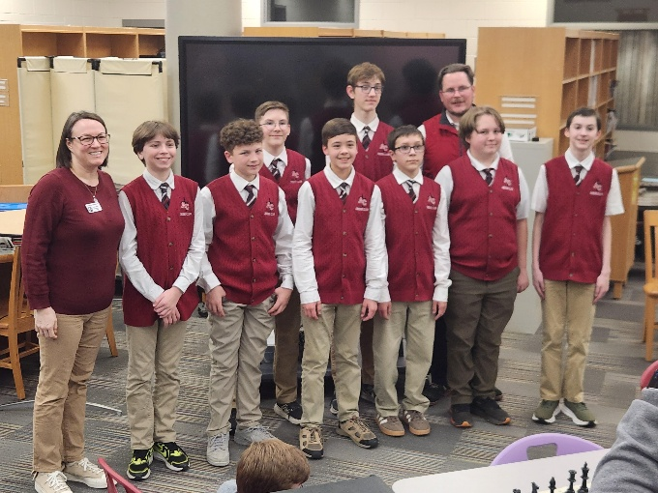
Figure 2 Augusta Christian Schools (Middle School)

Augusta Preparatory Day School (Middle School)
Thank you to William Bowman for organizing and coaching the Augusta Prep Middle School team this year! The middle school team includes: Keenan Pieper (Captain), Ahaan Khiani, Grady Reeves, Rhea Parayil, Vishali Patel, Kit Holmes, Nolan Cira, Franklin Li, William JH Fleming, Olivia Layman, Allan Shaefer, Aiden Fludd, Alex Layman and Noah Sigler.

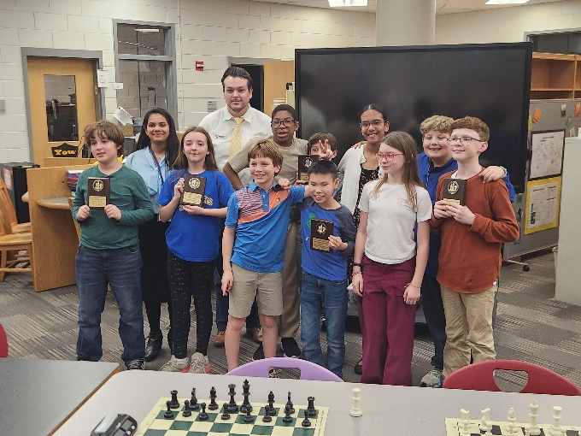

Evans Middle School
Thank you to Gregory and April Tredore for organizing and coaching the Evans Middle School team this year! The middle school team includes: Kristan Howard (Captain), Miguel Peterson, Aiden Dos, Hayan Wagar, Benjamin Harden, Daniel Maffrey, Kristian Howard, Anthony Nguyen, Eli Parrish, Unnah Parayho, Logan Johnson, Ryker Klockenga, Diego Peterson, Rowan Holder, Logan Cook, Jonah Fease, Aiden Lane, Nathan Ward and Makayla Jones.

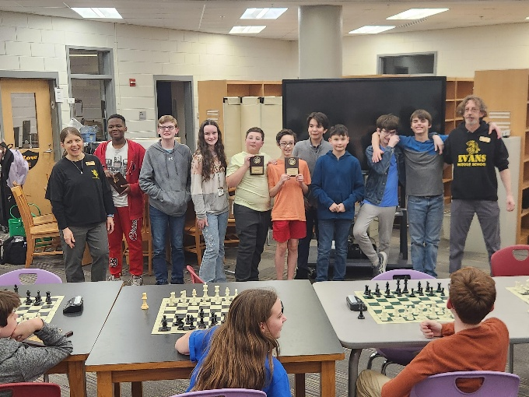
Figure 3 Evans Middle School

St. Mary on the Hill
Thank you, Sarah O’Neil, for organizing and coaching the St. Mary on the Hill Catholic School team this year! The middle school team includes: Peter Newton (Captain), Collin Gelpi, Honor Smith, Ethan Hong, Rowan McBride, Lucy Newton, Benjamin Aldredge, Jackson Aldredge, Jackson Serakas, Emma Gunnells, Arvie Brannigan, Grant Usher, Isaac Hong and Asher Smith.

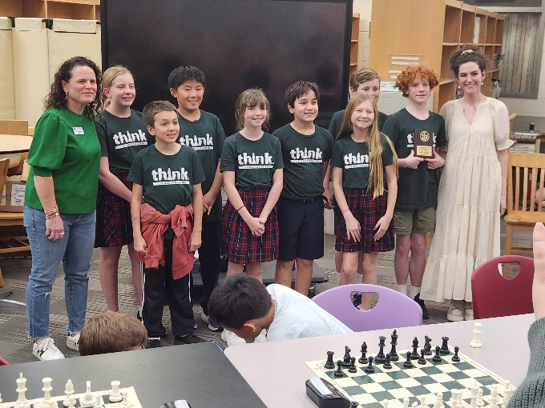

Elementary Chess Clubs

Stevens Creek Elementary

We drew to the close of our Stevens Creek Chess Club in 2026 continuing our lessons focusing on the abilities and strengths of individual pieces. We are capped of this year’s chess club with an in school tournament where students compete head to head in three separate sections! We have thoroughly enjoyed teaching chess to these students and are so thankful for the accommodation that Mrs. Ennis and Stevens Creek provided for their students!

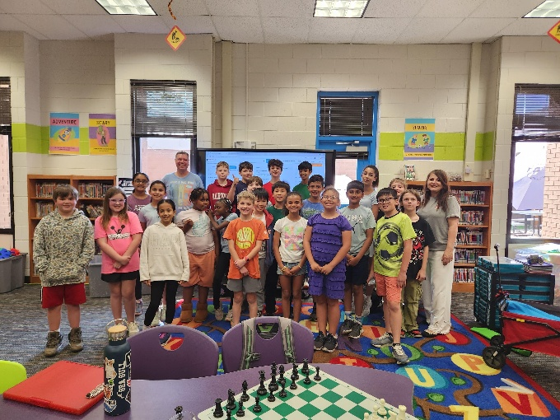
Figure 4

We’d love to help your school develop their concentration, math and cognitive skills through chess! Please let us know how we can help foster chess at your school! Please email columbiacounty.chess@gmail.com .

We are happy to offer our lessons from our Elementary school chess clubs to help you get started or assist in one you already run! We are happy to share through our website Elementary School Lessons – Columbia County Chess Association .

Barton Chapel

Mr. Stokes and Particia Jones continue their good work with their chess club at Barton Chapel Elementary School. The Columbia County Chess Association was happy to provide the online access of the Chess4Life software for their students to further their awareness and knowledge of chess. We hope to see more of these students over the boards in the future!

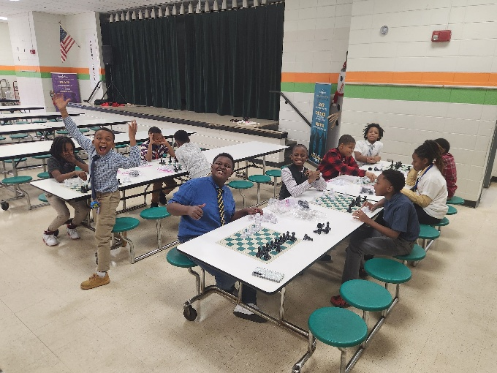
Figure 5 The students are Barton Chapel love their chess!

Augusta Prep in Atlanta for a Scholastic Tournament

William Bowman led his team of August Prep Middle and Upper school students to Atlanta in March to compete in the 2026 Walker Chess Invitational.

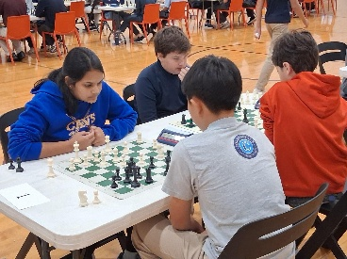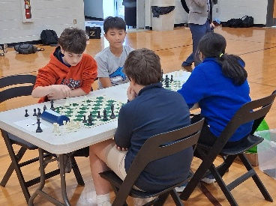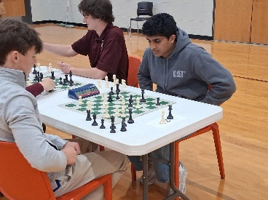

Both Upper and Middle school students had outstanding performances, but to add congratulations to Rhea Parayil and Nolan Cira for their 1st and 2nd place finishes (respectively) in the Middle School competition. Cogratulations to AD Doppalapudi for finishing in a 2nd Place tie in the Upper School competition.

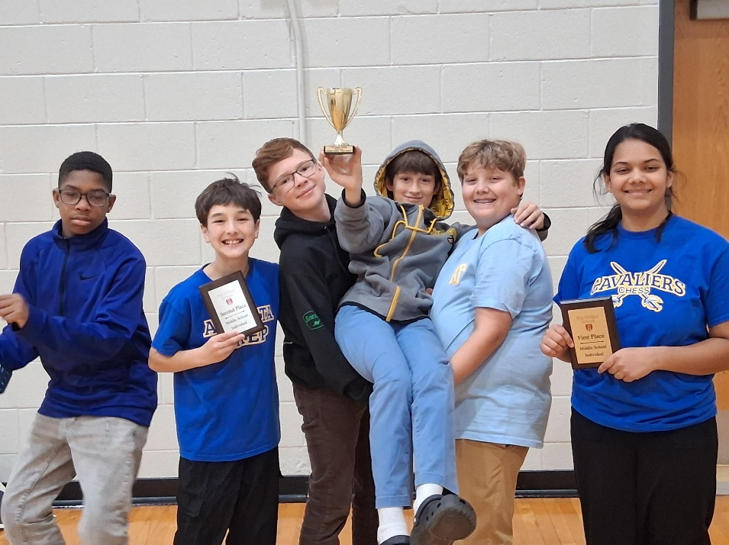
Figure 6 Congratulations to the Augusta Prep students for their performances!

CCCAs First “Women in Chess” Event

The Columbia County Chess Association is proud to provide our first “Women in Chess” event on May 2nd, 2026! Tournament Director Abigail Lin will be heading up and officiating our clubs first chess event solely for and run by Women. For Women, young women or female children, join the ladies for 4 rounds of G/30;+5 games running all day!

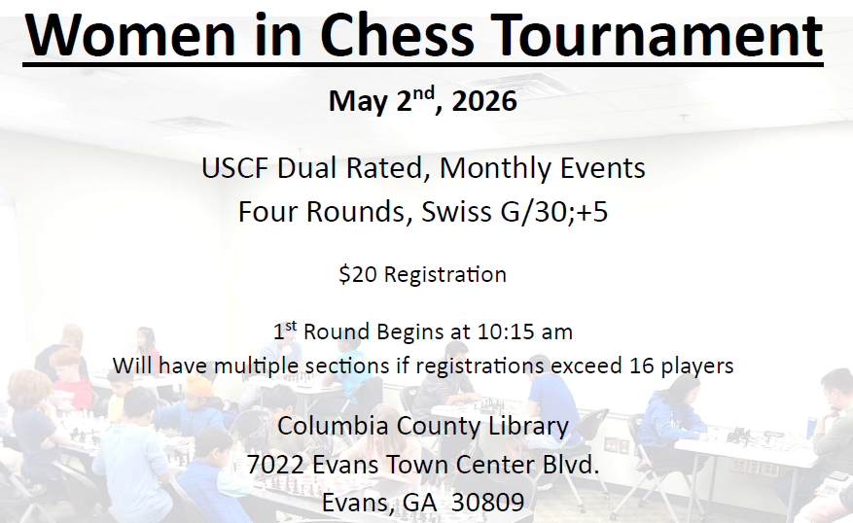

More information is soon to come!

Registration is open through Women in Chess – Columbia County Chess Association .

The 2026 Columbia County Chess League

March marked the 3rd installment of the chess league events of 2026 with excitement overflowing in the Under sections! With, yet again, the introduction of another infusion of new players to rated chess, we continue to enjoy the growth of chess in our community!

Our Monthly, Chess League Tournaments will last through 2026 with the regular season concluding in October. A 12-player tournament will be played from each section (Open, U1300 and U800) beginning in November with the top players of each section. These 12-players with compete in a 6-player group round-robin competition where the top 2 from each round-robin group will advance to the 4-player bracketed playoff. The winner of this playoff will be crowned the 2026 Chess League Champion (of their given section)!

Who can join the ranks of Abigail Lin, Erik “Lucky” Walker, Jalen Taylor (U1100) and D-Taune Ingram (U1000) as the Columbia County’s Chess League Champions? To join in this year-long competition, please visit and register through 2026 Registration – Columbia County Chess Association .

Summary, results and pictures are through Feb ’26 Chess League – Columbia County Chess Association.

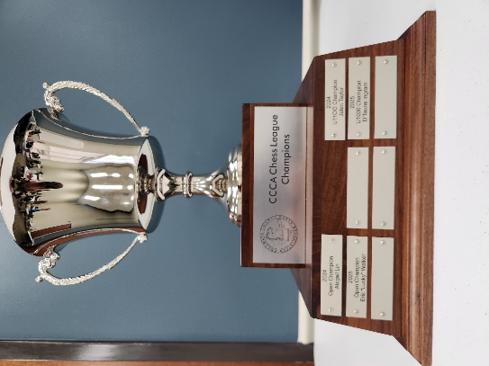
Figure 7 The coveted CCCA Chess League trophy remains on display at the Columbia County Library.

Open Section

We found players entangle in high level chess battle in our Open section in March. With 1800 and 1900-level players in round robin competition, neither cam away the victor after games concluded. It was the up-and-coming Jacob Hanna coming away the victor going 2.0 / 3 points, with Blake Splitter and Williams Bowman finishing in a tie for 2nd Place at 1.5 / 3.0 points.

1st Place – Jacob Hanna
2nd Place (tie) – Jacob Hanna and Blake Splitter

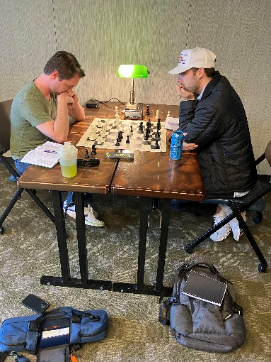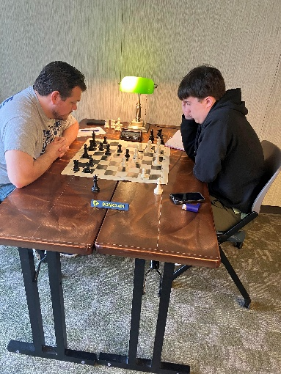
Figure 8 Blake Splitter (left), Jacob Hanna, William Bowman and Alexander Looney enjoy the round-robin competition!

William Bowman assumes the top spot of the CCCA Chess League Standings, with Alexander Looney and Jacob Hanna closely behind tied for 2nd Place.

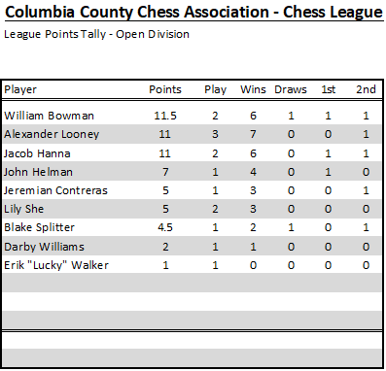
Figure 9 Chess League Open Standings after the March '26 Chess League Event.

U1300 Section

After receiving a fresh batch of players ascending from the U800 Section, 6 players battled it out to gain control of the years standings. Both Gurnoor Farmaha and Trevor O’Kane make their triumphant retuns to our chess club finish 3.0 / 4 points on the day finishing in a tie for first place. Darby Williams, Vedant Tiwari and Ryan Kim all finish in a 3-way log jam (tie) for third place at 2.0 / 4 points.

1st Place (tie) – Gurnoor Farmaha and Trevor O’Kane
3rd Place (tie) – Darby Williams, Vedant Tiwari and Ryan Kim

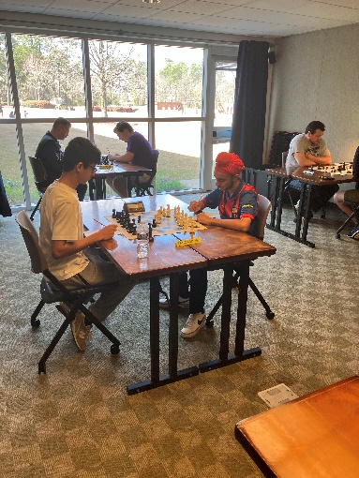
Figure 10 Vedant Tiwari and Gurnoor Farmaha kick off the 1st Round of Play!
Ryan Kim maintains his overall lead in the U1300 Chess League Standing with Gurnoor Farmaha in 2nd Place.

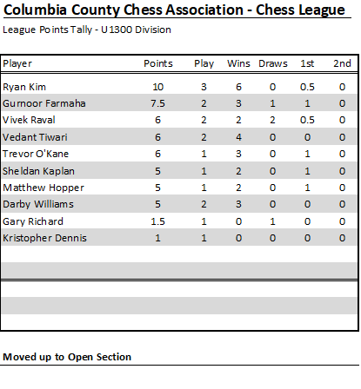
Figure 11 Latest 2026 Chess League Standings, U1300 Section

U800 Section

As we welcome 6 new players to our club playing in the U800 Section, Atharva Mishra continues his march through the divisions after winning the U400 Section in January going 3.5 / 4 points winning the U800 Section. 2nd Place finished in a three-way tie between Peter Newton, Vihaan Shah and Zhengwen (George) Xiang all with 3.0 / 4 points on the day!

1st Place – Atharva Mishra
2nd Place (tie) – Peter Newton, Vihaan Shah and Zhengwen (George) Xiang

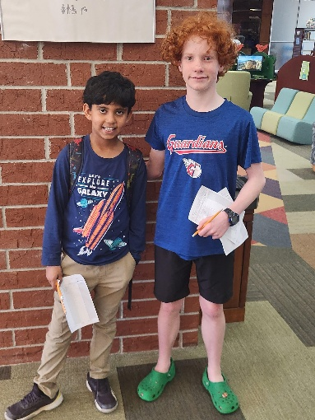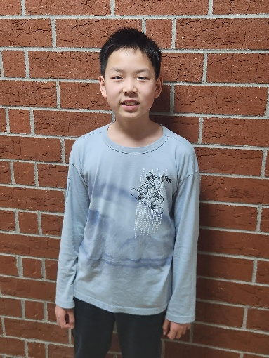
Figure 12 Congratulations to Atharva Mishra (left picture, left) winning first place in the U800 section! Peter Newton (left picture, right), Zhengwen (George) Xiang (right) and Vihaan Shah (not pictured) finish in a 2nd Place tie!
Atharva Mishra takes over the top spot in the U800 Chess League standings with Zhengwen (George) Xiang and Peter Newton closely behind.

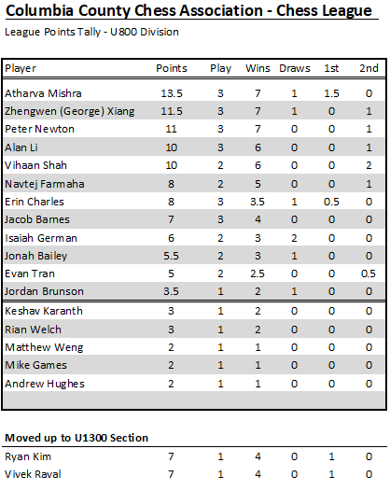
Figure 13 Latest 2026, U800 Section Chess League Standings

U400 / Beginners Section

As we see more and more excitement in the U400 / Beginners section, so do the number of competitors! New to our Chess League, Oliver Lin steps up to the boards and impressively goes perfect on the day, 4.0 / 4 points! Oliver Lin wins the U400 / Beginners section! Mihir Raval, excited every step of the way, secures 2nd Place.

- 1st Place – Oliver Lin
- 2nd Place – Mihir Raval

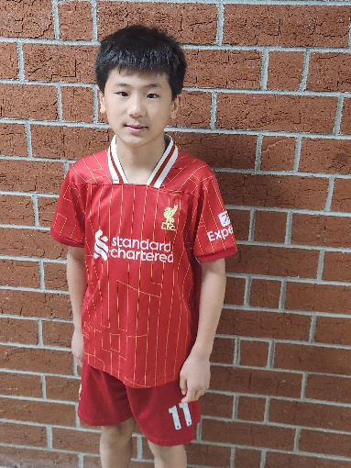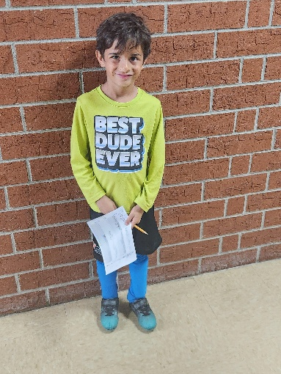
Figure 14 Congratulations to Oliver Lin (left) with first place finish, and Mihir Ravel (right) for ending in 2nd!
Jack Richards keep the overall point lead in the section with Zoya Looney closely behind in 2nd Place.

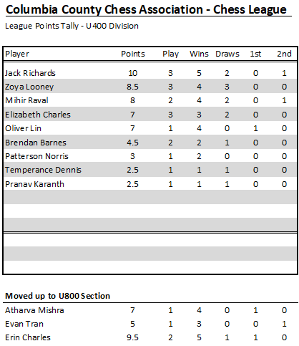
Figure 15 U400 (Beginners) Section Standings

2026 Chess League News

2026 Chess League Dates
There are still seven (7) more chess tournaments scheduled through the 2026 Regular Season with plenty of opportunity left to qualify for the playoffs! We offer an invitation to experience the journey through chess on the following tournament Saturdays in 2026!
- April 4th
- May 16th
- June 6th
- July 11th
- August 1st
- September 12th
- October 3rd

Playoffs will follow with the top twelve (12) from each section competing for the top four spots in a round-robin playoff! From there the Chess League Champion will be crowned (for each section) after a 4-player playoff!

More information and registrations are available through 2026 Registration – Columbia County Chess Association .

Wednesday Chess

We have been infused in the past weeks with many new (to us) players at our Wednesday Chess events at Cardboard Castle. We continue our regular schedule of Wednesday chess and have already seen many new eager players from the area.

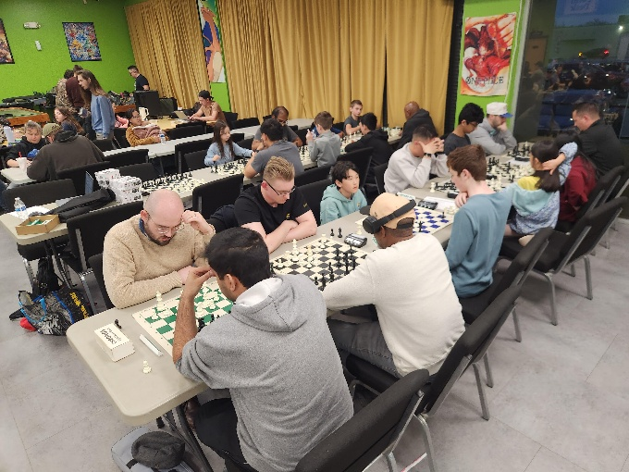

We continue to offer both the free casual and rated (mini-)tournaments each Wednesday. The results of these are as follows:

Blitz night is next on deck for Wednesday, April 1st, 2026 with (at least) 4 Rounds of G/10;+5 games. With our look-ahead for the next three weeks:
- April 8th – G\15;+5 games
- April 15th – G\5;+5 games
- April 22nd – G\10;+5 games.

Please visit our website for updates, schedules and results of our Wednesday night offerings at Cardboard Castle through Wednesday Chess – Columbia County Chess Association .

Online with the Columbia County Chess Association

USCF Rated Online Tournaments

USCF Rated online tournaments are returning in 2026 with increased prizes and new tournament directors leading the tournaments! The Columbia County Chess Association is proud to have Darby Williams heading up our online tournaments with our next session scheduled for Friday, April 17th, 2026, starting at 7:00 pm.

With our increased prize pool this year and we are excited to offering the following the top two positions of each section (Based on 10 entries):
- Open Section: $60 Pool (1st Place - $40, 2nd Place - $20)
- Under 1000 Section: $30 Pool (1st Place - $20, 2nd Place - $10)

Games on March 20th will be G/10;+5 games with an estimated 4 Rounds.

For our Scholastic level players (K-12) we are excited to offer the combination of the New (or renewal) annual USCF membership with registration for the Online tournament for $25!

Register through Online Tournaments – Columbia County Chess Association .

Not sure how USCF Rated Online Tournaments work? Please visit Instructions – Online Tournament – Columbia County Chess Association for more information.

March ’26 – USCF Rated Online Tournament
Players gathered online and enjoyed games and comraderie through chats and games through the evening! Young up-and-comer Alexander Looney wins the Open section going a perfect 4.0 / 4 points on the night, while Ryan Kim and Vedant Tiwari tie for 2nd Place on the night with 3.0 / 4 points.

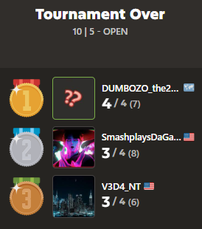

The U1000 section finished with six players tied for 1st Place! Congratulations to Alan Li, Suhrudh Medam, Jonah Bailey, Allan Schaefer, Charlie Shaefer and Rian Welch!

Chess.com Group – Columbia County Chess Association

Would you like to connect through an online chess platform to play and connect with other local players? We invite you to join our chess.com group, “Columbia County Chess Association”. We are excited to offer monthly FREE monthly daily game tournaments, along with different “Vote Chess” and “Team Chess” competition against other clubs in the South Carolina and Georgia areas!

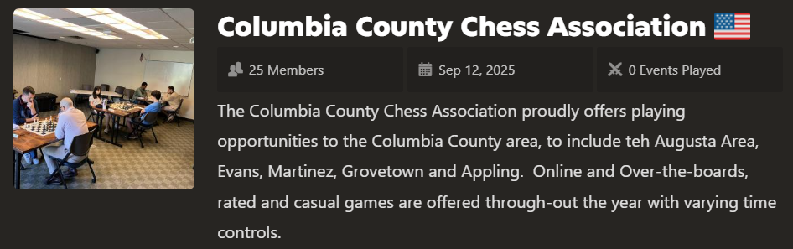

We would love for you to join us through https://www.chess.com/club/columbia-county-chess-association/join .

FREE Daily Game Competition Updates

Ongoing Daily Tournaments

January ’26 Daily Tournament
The Columbia County Chess Association restarted 2026 with the new *** FREE *** Daily Tournament, with ten local players competing for the coveted CCCA badges! Eight players remain as the competition continues. Competition remains tight for the January ’26 prize!

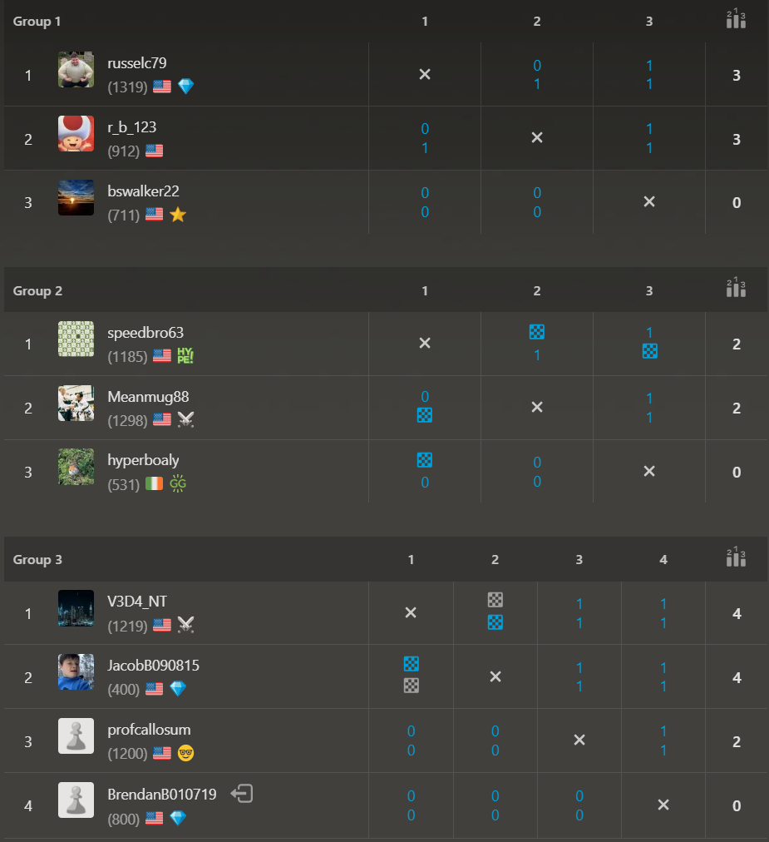

February ’26 Daily Tournament

Open Section
Six players gathered, and 6 players remain in contention for the Open Section badges and bragging rights for the month of February! Who comes away the victor?! “Shortoff Mountain”, “russelc79” and “Aitrusak” are ready to advance while waiting on the final games to complete!

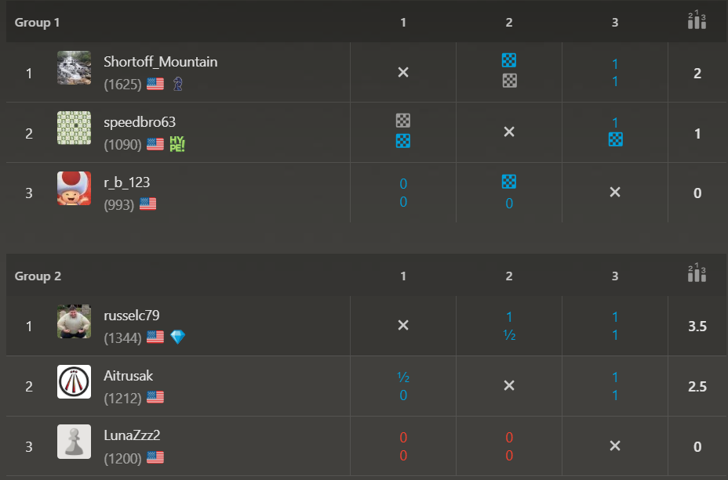

U1000 Section
We re-started the U1000 section of the ***FREE*** Daily tournaments in February. Three up-and-coming players put out their best games for the badges, and all three are still in competition! Good luck to all players! “Runswithit” comfortably waits for her final round opponent while the remaining games conclude!
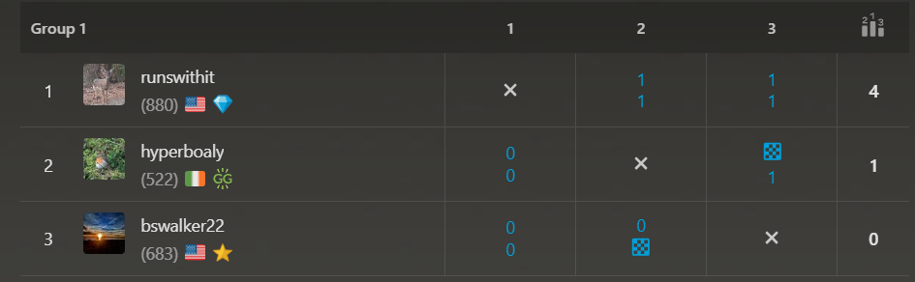

March ’26 Daily Tournament

Open Section
Seven players compete to see who advances to the next round in the Open Section!

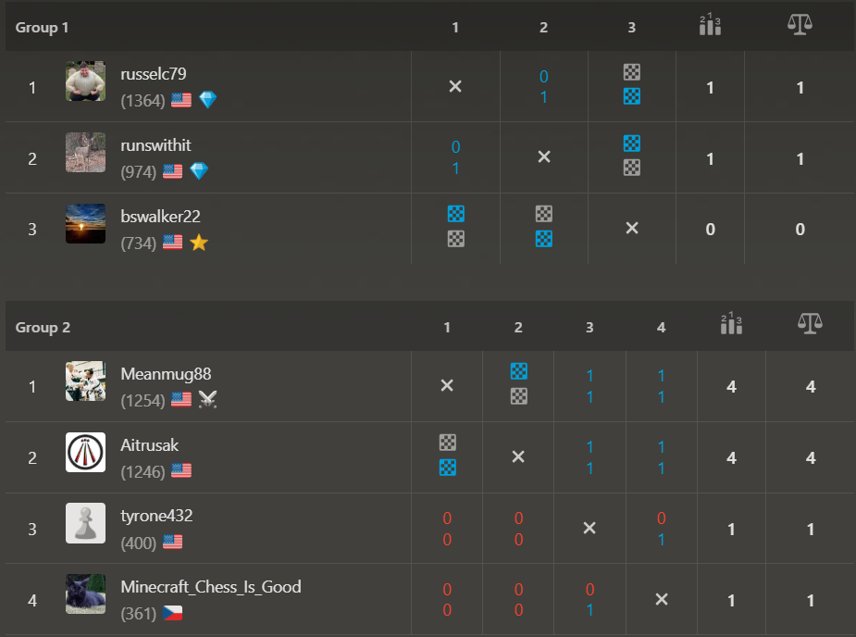

Upcoming April 18th Daily Tournaments
Come join us for our April '26 Daily Tournaments! Free entry and games begin on April 18th to compete for the coveted CCCA Winners badges! We are excited to continue to offer both the U1000 and Open sections for our various level of players!

Join us now through:
- Open Section: https://www.chess.com/tournament/ccca-april-26-daily-tournament-open/join/163f9b .
- U1000 Section: https://www.chess.com/tournament/ccca-april-26-daily-tournament-u1000/join/276169 .

USCF Memberships - Scholastic Players

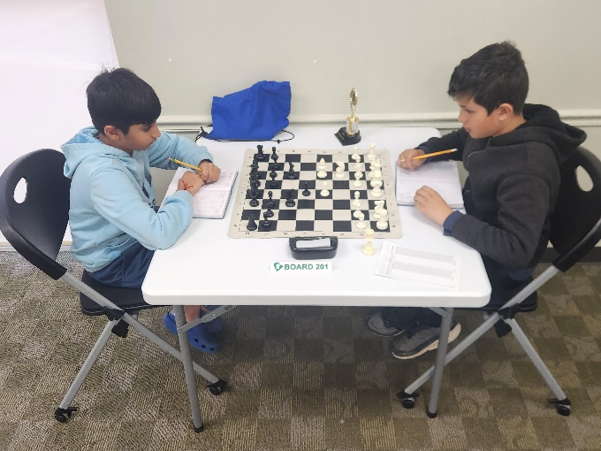

The United States Chess Federation (USCF) requires all chess players player under their guidelines to have USCF Membership. This can be a cumbersome part of playing chess by ensuring registration prior to chess play. This can also be expensive because memberships just increased to $54 for a single players. We are very excited to foster and nurture the enthusiasm surrounding chess and are actively finding new ways to make chess more accessible.

The Columbia County Chess Association has invested in the future of our scholastic players with USCF Vouchers. For this reason we are excited to offer the following to our first time scholastic players:
- USCF Rated Online Tournament + an Annual USCF Membership (for K-12 players) for $25
- Wednesday Chess + an Annual USCF Membership (for K-12 players) for $25
- Saturday Chess Tournament + an Annual Membership (for K-12 players) for $50

This offer also extends to our existing scholastic players membership, which we can now offer for $18 for an annual USCF Membership renewal! We hope this helps everyone enjoy this beautiful game!

2026 Columbia County Chess Association Chess Enthusiast Packages

For 2026, you can choose to purchase entries into events as you go, or you can get a CCCA Club Membership for $380.

When you purchase the Chess Enthusiast Package, you’ll get the following benefits:

US Chess Federation (USCF) Membership

Whenever you play rated games anywhere in the United States, you must be a member of the USCF. They’ve got their own separate membership fee, however, if you purchase a Club Membership with Columbia County Chess Association, we’ll cover that fee for you.

Remember: the USCF membership has its own benefits too! Don’t forget to check out their monthly Chess Life magazine (the online version is free for USCF members). After all, your USCF membership also paying for a subscription to the online portion of the magazine, so why not enjoy it?

Gain entry into one of the following offerings for all of 2026:

1) Wednesday Chess events at Cardboard Castle for the remainder of 2026 (a $380 value)
2) Entry into the remainder of the 2026 Chess League Regular Season ($320 value, does not include the end-of-year playoffs)

You get to choose one of the above options as part of your package. If you would to participate in both, then there may be an extra fee associated.

Access to chess training software

You get access to one of the following software options:

1) Chess4Life – a child-friendly chess training platform
2) Chess.com membership – We’ll pay for you to have a Diamond-level account, which includes puzzles, online training, and more.

Chess stuff

You will receive one of two packages:

- Tournament size chess set including a travel tournament bag, triple weighted pieces, and silicone board
- High quality chess clock

With the purchase of a full year of membership, you’ll get access lots of really cool stuff and save some money at the same time!

Apply for memberships online through Chess Enthusiast Packages – Columbia County Chess Association .

