Columbia County Chess Association
April 2026

Thank you for joining with our upcoming Women in Chess Event, Scholastic Chess, Chess League, and all our other offerings with the Columbia County Chess Association! We are very excited about all things chess happening this year!

In this month’s newsletter:

- Women in Chess Event coming May 2nd, 2026!
- The 2026 Columbia County Chess League
  - Open Section
  - U800 Section
  - U400 / Beginners Section
  - 2026 Chess League News
    - 2026 Chess League Dates
- Wednesday Chess
- Kids in Real Life (KIRL) Club
- Online with the Columbia County Chess Association
  - USCF Rated Online Tournaments
  - Chess.com Group – Columbia County Chess Association
  - FREE Daily Game Competition Updates
    - Completed Daily Tournaments
    - Ongoing Daily Tournaments
    - Upcoming March 21st Daily Tournament
- USCF Memberships – Scholastic Players
- 2026 CCCA Club Enthusiast Package
  - USCF Membership
  - Tournament Entries
  - Chess Training Software
  - Chess Gear

CCCAs First “Women in Chess” Event

The Columbia County Chess Association is proud to host our first “Women in Chess event, exclusively for the ladies and run by the ladies. This FREE event will begin at 1:00 pm at the Columbia County Library (Evans) in the downstairs conference room, There will be fellowship and lessons to start the afternoon, concluding with casual play.

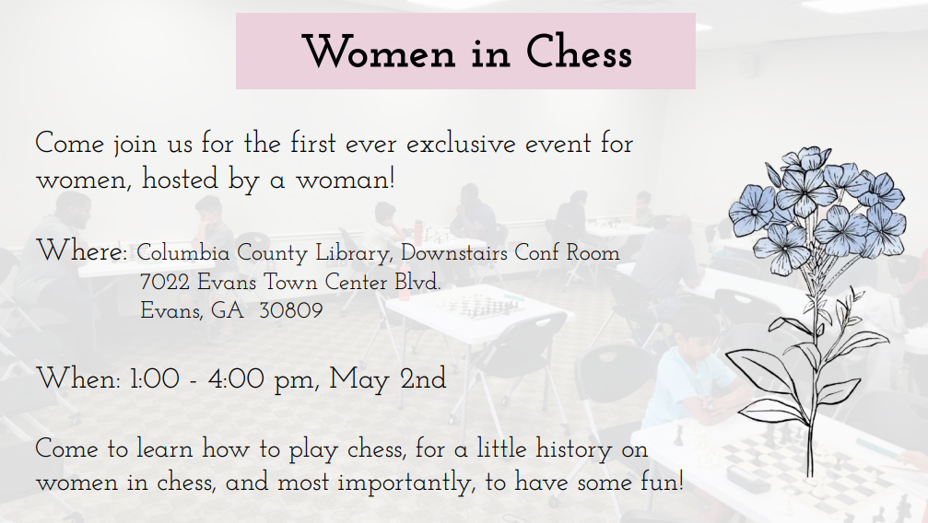

Attendance will be constrained by the room’s capacity.

Please let us know if you are coming through Women in Chess – Columbia County Chess Association .

The 2026 Columbia County Chess League

April marked the next installment of the chess league events of 2026 with excitement abound in the Under sections! With, yet again, the introduction of another infusion of new players to rated chess, we continue to enjoy the growth of chess in our community!

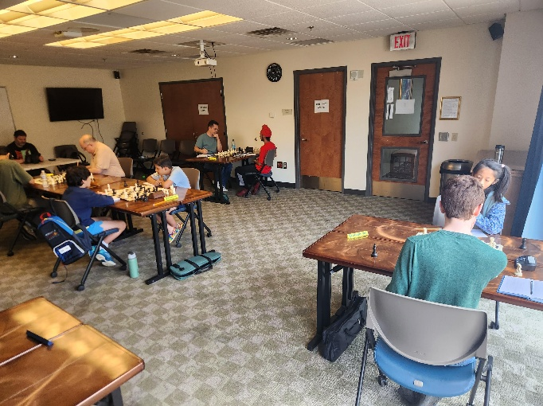

Our monthly, Chess League Tournaments will last through 2026 with the regular season concluding in October. A 12-player tournament will be played from each section (Open, U1300 and U800) beginning in November with the top players of each section. These 12-players with compete in a 6-player group round-robin competition where the top 2 from each round-robin group will advance to the 4-player bracketed playoff. The winner of this playoff will be crowned the 2026 Chess League Champion (of their given section)!

Who can join the ranks of Abigail Lin, Erik “Lucky” Walker, Jalen Taylor (U1100) and D-Taune Ingram (U1000) as the Columbia County’s Chess League Champions? To join in this year-long competition, please visit and register through 2026 Registration – Columbia County Chess Association .

Summary, results and pictures are through Apr ’26 Chess League – Columbia County Chess Association .

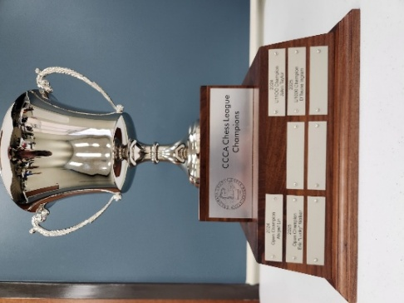
Figure 1 The coveted CCCA Chess League trophy remains on display at the Columbia County Library.

Open Section

We found some high level chess in our Open Section this month, with 1800 and 1900 level players in round-robin competition. William Bowman and (new to us) Sanjay Gorur comes away the victors with 2.0 / 3 points while Alexander Looney finishes in third with 1.5 / 3 points.

1st Place (tie) – Willam Bowman and Sanjay Gorur
3rd Place – Alexander Looney

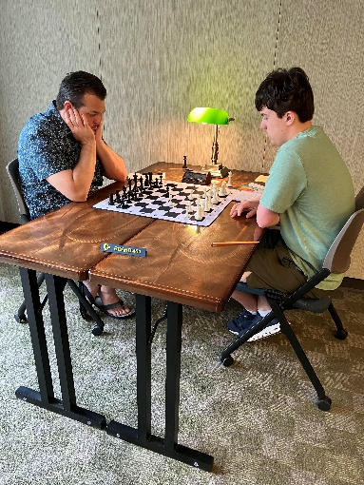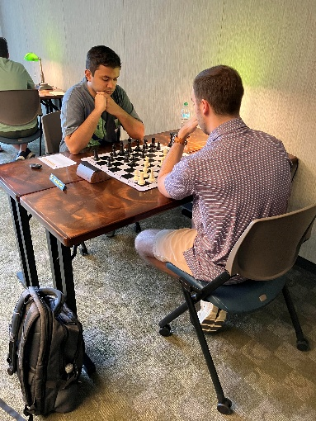
Figure 2 Willaim Bowman, Alexander Looney, Sanjay Gorur and Jacob Hanna enjoy the round-robin competition!

William Bowman assumes the top spot of the CCCA Chess League Standings, with Alexander Looney and Jacob Hanna closely behind in 2nd and 3rd Places (respectively).

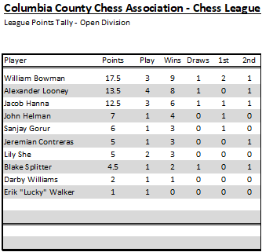
Figure 3 Chess League (Open) Standings after the April '26 Chess League Event.

U1300 Section

With a full field of players in the U1300 section from their rises in 2026, eight players battled it out over the boards. Both young phenom, Lily She and steady Darby Williams, come away tied for first place (3.0 / 4) points on the day. Keaton York returns to the Chess League scene, after taking 2025 off from rated play, finishing 2.5 / 4 points with sole possession of 3rd Place.

1st Place (tie) – Lily She and Darby Williams
3rd Place – Keaton York

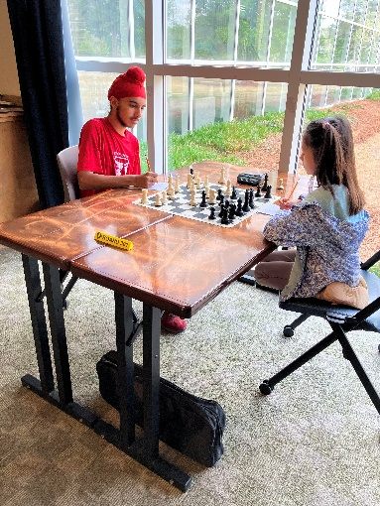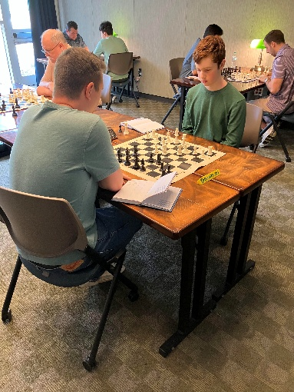
Figure 4 Gurnoor Farmaha (left), Lily She, Darby Williams and Keaton York kick off the 1st Round of Play!
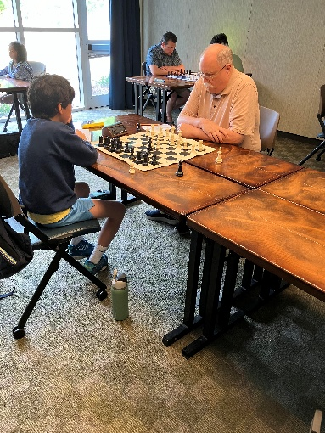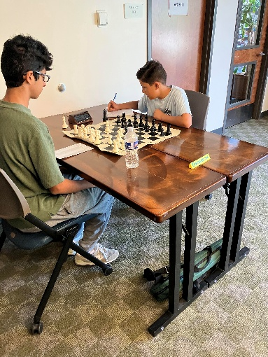
Figure 5 Ryan Kim (left), Rick Hardy, Vedant Tiwari and Vivek Raval all enthusiastically begin their rounds!

Ryan Kim maintains his overall lead in the U1300 Chess League Standing with Peter Newton and Lily She closely behind in 2nd Place.

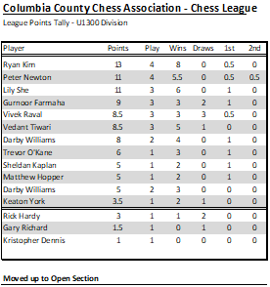
Figure 6 Latest 2026 Chess League Standings, U1300 Section

U800 Section

Peter Newton enjoys a much deserved first place finish after his tough games, he goes a perfect 4.0 / 4 points for the month’s U800 crown! Zhengwen (George) Xiang and Navtej Farmaha continue their success going 3.0 / 4 points in a second place tie. Congratulations to the winners for their fantastic play!

1st Place – Peter Newton
2nd Place (tie) – Zhengwen (George) Xiang and Navtej Farmaha

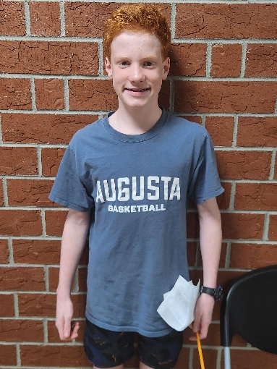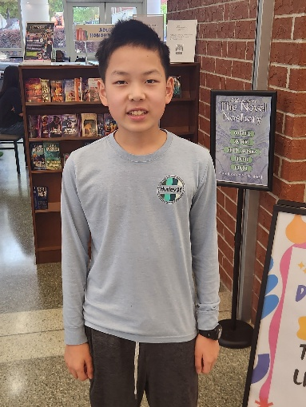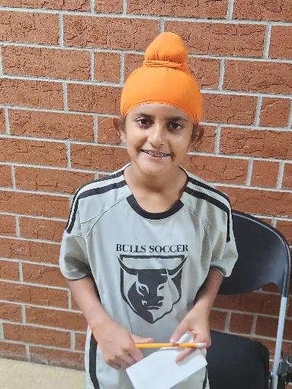
Figure 7 Congratulations to Peter Newton (left), Zhengwen Xiang and Navtej Farmaha for their performances!
Atharva Mishra takes over the top spot in the U800 Chess League standings with Zhengwen (George) Xiang and Peter Newton closely behind.

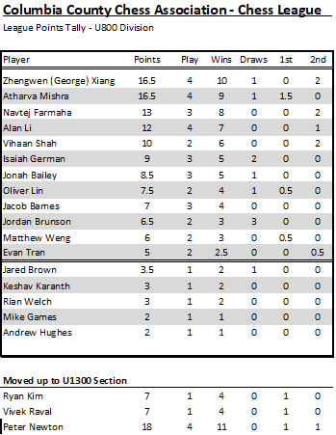
Figure 8 Latest 2026, U800 Section Chess League Standings

U400 / Beginners Section

The excitement and enthusiasm grows each month in the Beginners Section. Matthew Weng flexes his muscle going perfect through the section with 4.0 / 4 points. Mihir Raval and Zoya Looney tied for 2nd Place at 2.5 / 4 point!

- 1st Place – Matthew Weng
- 2nd Place (Tie) – Mihir Raval and Zoya Looney

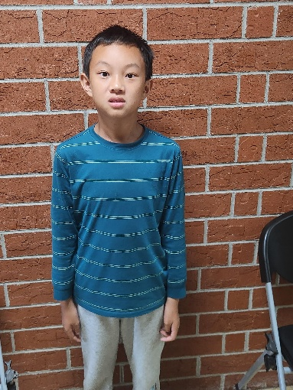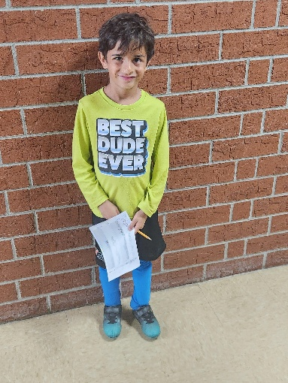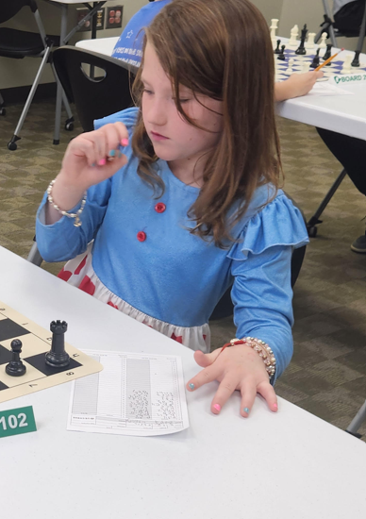
Figure 9 Congratulations to Matthew Weng (left) with first place finish, and Mihir Ravel and Zoya Looney (right) for their 2nd Place tie!
Jack Richards keep the overall point lead in the section with Zoya Looney closely behind in 2nd Place.

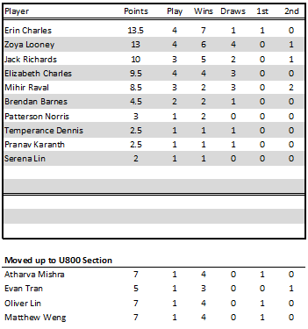
Figure 10 U400 (Beginners) Section Standings

2026 Chess League News

2026 Chess League Dates
There are still seven (6) more chess tournaments scheduled through the 2026 Regular Season with plenty of opportunity left to qualify for the playoffs! We offer an invitation to experience the journey through chess on the following tournament Saturdays in 2026!
- May 16th
- June 6th
- July 11th *
- August 1st *
- September 12th *
- October 3rd *

Although we will try our best to hold the dates advertised for each event, those designated with an asterisk (*) may change due to room availability at the library.

Playoffs will follow with the top twelve (12) from each section competing for the top four spots in a round-robin playoff! From there the Chess League Champion will be crowned (for each section) after a 4-player playoff!

More information and registrations are available through 2026 Registration – Columbia County Chess Association .

Wednesday Chess

We have been infused in the past weeks with many new (to us) players at our Wednesday Chess events at Cardboard Castle. We continue our regular schedule of Wednesday chess and have already seen many new eager players from the area.

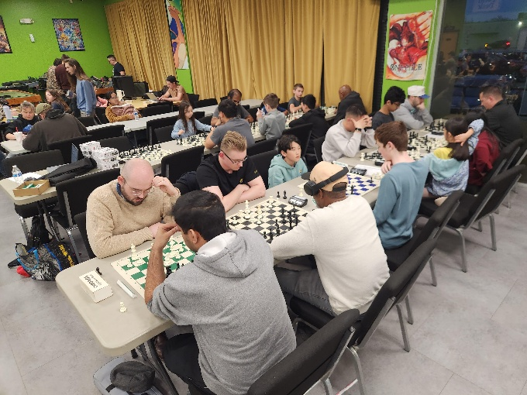

We continue to offer both the free casual and rated (mini-)tournaments each Wednesday. The results of these are as follows:

Our look-ahead for the next weeks include:
- April 29th – G\10;+5 games
- May 6th – G\5;+5 games
- May 13th – G\10;+5 games
- May 20th – G\10:+5 games

Please visit our website for updates, schedules and results of our Wednesday night offerings at Cardboard Castle through Wednesday Chess – Columbia County Chess Association .

Kids in Real Life (KIRL) Club

The Columbia County Chess Association is excited about the growth of the community outside of the virtual world. One of our loyal families, the Farmaha’s, have founded and organized a platform to keep kids engaged in real-life activities. The Columbia County Chess Association is happy to support the Kids-In-Real-Life (KIRL) Club!

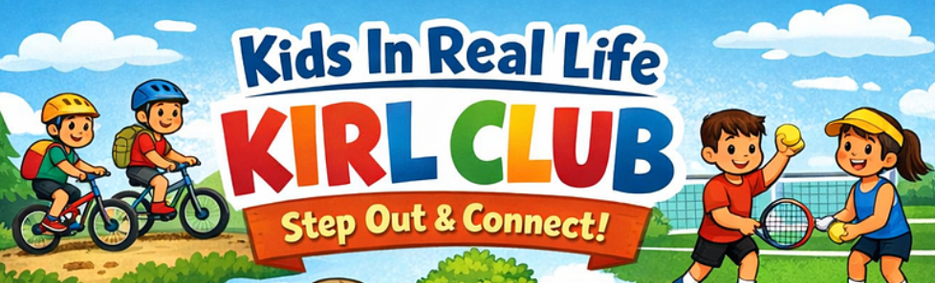

Kids-in-Real-Life Club promotes real world activities, away from the screens and virtual world. The Club welcomes kids and adults who enjoy outdoor activities, social interaction, and building genuine connections within their community. This club works to foster and cultivate a generation of socially connected and active who value real-world interactions, shared experiences and healthy lifestyles over digital dependance.

We invite you to check out their site through Kids in Real Life (KIRL) club | powered by Four Norms .

Online with the Columbia County Chess Association

USCF Rated Online Tournaments

USCF Rated online tournaments continue in 2026 with increased prizes and new tournament directors leading the tournaments! The Columbia County Chess Association is proud to have Darby Williams heading up our online tournaments with our next session scheduled in June, starting at 7:00 pm.

With our increased prize pool this year and we are excited to offering the following the top two positions of each section (Based on 10 entries):
- Open Section: $60 Pool (1st Place - $40, 2nd Place - $20)
- Under 1000 Section: $30 Pool (1st Place - $20, 2nd Place - $10)

Games in June will be G/10;+5 games with an estimated 4 Rounds.

For our Scholastic level players (K-12) we are excited to offer the combination of the New (or renewal) annual USCF membership with registration for the Online tournament for $25!

Register through Online Tournaments – Columbia County Chess Association .

Not sure how USCF Rated Online Tournaments work? Please visit Instructions – Online Tournament – Columbia County Chess Association for more information.

April ’26 – USCF Rated Online Tournament
Players gathered online and enjoyed games and community through chats and games! After a night of exciting and inspiring play, we found a four-way tie for 1st Place in the Open Section! Congratulations to author David Couture, Alexander Looney, Tristan Cesolini and Julian Miguel Hernandez Caceres for their outstanding play throughout the night!

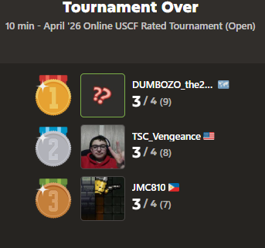

There was a clear-cut winner of the U1000 Section; Brannen Vaughters. Brannen goes perfect on the night (4.0 / 4 points). Jadon Thomas Christy Collins finishes in 2nd Place on the night. Thank you and congratulations to all of our players participating in the tournament!

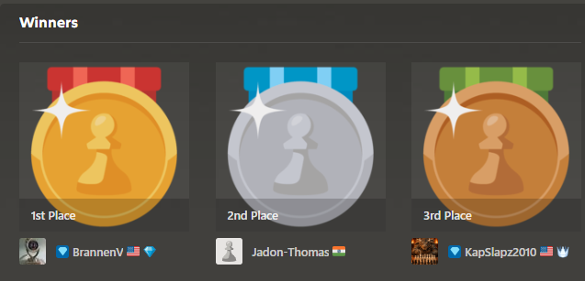

Chess.com Group – Columbia County Chess Association

Would you like to connect through an online chess platform to play and connect with other local players? We invite you to join our chess.com group, “Columbia County Chess Association”. We are excited to offer monthly FREE monthly daily game tournaments, along with different “Vote Chess” and “Team Chess” competition against other clubs in the South Carolina and Georgia areas!

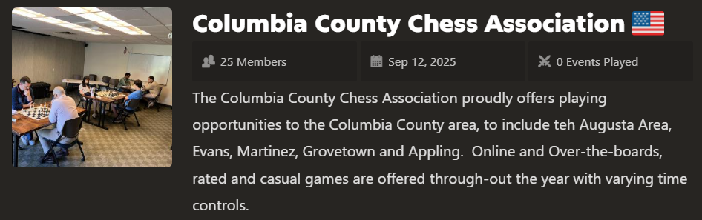

We would love for you to join us through https://www.chess.com/club/columbia-county-chess-association/join .

FREE Daily Game Competition Updates

Ongoing Daily Tournaments

January ’26 Daily Tournament
The Columbia County Chess Association restarted 2026 with the new *** FREE *** Daily Tournament, with ten local players competing for the coveted CCCA badges! Six players remain as the competition continues. Competition remains tight for the January ’26 prize!

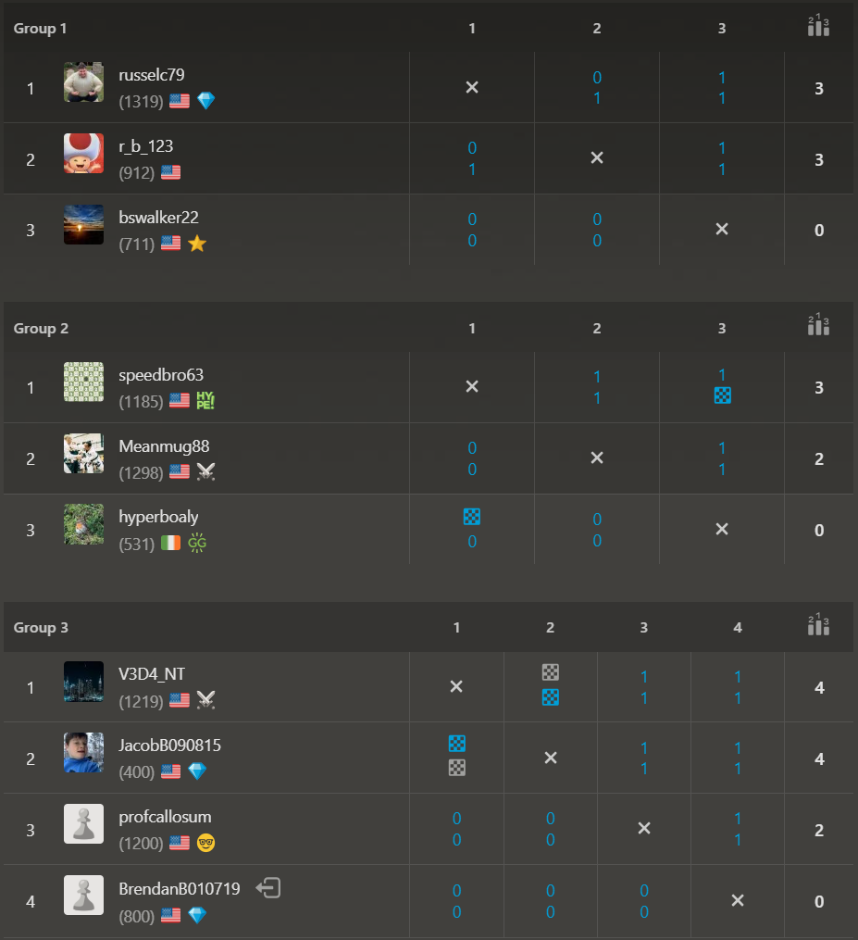

February ’26 Daily Tournament

Open Section
Six players gathered, and 5 players remain in contention for the Open Section badges and bragging rights for the month of February! Who comes away the victor?! “Shortoff Mountain”, “russelc79” and “Aitrusak” are ready to advance while waiting on the final games to complete!

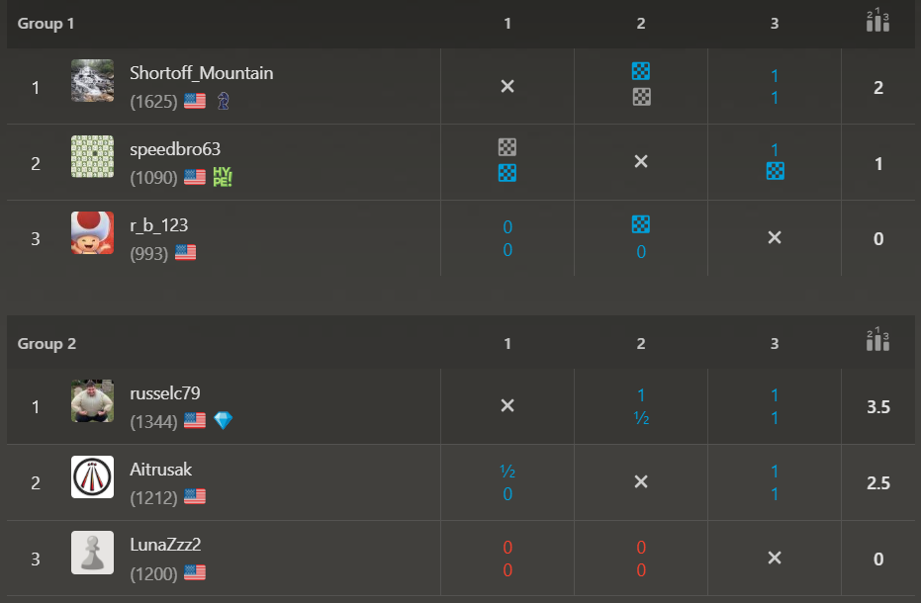

U1000 Section
Three fierce competitors battled it our online over the virtual boards and concluded their competition in the February Daily Tournament (U1000 Section)! Congratulations to “Runswithit” for her first place finish!

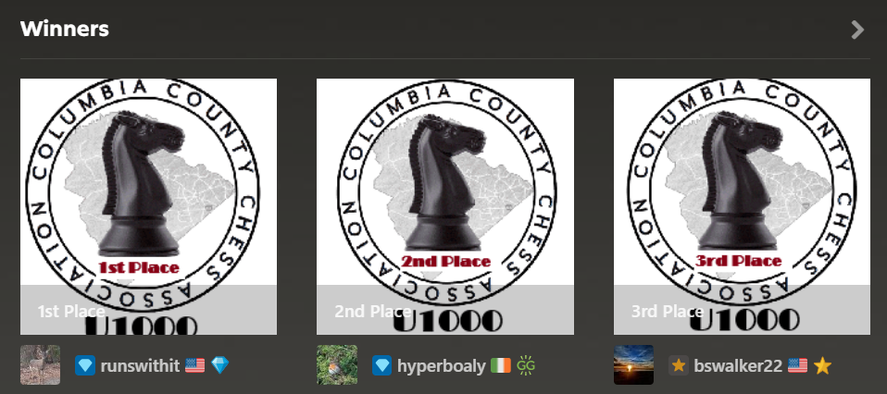

March ’26 Daily Tournament

Open Section
With the entrance of 7 players in the March ’26 (Open Section) Daily Tournament, 5 remain in contention for the coveted club badges!

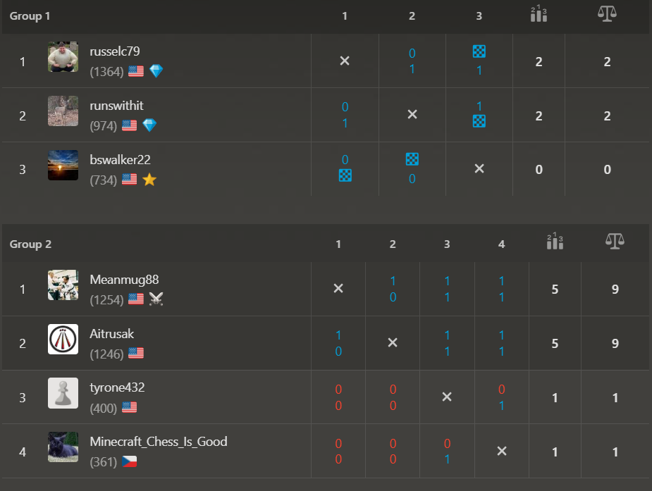

April ’26 Daily Tournament

Open Section
The April ’26 Daily Chess tournament is off and running! All players remain in contention and all eagerly await the challenging games!

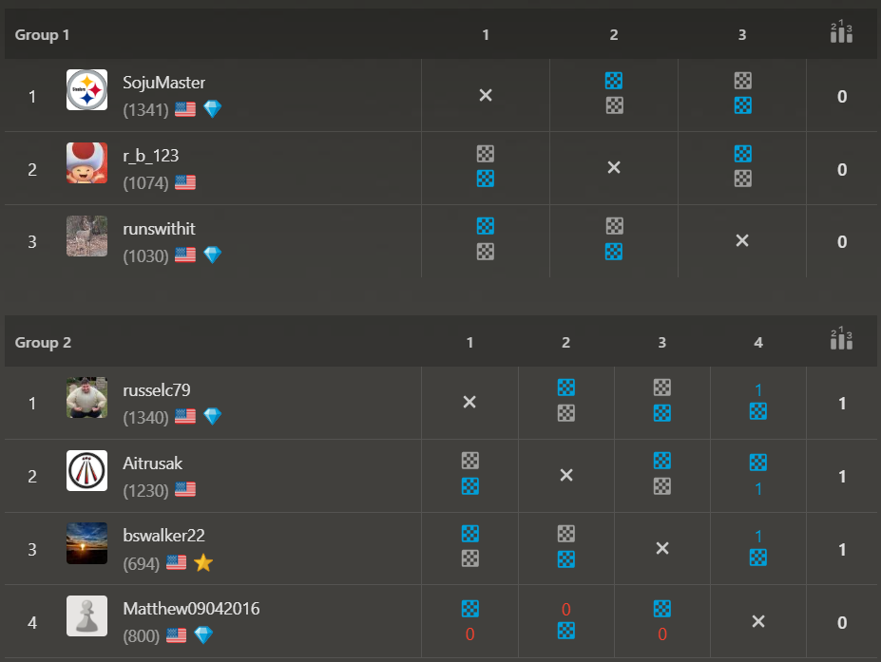

U1000 Section
Three players compete for the Under section badges with games ongoing!

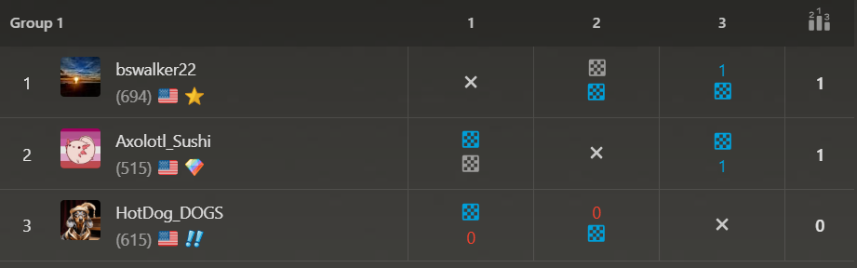

Upcoming May 23rd Daily Tournaments
Come join us for our May '26 Daily Tournaments! Free entry and games begin on May 23rd to compete for the coveted CCCA Winners badges! We are excited to continue to offer both the U1000 and Open sections for our various level of players!

Join us now through:
- Open Section: https://www.chess.com/tournament/ccca-may-26-daily-tournament-open/join .
- U1000 Section: https://www.chess.com/tournament/ccca-may-26-daily-tournament-u1000-section/join/746459 .

USCF Memberships - Scholastic Players

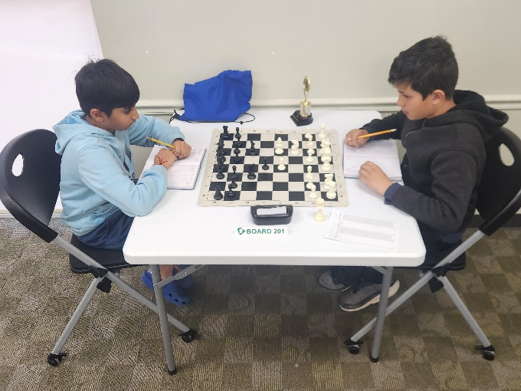

The United States Chess Federation (USCF) requires all chess players player under their guidelines to have USCF Membership. This can be a cumbersome part of playing chess by ensuring registration prior to chess play. This can also be expensive because memberships just increased to $54 for a single players. We are very excited to foster and nurture the enthusiasm surrounding chess and are actively finding new ways to make chess more accessible.

The Columbia County Chess Association has invested in the future of our scholastic players with USCF Vouchers. For this reason we are excited to offer the following to our first time scholastic players:
- USCF Rated Online Tournament + an Annual USCF Membership (for K-12 players) for $25
- Wednesday Chess + an Annual USCF Membership (for K-12 players) for $25
- Saturday Chess Tournament + an Annual Membership (for K-12 players) for $50

This offer also extends to our existing scholastic players membership, which we can now offer for $18 for an annual USCF Membership renewal! We hope this helps everyone enjoy this beautiful game!

2026 Columbia County Chess Association Chess Enthusiast Packages

When you purchase the Chess Enthusiast Package, you’ll get the following benefits:

US Chess Federation (USCF) Membership

Whenever you play rated games anywhere in the United States, you must be a member of the USCF. They’ve got their own separate membership fee, however, if you purchase a Club Membership with Columbia County Chess Association, we’ll cover that fee for you.

Remember: the USCF membership has its own benefits too! Don’t forget to check out their monthly Chess Life magazine (the online version is free for USCF members). After all, your USCF membership also paying for a subscription to the online portion of the magazine, so why not enjoy it?

Gain entry into one of the following offerings for all of 2026:

1) Wednesday Chess events at Cardboard Castle for the remainder of 2026 (a $380 value)
2) Entry into the remainder of the 2026 Chess League Regular Season ($320 value, does not include the end-of-year playoffs)

You get to choose one of the above options as part of your package. If you would to participate in both, then there may be an extra fee associated.

Access to chess training software

You get access to one of the following software options:

1) Chess4Life – a child-friendly chess training platform
2) Chess.com membership – We’ll pay for you to have a Diamond-level account, which includes puzzles, online training, and more.

Chess stuff

You will receive one of two packages:

- Tournament size chess set including a travel tournament bag, triple weighted pieces, and silicone board
- High quality chess clock

With the purchase of a full year of membership, you’ll get access lots of really cool stuff and save some money at the same time!

Apply for memberships online through Chess Enthusiast Packages – Columbia County Chess Association .

